Paasprogramma’s 2022

vrijdag 15 april, 20:00 (ná Country Nu)
Goede Vrijdag

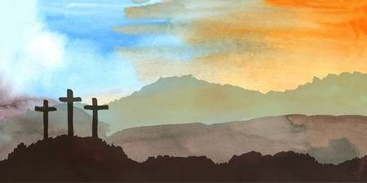

- Latresa & the Signal Sea of Galilee
- Peasal Sisters & Emmylou Sea of Galilee
- Lewis Family The man of Galilee
- Stonemans A light lit up in Galilee
- Johnny Cash The last supper
- Mountain Ramblers Calvary
- Slim Dusty Calvary Hill
- Wilma Lee & Stoney Cooper I’m walking my Lord up Calvary hill
- Roy Rogers & Dale Evans Near the cross
- Pat Boone The old rugged cross
- Ernest Stoneman He was nailed to the cross for me
- Koor en orkest o.l.v. René Jacobs
O Haupt voll Blut und Wunden
- Janet McGary At the foot of the cross
- Joyce Greene & Family Six hours on the cross
- Irlene Mandrell Someone died for me
- Roy Acuff Jesus died for me
- Doyle Lawson I live for him cause he died for me
- Elly en Rikkert Alles wordt donker

zondag 17 april, 8:00
Opstanding (1)

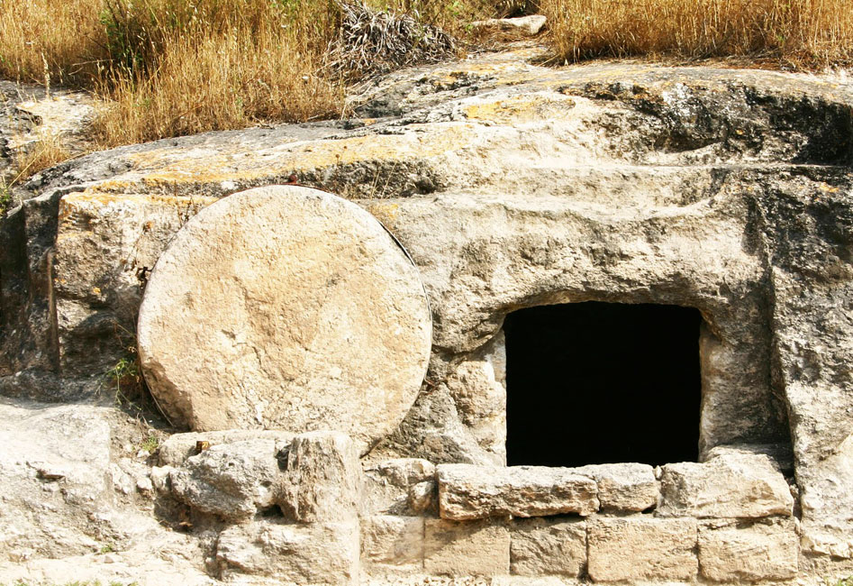

- Yvonne Devaney Mary Magdalena
- Johnny Cash Mary Magdalena returns to Galilee
- Dolly Parton He's alive
- Phil Wickham Christ is risen
- Paul Williams Jesus had rose from the dead
- Tabernacle Choir at Temple Square
Christ the Lord is risen today
- New London Choral I know that my redeemer lives
- Cristy Lane I know my redeemer lives
- Reno, Smiley & Harrell My redeemer lives again
- George Hamilton IV Because he lives
- Leden Ichthus Kerk Den Haag
Daar juicht een toon
- Carol Elizabeth Jones & Laurel Bliss
Resurrection day
- Early Grass Revival Resurrection morning
- Tom Russell Resurrection mountain
- Ray Wylie Hubbard Resurrection
- Onbekende Rus Khristos Voskres Hristos
- Elly & Rikkert Hij leeft
- Carrie Underwood & Vince Gill
How great thou art

zondag 17 april, 9:00
Opstanding (1)

- Elly & Rikkert & kinderkoor Pasen
- Corner House Easter Sunday
- Frans kinderkoor Chanson pour Pagues
- Jiri Pavlica & Hradistan Velikonochi cas
- Tom T Hall Easter is
- Cody Carnes The cross has the final word
- Jerry Earl & Robert van Eamon
Easter snow
- Zoe & Cloyd Resurrection day
- Edwin Hawkins Singers Oh Happy Day
- Melonie Cannon Mary Magdalena
- Mac Martin Resurrection morn
- Matt Maher Because he lives
- Claire Lynch Who but man
- Matraca Berg The resurrection
- Dixon Brothers Easter day
- Ralph McTell Easter lillies
- Blue Sky Boys The blood of Jesus
- New London Choral Finale
- Johnny Cash, Carter Family & Statler Brothers
Ascension, Amen chorus

Paasprogramma’s 2023

Zondag 9 april, 09:00
Pasen 2023 – 1
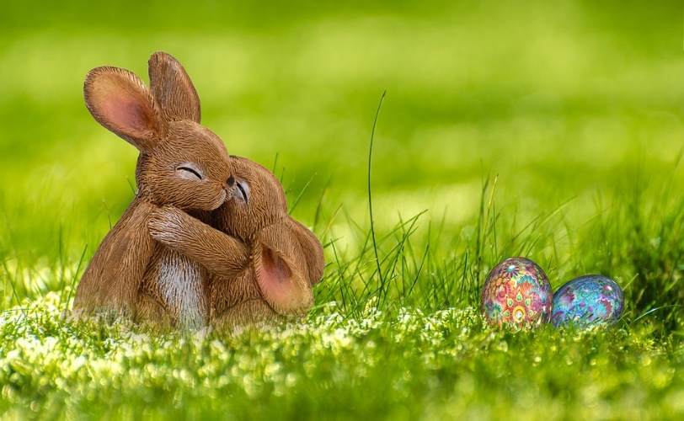

- Elly & Rikkert & kinderkoor Pasen, pasen
- Frans Kinderkoor Chanson pour Paques
- Jiri Pavlica & Hradistan Velikononcni cas
- Bajo Duero Pascua de resurreccion de
Pobladura de alista
- Michel Fugain Et Le Big Bazar Le printemps
- Rusty Draper Easter Morning
- Tom T Hall Easter Is
- Lewis Family Calvary
- Tennessee Ernie Ford Must Jesus Bear The Cross Alone
- Sullivan Family Lonely Lonely Road To Calvary
- Slim Dusty Calvary Hill
- Jimmy Williams & Red Ellis Three wooden crosses
- Slim Whitman He Bought My Soul At Calvary
- Bill Anderson & Jan Howard The Old Rugged Cross
- Tommy Collins Jesus Keep Me Near The Cross
- Stonewall Jackson Kneel At The Cross
- Wabash Valley Boys After Calvary
- Early Grass Revival The resurrection morning
- Country Ham In The Garden
- Rose Maddox I’ll meet you in church Sunday morning
- Buffoons Sunday morning
Bonus:
- Carl Story Near the cross

Zondag 9 april, 10:00
Pasen 2023 – 2
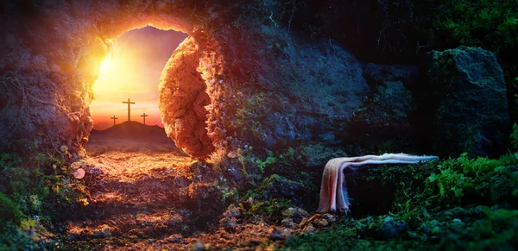

- Mike Batt Lady Of The Dawn
- Johnny Cash Mary Magdalene returns to Galilee
- Dolly Parton He’s Alive
- Alan Jackson He Lives
- Wanda Jackson Because He Lives
- Magnus Lindborg Jesu uppståndelse
- John Fahey Jesus Christ Is Risen Today
- koor Jesus Christ is risen today
- Zoe & Cloyd Resurrection Day
- Tom Russell Resurrection mountain
- State Academic Capella Thy resurrection (Russisch)
- Cristy Lane I Know My Redeemer Lives
- New London Choral I Know That My Redeemer Liveth
- Kerkleden & mannenkoor Daar juicht een toon
- Gospel Gentlemen Jesus died at Calvary
- Hank Williams Jesus died for me
- Standing Stone Bluegrass Jesus still lives
- onbekend Jezus leeft, hij is opgestaan
- Carrie Underwood Great Is Thy Faithfulness
- Johan Sebastian Bach O Haupt vol blut und wunden
- Georg Friederich Händel Hallelujah

