Waterland CB
Regio Noordkop Country & Bluegrass

www.regionoordkop.nl https://rtvpurmerend.nl
ether: 106.6 FM
Digitaal Ziggo: Kan. 918
luisteren on line kan via: luisteren online kan via:
www.regionoordkop.nl/live-radio/ https://rtvpurmerend.nl/radio/live

Na de uitzending kan het programma worden beluisterd wanneer u maar wilt, via
http://hans.vdveen.org/muziek/

U vindt daar de uitzendingen van het laatste half jaar, waar u vrij uit kunt kiezen.
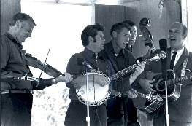


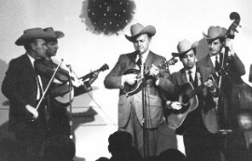
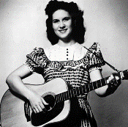
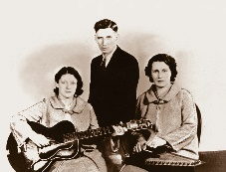
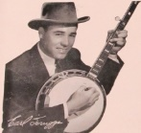
15 & 17 juni 2025
Zondag 19:00-20:00 – Waterland Country Bluegrass
Dinsdag 20:00-21:00 – Country & Bluegrass NieUw
Dinsdag 21:00-22:00 – Traditionele Country
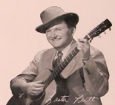
Dinsdag 22:00-23:00 – Bluegrass

samenstelling, montage & presentatie
Hans van der Veen
Even ging de tijd me TE hard. Het blijkt al dinsdag te zijn, dus maar snel de playlisten.
Zondag: al geweest. Ik vond hem best aardig met al die Jantjes, die overigens niet allemaal pruimen zagen hangen.
Dinsdag 1: twee dingen vraag ik me af. Eerst of ik die nieuwste van Willie Nelson toch niet al eerder heb genoemd. Hij maakt ook zo verschrikkelijk veel. Ten tweede of Valerie Smith wel onze Valerie is. Het kan haast niet anders, maar … U moet zelf maar eens goed luisteren.
Dinsdag 2: twee minder bekende liedjesschrijfsters. Leek me wel eens aardig en dat werd het ook.
Dinsdag 3: begin van een nieuwe serie, waarvan ik nog niet weet hoe ver ik ermee kom: de allermooiste bluegrass.

Veel luisterplezier!!

Zondag 15 juni, 19:00-20:00
Waterland CB
CB-006
Jantjes
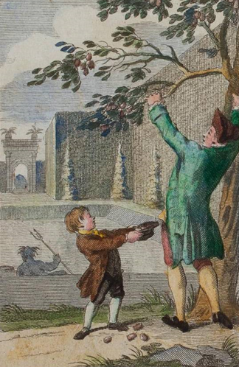

- John D. Loudermilk Blue train
- John McCutcheon What we want
- John & Audrey Wiggins String of bad love
- John & Nienke Just a minute
- John Brack (ZA) Why can’t you be on time
- John Wesley Riles Catch the wind
- John Denver Carolina in my mind
- John Allan Cameron The four Mary’s
- John Greenway Old Bullock Day
- John Bowman I’ll be your witness
- John Herald Goodbye old pal
- John Hartford The girl I left behind me
- John Lilly Prisoner’s birthday
- John Cadley Never say never
- John & Frances Reedy Lost John
- John Duffey This morning at nine
- John Rigsby Walking with you in my dreams
- John Lowell She’s leaving Cheyenne
- Jan Schiferl If wishes were horses
- John Brunschwyler & Brennen Ernst Scramble
- John D. Loudermilk The great snowman

Dinsdag 17 juni, 20:00-21:00
Country & Bluegrass NieUw
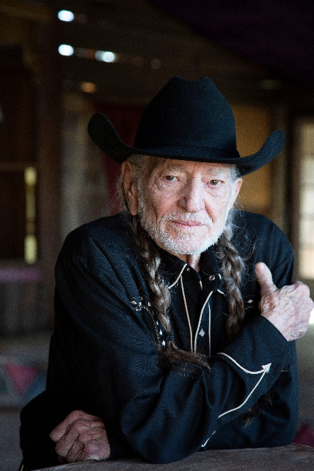
2025-23
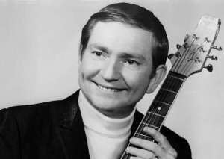

Willie Nelson vroeger en nu.

Intro
- Wolfe Milestone Me and my radio
Life’s Highway
- Goldwing Express Keep on the firing line
- Katie Laur Band Bedrock breakdown
- Bluegrass 45 The old man’s story
- Stringbean Wanda
- Waylon Jennings Lorena
Nieuwe Country
- Willie Nelson Banks of the old Bandera
- Maddie & Tea Down that road
- Kassi Ashton The stars know
- Kassi Valazza Your heart’s a tin box
- Bryan Martin Ain’t my old man
- Fancy Hagood Ever really ready
Nieuwe Bluegrass
- Strawberry Flats Lake Superior home
- Wheels North Jonah’s town
- Samuel Bourgeois Son ami Mason
- Valerie Smith Walk right back
Outro
- Willie Nelson Oh, what a beautiful world

Dinsdag 17 juni, 21:00-22:00
Regio Noordkop Country
Songs written by
Sharon (Rose) Higgins
en
Joyce McCord
(de zusjes van Damon Black)
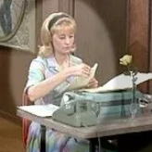
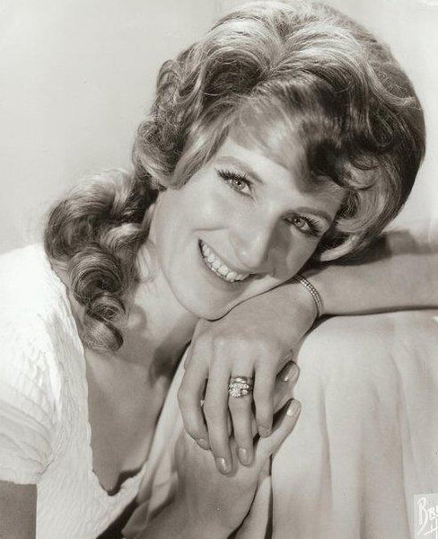

Sharon (links) en Joyce (boven)

Sharon
- Mel Tillis Love Ain't Gonna Die (I'm Gonna Have to Kill It)
- Lawanda Lindsey Woman of the World (Leave My World Alone)
- Norma Jean All I've Got Left
- Loretta Lynn When you leave my world
- Philomena Begley It's a Long Way from Heaven (co)
- Jeanne Pruett Hold on Woman
- Wayne Kemp She'll Love You to Pieces
- Bill Harrell I saw the master this mornin
- Wynonna Judd All of that love from here
- Grascals Silver strands (co)
- Oak Ridge Boys Beneath the Christmas tree (co)
- Lonesome River Band Crazy Heart
- Norma Jean The Only Way to Hold Your Man
- Loretta Lynn I feel like I could fall in love with anyone tonight
Joyce
- Porter & Dolly Always always
- Smiley Bates Sorrow overtakes the wine
Sharon als zangeres
- Sharon Higgins The girl who always does and says she don’t
- Sharon Higgins She loved all the love out of you
- Sharon Higgins Sister ’s goin wild
- Sharon Higgins You need’s me

Dinsdag 17 juni, 22:00-23:00
Regio Noordkop Bluegrass
Prime Cuts (1-9)

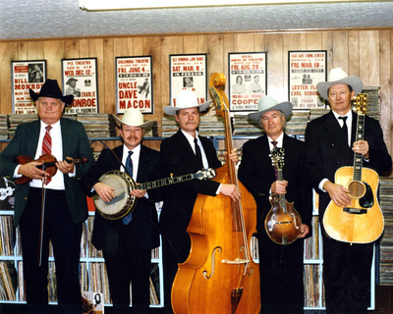
Delmer Sexton & the Rone County Bluegrass Boys

- Kentucky Rose The cottage with the roses
down the lane among the Pines
- Delmer Sexton & the Rone County BG Boys
When the golden leaves begin to fall
- Emma Smith Back to the basics
- Clay County Work all week
- Troublesome Hollow 5 Lbs of possum
- Coffey Brothers BG Band Medals for mothers
- Cindy Craven Old familiar song
- Larry Perkins Louis Collins
- The Sidemen Why baby why
- Andy Owens Project Jalapeno flashback
- All Girls Boys Blues be on my mind
- Barbara Saint John The little quaker boy
- Iris Dement The shores of Jordan
- Vernon McIntyre’s Appa lachian Grass
Fairytale land
- Larry Stephenson Band When I left East Virginia
- Wes Homner Sing me to sleep
- John McEuen Carolina Traveler

De vorige week
Wilt u luisteren naar het programma van de vorige week?
Control+klik op onderstaande links

Zondag 8 juni, Waterland CB: Sweets & sweethearts
https://hans.vdveen.org/muziek/W - WATERLAND CB/458W - Waterland CB - 2025-06-08 - Sweets.mp3

Dinsdag 10 juni, Country & Bluegrass NieUw
https://hans.vdveen.org/muziek/A - COUNTRY NU (pas verschenen)/458A - R-N C&BG Nieuw - 2025-06-10.mp3

Dinsdag 10 juni, Noordkop Country: 1940 & 1970 (6)
https://hans.vdveen.org/muziek/B - NOORDKOP COUNTRY/458B - R-N Country - 2025-06-10 - 1940 & 1970 (6).mp3

dinsdag 10 juni, Noordkop Bluegrass: Bluegrass Nogwat (8)
https://hans.vdveen.org/muziek/C - NOORDKOP BLUEGRASS/458C - R-N Bluergrass - 2025-06-10 - Bluegrass Nogwat (8).mp3

