Waterland CB
Regio Noordkop Country & Bluegrass

www.regionoordkop.nl https://rtvpurmerend.nl
ether: 106.6 FM
Digitaal Ziggo: Kan. 918
luisteren on line kan via: luisteren online kan via:
www.regionoordkop.nl/live-radio/ https://rtvpurmerend.nl/radio/live

Na de uitzending kan het programma worden beluisterd wanneer u maar wilt, via
http://hans.vdveen.org/muziek/

U vindt daar de uitzendingen van het laatste half jaar, waar u vrij uit kunt kiezen.
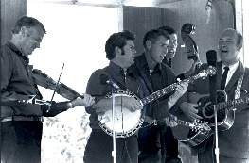


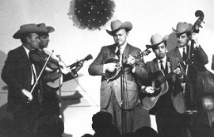


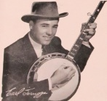
8 & 10 juni 2025
Zondag 19:00-20:00 – Waterland Country Bluegrass
Dinsdag 20:00-21:00 – Country & Bluegrass NieUw
Dinsdag 21:00-22:00 – Traditionele Country

Dinsdag 22:00-23:00 – Bluegrass

samenstelling, montage & presentatie
Hans van der Veen
Je moet als DJ en als politicus iedereen te vriend houden, daarom een uurtje over sweets en sweethearts. Zo, dat is eenvoudig verklaard.
Uur 2, of dinsdag 1: zou er nog wat leuks tussen zitten? Die Wild Flowers zijn wel leuk, en ook die Tsjechische band. Ik heb zoals gewoonlijk weer heel veel nieuw spul afgekeurd, anders zou het meer op een rock-programma lijken.
Die vrolijke man boven R-N Country leefde van 1905 tot 1984. Na zijn overlijden vond zijn familie 50 master tapes met studio opnamen die nooit waren uitgebracht. Daar is een 3-CD box van gemaakt, maar het lijkt me toe dat lang niet alles openbaar is gemaakt.
Tenslotte weer een aflevering Bluegrass Nogwat, dielevert altijd weer verrassende dingen op. Ik ga nog eens iets soortgelijks bedenken.
Ik wens u weer veel luisterplezier!!

Zondag 8 juni, 19:00-20:00
Waterland CB
CB-022
Sweets & Sweethearts

Aha, zo komt ze aan haar naam (track 10)

Country
- Terry Parker = The yodeling sweetheart (Can)
Second fiddle to an old guitar
- Sweetheart Sisters (Can) Valse dans mes bras ce soir
- Sweethearts of the Rodeo Hoping that you’re hoping
- Sweetback Sisters The mysterie of you
- Sweet Violet Boys, aka Prairie Ramblers
Walking in my sleep
- Sweet Virginia Leaving again
- Canadian Sweethearts Heartaches by the number
- Ann Jones & her Western Sweethearts
Goodbye and good luck
Bluegrass
- Sweet Yonder Shady grove
- Sweet Marie (Noorwegen) Confrontation
- Dirt Road Sweetheart & Nora Jane Struthers
Baby girl
- The Sweet Lowdown Sing high to low
- Sweet Potato Pie Her father’s eyes
- Sweet Potato Vine (Fra) Grey cat on a Tennessee farm
- Sweet Lillies On my way back home to you
- Sweet Lou's Sour Mash Stickin’ in my eye
- Sweetwater Stringband Up and over
- Sweetgrass Serenade Promised land
- Sweet Tidings Gospel Jam Shall we gather at the river
- Sweet Joe Pye (Ned) Moonwalk

Dinsdag 10 juni, 20:00-21:00
Country & Bluegrass NieUw
2025-22

Jordana Bryant

Nieuwe “Country”
- Bon Iver Speyside
- Suzy Thompson If I could stay
- Yarn I want you
- Sarah Pierce Dream as big as Texas
- Jesper Lindell (Zwe) One of these rainy days
- Ad Vanderveen (Ned) Nothing written in stone
- Sam Outlaw Do you really love me
- Jordana Bryant Something like us
- Jason Boland and the Stragglers The next to last Hank Williams
Nieuwe Bluegrass
- Chandler Beavers Daybreak in Dixie
- King James Boys The best selling book of all time
- Steve Bruce Band Behind the plow
- The Wild Flowers Grandpa’s coat
- Hightop Mountain Harmony Waltz of the wind
- Mary Lee Family Band (Braz) What are you
- Obejvaci (Tsj) Siamsa
- Dave Kline & The Mountain Folk Band Eat that cabbage raw
Bonus
- Dave Kline & The Mountain Folk Band The ballad of Mary Coffey

Dinsdag 10 juni, 21:00-22:00
Regio Noordkop Country
De singles van 1940 en 1970 – 6
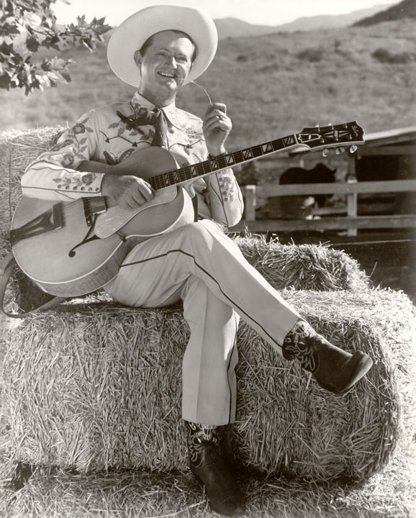
Al Dexter

1940
- Roy Rogers Chapel In The Valley
- Al Dexter Walking In My Sleep
- Fiddlin’ Arthur Smith It's A Weary World
- Buddy Jones Dear Old Sunny South By The Sea
- Carter Family My home among the hills
1970
- Billie Jo Spears Marty Gray
- Waylon Jennings Singer of sad songs
- Jerry Lee Lewis There Must Be More to Love Than This
- Tammy Wynette Run Woman Run
- John Denver Follow Me
- Connie Eaton Angel of the Morning
- Leon Ashley Tell Him Daddy Said Hello
- Bobby Goldsboro Down On The Bayou
- (New) Kingston trio Tell The Riverboat Captain
- Carl Butler Used To Own This Train
- Tommy Hunter Wait for Sunday
- Wynn Stewart It's a Beautiful Day
- Hank Locklin Rosalita
- Country Joe McDonald Tiger by the tail
- Merv Shiner Protest
Bonus:
- Hamilton County BG band Roll muddy river

Dinsdag 10 juni, 22:00-23:00
Regio Noordkop Bluegrass

Bluegrass Nogwat
8

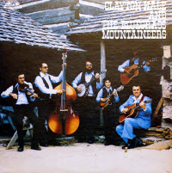
Clayton Hale & the Bluegrass Mountaineers

- Bluegrass Mountaineers (Clayton Hale & the)
Tender loving arms
- Bluegrass Mountaineers (Earl Taylor & the)
Sweetheart you done me wrong
- Bluegrass Mountaineers (Earl Garner & the)
Little John Hardy
- Bluegrass Mountaineers (Edward Efaw & the)
We shall rise
- Bluegrass Mountaineers (Larry Efaw & the)
Remember you love in my prayers
- Bluegrass Mountaineers No one but you
- Bluegrass Pals (Emmy & her) I wonder how the old folks are at home
- Bluegrass Pals (Laurie Lewis & her)
Blow wind blow
- Bluegrass Pals (Jack Gray & the)
Working on the road
- Bluegrass Pals (Andi & the) One song romance
- Bluegrass Pals (Holbrook Duet with)
Angel, get my mansion ready
- Bluegrass Partners (Shirley Landrum & the)
How great is my God
- Bluegrass Partners (George Winn & the)
- The prisoner’s song
- Bluegrass Partners (Indiana) One little tear for me
- Bluegrass Partners (Tennessee In my mind to ramble
- Bluegrass Playboys (Wynn Osborne & his)
Dear old Dixie
- Bluegrass Playboys (Paul Mullins & the)
I never dreamed
- Bluegrass Playboys (Bradford Lee Folk & the)
Foolish game of love
Bonus:
- Bluegrass Playboys (Wynn Osborne & his)
Farewell blues

De vorige week
Wilt u luisteren naar het programma van de vorige week?
Control+klik op onderstaande links

Zondag 1 juni, Waterland CB: kruidenierswinkels, verschoven naar augustus

Dinsdag 3 juni, Country & Bluegrass NieUw
https://hans.vdveen.org/muziek/A - COUNTRY NU (pas verschenen)/457A - R-N C&BG Nieuw - 2025-06-03.mp3

Dinsdag 3 juni, Noordkop Country: De songs van de Cats
https://hans.vdveen.org/muziek/B - NOORDKOP COUNTRY/457B - R-N Country - 2025-06-03 - De songs van The Cats.mp3

dinsdag 3 juni, Noordkop Bluegrass: Claire Lynch (1)
https://hans.vdveen.org/muziek/C - NOORDKOP BLUEGRASS/457C - R-N Bluegrass - 2025-06-03 - Claire Lynch (1).mp3

