Waterland CB
Regio Noordkop Country & Bluegrass

www.regionoordkop.nl https://rtvpurmerend.nl
ether: 106.6 FM
Digitaal Ziggo: Kan. 918
luisteren on line kan via: luisteren online kan via:
www.regionoordkop.nl/live-radio/ https://rtvpurmerend.nl/radio/live

Na de uitzending kan het programma worden beluisterd wanneer u maar wilt, via
http://hans.vdveen.org/muziek/

U vindt daar de uitzendingen van het laatste half jaar, waar u vrij uit kunt kiezen.
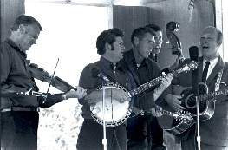

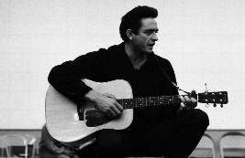
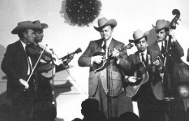
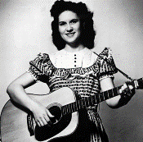
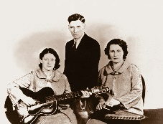
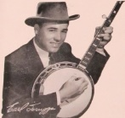
6 & 8 april 2025
Zondag 19:00-20:00 – Waterland Country Bluegrass
Dinsdag 20:00-21:00 – Country & Bluegrass NieUw
Dinsdag 21:00-22:00 – Traditionele Country
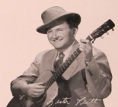
Dinsdag 22:00-23:00 – Bluegrass

samenstelling, montage & presentatie
Hans van der Veen
Gaat u naar King Springs Road (zondagmiddag 15:00 in de Hooghe Heeren), dan kunt u nog net op tijd thuis zijn voor Waterland CB, tenzij u ver weg woont. Maar rijd u niet te hard, want u kunt het altijd nog in de herhaling horen. De programma’s van de laatste twee weken op dinsdag kunt u tegenwoordig ook beluisteren via de website van de omroep, via het blokje “Gemist”. Prima idee, ik hoop dat het na de fusie blijft.
Want er wordt hard vergaderd. Per 1 september moeten de programma’s van Noordkop Centraal (Schagen) en Regio Noordkop worden samengevoegd. We gaan dus een paar spannende weken tegemoet.
Maar voor deze week kan ik u in elk geval nog veel luisterplezier wensen.

Zondag 6 april, 19:00-20:00
Waterland CB
CB-016
Emma & Lost
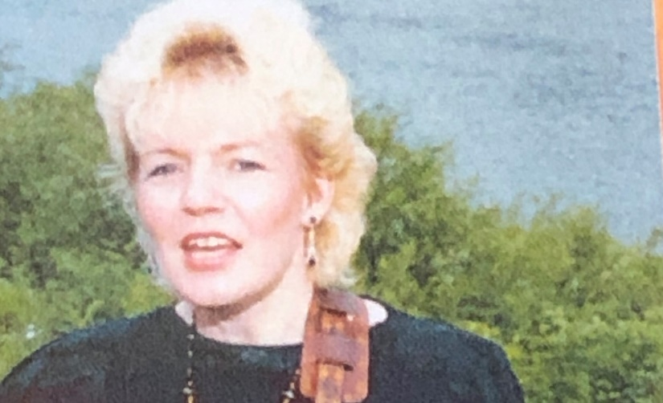
Emma Smith

Country: Emma
- Emma Swift (Austr) Seasons
- Emma Ogosi (Nigeria) Give a little
- Emma Mattucci Teenager in love
- Emma Jo Mirror
- Emma Peterson Just for the record
- Emma Zeck Bad girl
- Emma Jene Boy meets girl
- Emma Smith Give me the roses now
- Emma Kelly Blackbird
- Caitlin Jemma Dear someone
Bluegrass: Lots
- Buzz Busby Lost
- None of the Above Lost along the way
- Lonesome Pine Fiddlers Lost girl
- McPeak Brothers Lost river
- Seldom Scene Lost in a memory
- Al Jones Lost to a stranger
- Kentucky Shine Lost in the pines
- Tony Rice Lost Indian
- Ricky Skaggs Lost and I’ll never find my way
- Virginia Mountain Boys Lost train blues

Dinsdag 8 april, 20:00-21:00
Country & Bluegrass NieUw
2025-13
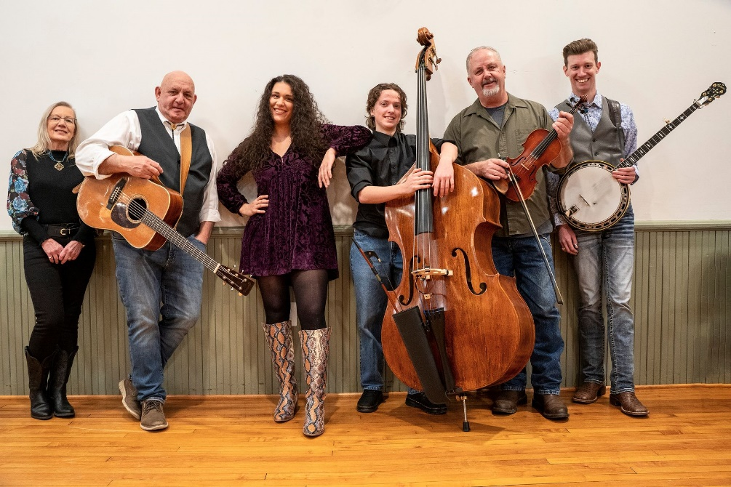
Crandall Creek

7 april jarig
- Bobby Bare The streets of Baltimore
8 april jarig
- Restless Heart (John Ditrich) Till I loved you
- John Schneider Sounds like something I would say
Recent verschenen Country
- Max McNown Roses and wolver
- Kane Brown When you forget
- Victoria Liedtke & Jason Ringenberg Morte than words can tell
- J.R. Carroll In the shadow
- Roger Street Friedman The kitchen window
- Nicolette Wherever you go
Recent verschenen Bluegrass
- Volume Five County wishing well
- Crandall Creek Less or more
- Greg Blake Bluefield Mountain wind
- Self Rising Flour Bluegrass today
- Willie Carlisle The arrangements
- Wilson Banjo Co Black wedding dress
- The Sidekicks Take me there
Bonus
- Crandall Creek Little white church

Dinsdag 8 april, 21:00-22:00
Regio Noordkop Country
Goin’ Fishin’ – 3
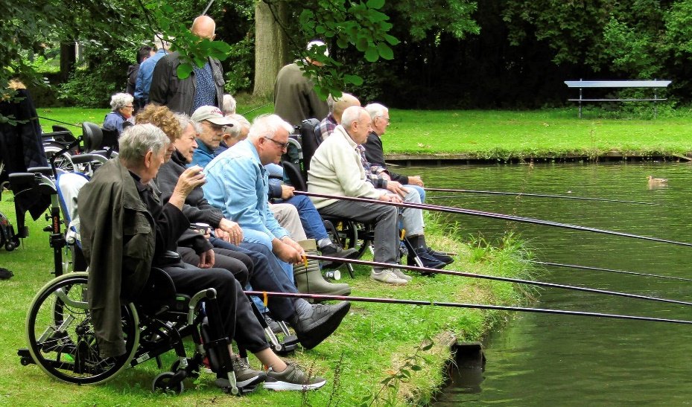

- Johnny Horton I’m a fishin’ man
- Stoney Edwards Fishin’ song
- Lucas Hoge Wishin’ I was fishin’
- Mabelle Seiger Stop Wishin’, Go Fishin'
- Almanac Singers Greenland fishing
- Buck Owens Fishin’ on the Mississippi
- Pickled Holler Fishing in te pond
- Ernie Ford Farther down the river
(where the fishin’s good)
- Ricky Skaggs Gulf of Maxico fishing boat blues
- Cisco Houston Talking fishing
- Okee Dokee Brothers Ice fishin’ shack
- Carl Perkins The Lord’s fishing hole
- Dick Nolan & Ray Payne Old fishin’ hole
- Smiley Burnette Old fishin’ pole (hengel)
- Lisa Lambert & Pine Ridge Boys Fishin’ blues
- Mike & Alice Seeger Fishing blues
- Joe Brown & the Black Mt Boys Fishing fever
- Don Rich (& the Buckaroos) Fishing reel
Reserve:
- Hank Locklin We’re gonna goin’ fishin
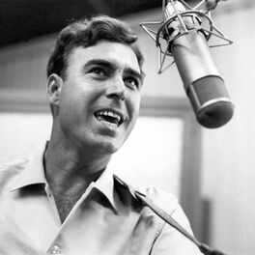

Johnny Horton

Greenland Fishing
Almanac Singers

'Twas in eighteen hundred and fifty-three
And of June the thirteenth day,
That our gallant ship her anchor weighed
And for Greenland bore away, brave boys,
And for greenland bore away.

The lookout in the crosstrees stood
With his spy glass in his hand;
"There's a whale, there's a whale, there's a whale fish!" he cried.
"And she blows at every span, brave boys,
She blows at every span!"

And the captain stood on the quarterdeck,
And a fine little man was he;
"Overhaul, overhaul! Let your davit tackles fall,
And launch your boats for sea, brave boys,
And launch your boats for sea!"

Now the boats were launched and the men aboard,
And the whale was in full view;
Resolved was each seaman bold
To steer where the whale fishes blew, brave boys,
To steer where the whale fishes blew!

We struck that whale and the line paid out,
But she gave a flourish with her tail;
And the boat capsized and four men were drowned,
And we never caught that whale, brave boys,
And we never caught that whale!

"To lose the whale," our captain cried,
"It grieves my heart full sore!
But, oh to lose four gallant men
It grieves me four times more, brave boys,
It grieves me four times more!"

Oh, Greenland is a dreadful place,
A land that's never green;
Where there's ice and snow, and the whale fishes blow
And the daylight's seldom ever seen, brave boys,
And the daylight's seldom ever seen.

Almanac Singers: Woody Guthrie, Lee Hayes, Pete Bowers, Millard Lampell, Pete Seeger
Maar Pete Bowers = Pete Seeger

Dinsdag 8 april, 22:00-23:00
Regio Noordkop Bluegrass
Hank Williams – 5
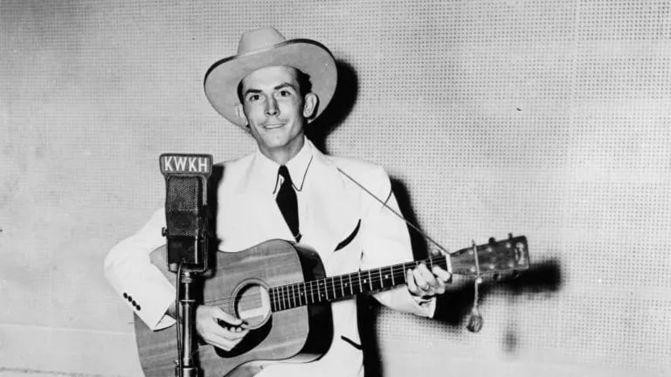

- Hank Williams The log train
- Rex & Noelene Franklin Mansion on the Hill
- Braxton Shooford A teardrop on a rose
- Northern lights We Live In Two Different Worlds
- Molly O'Day Singing Waterfall
- Hylo Brown Picture From Life's Other Side
- Seldom Scene & Tony Rice Alone and forsaken
- Statler Brothers Wedding bells
- Band Of Ruhks Lost Highway
- Ernie Thacker Six More Miles
- Peter Rowan I Can't Help It
- Becky Buller The Prodigal Son
- Emmylou Harris They' ll never take his love from me
- Don Reno Beyond The Sunset
- Caleb Klauder & Reeb Willms Thy burdens are greater than mine
- Dian James & the Greenbriar Boys
Tramp On The Street
- Russell Moore & IIIrd Tyme Out
You Win Again
- Jim & Jesse (I Heard That) Lonesome Whistle
Bonus:
- Hank Williams (I Heard That) Lonesome Whistle

De vorige week
Wilt u luisteren naar het programma van de vorige week?
Control+klik op onderstaande links

Zondag 30 maart, Waterland CB: Buzz Cason & singles 1975
https://hans.vdveen.org/muziek/W - WATERLAND CB/448W - Waterland CB - 2025-03-30 - Buzz Cason & singles 1975.mp3

Dinsdag 1 april, Country & Bluegrass NieUw
https://hans.vdveen.org/muziek/A - COUNTRY NU (pas verschenen)/448A - R-N C&BG Nieuw - 2025-04-01.mp3

Dinsdag 1 april, Noordkop Country: Wedding
https://hans.vdveen.org/muziek/B - NOORDKOP COUNTRY/448B - R-N Country - 2025-04-01 - The wedding.mp3

dinsdag 1 april, Noordkop Bluegrass: Bluegrass Nogwat (5)
https://hans.vdveen.org/muziek/C - NOORDKOP BLUEGRASS/448C - R-N Bluegrass - 2025-04-01 - Bluegrass Nogwat (5).mp3

