Saturdaymorning CB
Waterland CB


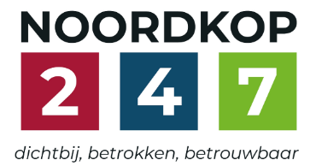
Noordkop Country & Bluegrass

Zaterdag 09:00-12:00: Saturday morning CB
www.Crossroadscountryradio.nl
luisteren kan alleen online via de website.
Herhaling: Donderdag 09:00-12:00
Zondag 19:00-20:00: Waterland CB
https://rtvpurmerend.nl
luisteren online kan via https://rtvpurmerend.nl/radio/live
Dinsdag 22:00-24:00: Noordkop CB
www.regionoordkop.nl
ether: 105.6 en 107.7 FM
luisteren online: www.noordkop247.nl/ live-radio/
Na de uitzending kan het programma worden beluisterd wanneer u maar wilt, via
http://hans.vdveen.org/muziek/
U vindt daar de uitzendingen van het laatste half jaar, waar u vrij uit kunt kiezen.
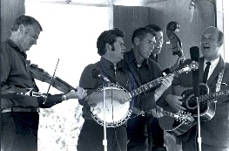

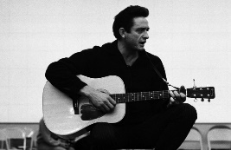
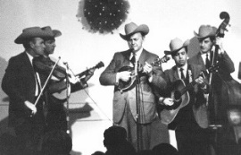
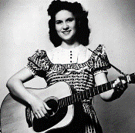
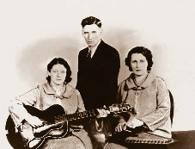
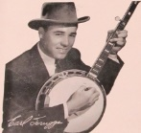
18, 19 & 21 juli 2026
Zondag 19:00-20:00 – Waterland Country & Bluegrass
Dinsdag 22:00-23:00 – Noordkop Country
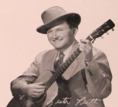
Dinsdag 23:00-24:00 – Noordkop Bluegrass
Zaterdag 09:00-12:00 – Crossroads Radio

samenstelling, montage & presentatie
Hans van der Veen

Wist u wat een knuppelpad is? Een paadje dat veenarbeiders zelf hebben aangelegd om van de winplaats naar de bewoonde wereld te komen, hoewel dat “bewoonde” ook niet veel voorstelde. Het is een van de wegen die in het eerste uur aan bod komen.
Daarna zijn het allemaal vervolgdelen, tot het laatste uur: klokken, met het wonderschone Clocks van Emmylou, waar het voor haar allemaal mee begon. Dus wens ik u weer veel luistergenot.

Zaterdag 18 juli
Herhaling: donderdag 23 juni
Bij CrossroadsCountryRadio.nl
Saturday morning CB uur 1
09:00-10:00: Country
The road
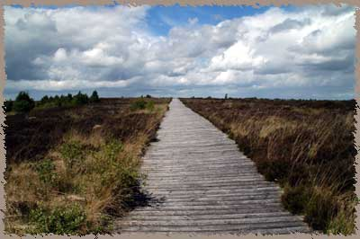
een old bog road (knuppelpad)

- Crystal Gayle River road
- Anita Ree (Austr) Endless road
- Paul Clayton Green rocky road
- The Corries (Schotl) Road to Dundee
- John Denver Take me homer, Country road
- Hilde Vos (Ned) The long road
- Carter Family It’s a long, long road to travel alone
- Johnny Horton The church by the side of the road
- Don Williams It ain’t worth the lonely road back
- Hank Snow Down the old road to home
- Hank Locklin The old bog road
- Buddy Thomson & Lynne Bennett (Austr)
Freedom of the Open Road
- Peter Coad & the Coad Sisters (Austr)
Wagon road
- Margaret Rackley (Austr) Bluebells on thje roadside
- Dry Branch Fire Squad Girl at the roadside tavern
- Slim Dusty (Austr) Gumtrees by the roadway
- Highwaymen Green green rocky road
- Jimmy Drifwood Jordan am a hard road to travel
- Stonewal Jackson Road to recovery
- Larry Cordle The house at the end of the road

Saturday morning CB uur 2
10:00-11:00: Country
De hits en hitjes van 1967
4. Hoogstens 6, 7, 8 en 9
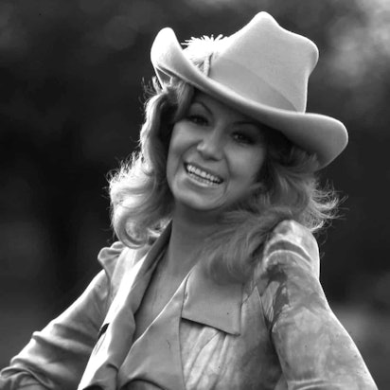
Dottie West

Hoogstens 6
- Webb Pierce Fool Fool Fool
- Ray Price I'm Still Not Over You
- George Hamilton IV Break My Mind
- Charley Pride I Know One
- Johnny Cash and June Carter Long-Legged Guitar Pickin' Man
Hoogstens 7
- Kenny Price Happy Tracks
- George Jones If My Heart Had Windows
- Loretta Lynn If You're Not Gone Too Long
- George Hamilton IV Urge for Going
- Roger Miller Walkin' in the Sunshine
Hoogstens 8
- Waylon Jennings The Chokin' Kind
- Charlie Walker Don't Squeeze My Sharmon
- Warner Mack Drifting Apart
- Don Gibson Funny, Familiar, Forgotten Feelings
- Dottie West Paper Mansions
Hoogstens 9
- Wynn Stewart 'Cause I Have You
- Claude Gray I Never Had the One I Wanted
- Charley Pride Just Between You and Me
- Ray Price Danny Boy
Een uitstapje
- Slim Whitman Londonderry air
Voorproef
- Robert Mitchum Little Old Wine Drinker Me

Saturday morning CB uur 3
11:00-12:00: Bluegrass
Bluegrass Brothers – 10
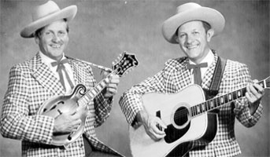
Lilly Brothers

- King Brothers Baby girl
- Wilson Brothers (Kentucky) Let me rest at the top of the mountain
- Wilson Brothers (Georgia) Train forty five
- Wilson Brothers (North Carolina) - Little white church
- Ben & Eric Marshall & The Marshall Brothers & Highroad
The farmer’s hand
- Bolt Brothers & Stacie Old broken tree
- Stockwell Brothers Silver and gold
- Hill’s Brothers Band White carp breakdown
- Hill Brothers & Willie Simons I’m glad I counted the cost
- Johnson Brothers A passing policeman
- Waller Brothers The old photograph
- Brewster Brothers (met Carl Story) - Rank stranger
- Dowdy Brothers Raining this morning
- Hobbs Brothers Turkey in the straw
- Lilly Brothers That star belongs to me
- Binkley Brothers & Dixie Clodhoppers
Little old log cabin in the lane
- Sons & Brothers I believe
- Cope Brothers Hills of Roane County
- Clendenen Brothers Dark hollow
- McReynolds brothers Shenandoah waltz
Bonus:
- McReynolds Brothers Memories and tears

Zondag 19 juli, 19:00-20:00
Bij RTV Purmerend
Waterland CB
Bruggen (6)

Brooklyn Bridge

- C Dolly Parton The bridge
- C Charley Pride I’m building bridges
- BG Ted Lundy Old swinging bridge
- BG Bill Duncan & the Harmony Mt Boys
The Old Swinging Bridge = andere
- C Barry & Lin Chandler (Austr)
The old iron bridge
- BG Osborne Brothers Walk Softly On The Bridges
- C Jack Scott Burning bridges
- C Bobbie Jean Barton You burned the bridge the bridges
- C Pickering Brothers The only bridge I never burned
- OT DeZurik Sisters My Honey Moon Bridge Broke Down
- BG Rock Hearts Unfinished bridges
- C Still on the Hill Lost bridge
- BG Ray Anderson Silver bridge disaster
- BG Ken Perlman Munlochy Bridge Strathspey
- C Burl Ives Brooklyn bridge
- BG New Grass Revival Rainbow Bridge
- C Mark Olsen Clifton bridge
- BG J.D. Jarvis Across the bridge
- C Merle Haggard Too many bridges to cross over
- BG Mark O’Connor Floating bridge of dreams

Dinsdag 21 juli, 22:00-23:00
Bij Noordkop 247
Noordkop Country
Songs written by
Johnny Russell
2
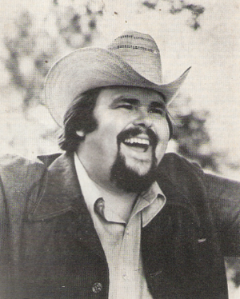

- Johnny Russell The baptism of Jesse Taylor
- George Hamilton IV I ain’t mad (I’m just leavin’)
- Wilburn Brothers Hurt her once more
- Greenhorns Zádnej vlak (I'm Leavin')
- Faron Young Some of these memories (hurt me
all of the time)
- Frankie McBride I'm Comin' Home Momma
- Ernest Tubb & Loretta Lynn Beautiful unhappy home
- Johnny Russell I’ll be gone before you even know I left
- Johnny Russell Do I even cross your mind
- Cal Smith The only thing I want
- Faron Young Alone with you *
- Carl Smith Mighty Day
- Robert Gordon (If I Had Yesterday) Over Again
- Dottie West It Sure Seemed Right
- Ronnie Milsap Remember to remind me (I’m leaving)
- Leon Everette This man and woman thing
- Bill Anderson & Mary Lou Turner Just enough to make me want it
- Johnny Russell He’s got you right where I want you
- Johnny Russell Your fool
- Dolly Parton Do I ever cross your mind
- Johnny Russell Do I even cross your mind

* niet van Russell.....

Dinsdag 21 juli, 23:00-24:00
Bij Noordkop 247
Noordkop Bluegrass
Klokken
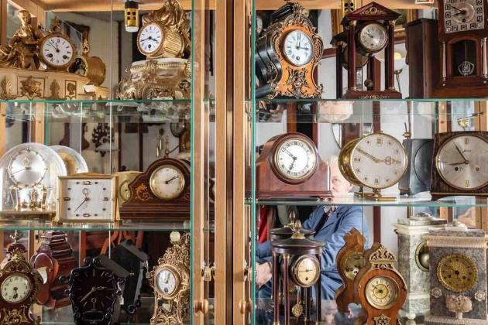

- Emmylou Harris Clocks (alt. version)
- Arizona Smoke Revue Grandfather’s clock
- Slavek Hanzlik My grandmother’s clock
- Vodopad Wilson clock
- Theo Larence Kitty cat clock
- Jimmy Gaudreau Joe’s old clock
- Johnnie & Jack Mister clock
- Peter Rowan Mr. Time Clock
- Bluegrass Meditations Time clock of life
- Country Bandits Two o’clock
- Carl Butler & Webster Brothers Watching the clock
- Southern Express BG Band Ten o’clock train
- Red Dog Ash Clock on the wall
- Backline Ticking of the clock
- Summervilla When the clock stops ticking
- Darin & Brooke Aldridge Trying to make clocks slow down
- Mail Pouch Express Clocks and spoons
- Morning Bugle Band Clock work
- Allen's Mill Band Let's Turn Back The Clock
- Rock Hearts Town hall clock
- Ray Mayo Who winds your clock
- Alison Brown Wind the clock

De vorige week
Wilt u luisteren naar het programma van de vorige week?
Control+klik op onderstaande links

Zaterdag 11 juli
Saturdaymorning Country: Bobby Bare (2)
https://hans.vdveen.org/muziek/XYZ - CROSSROADS COUNTRY RADIO - Country/515x - Saturday morning Country - 2026-07-11 - Bobby Bare (2).mp3

Saturdaymorning Bluegrass: Bruggen (5_
https://hans.vdveen.org/muziek/XYZ - CROSSROADS COUNTRY RADIO - Bluegrass/515y - Saturday morning Bluegrass - 2026-07-11 - Bruggen (5).mp3

Saturdaymorning Bluegrass: Bluegrass Brothers (9)
https://hans.vdveen.org/muziek/XYZ - CROSSROADS COUNTRY RADIO - Bluegrass/515z - Saturday morning Bluegrass - 2026-07-11 - Bluegrass Brothers (9).mp3

Zondag 12 juli
Waterland CB: Gardens
https://hans.vdveen.org/muziek/W - WATERLAND CB/515w - Waterland CB - 2026-07-12 - Tuinen.mp3

Dinsdag 14 juli
Noordkop Country: 1940 en 1970 (19)
https://hans.vdveen.org/muziek/B - NOORDKOP COUNTRY/515b - Noordkop Country - 2026-07-14 - 1940 en 1970 (19).mp3

Noordkop Bluegrass: Albums waar ook Angel Band op staat
https://hans.vdveen.org/muziek/C - NOORDKOP BLUEGRASS/515c - Noordkop Bluegrass - 2026-07-14 - Songs van albums waar Angel Band op staat.mp3

