Saturdaymorning CB
Waterland CB


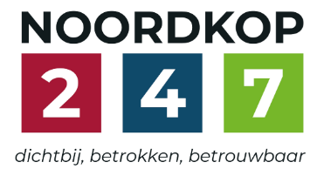
Noordkop Country & Bluegrass

Zaterdag 09:00-12:00: Saturday morning CB
www.Crossroadscountryradio.nl
luisteren kan alleen online via de website.
Herhaling: Donderdag 09:00-12:00
Zondag 19:00-20:00: Waterland CB
https://rtvpurmerend.nl
luisteren online kan via https://rtvpurmerend.nl/radio/live
Dinsdag 22:00-24:00: Noordkop CB
www.regionoordkop.nl
ether: 105.6 en 107.7 FM
luisteren online: www.noordkop247.nl/ live-radio/
Na de uitzending kan het programma worden beluisterd wanneer u maar wilt, via
http://hans.vdveen.org/muziek/
U vindt daar de uitzendingen van het laatste half jaar, waar u vrij uit kunt kiezen.
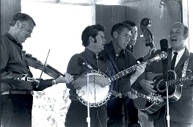

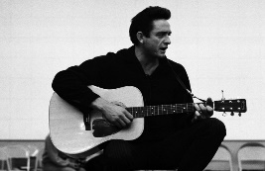
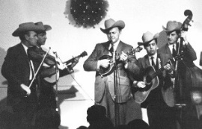
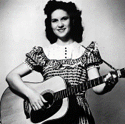
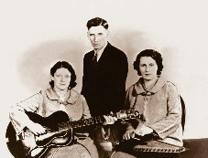
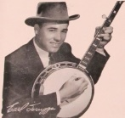
11, 12 & 14 juli 2026
Zondag 19:00-20:00 – Waterland Country & Bluegrass
Dinsdag 22:00-23:00 – Noordkop Country
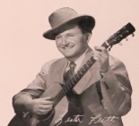
Dinsdag 23:00-24:00 – Noordkop Bluegrass
Zaterdag 09:00-12:00 – Crossroads Radio

samenstelling, montage & presentatie
Hans van der Veen

Deze week zijn ze ook weer mooi. Zaterdag allemaal B’s, puur toeval. Can de bruggen komt er nog één, maar de broers zijn voor het laatst. Zondag is het open-tuinen-dag. Wat u op de foto ziet is niet de onze, die is mooier. Er zitten een paar artiesten bij die u wellicht nog niet kende.
Dinsdag het laatste uur van de week begint met dat prachtige Angel Band van de Bill Clifton Family mooi. Ik heb hem deze week zeker tien keer afgedraaid.
Door dat stomme voetbal was ik deze week een paar keer vergeten te luisteren, maar gelukkig hebben we hans.vdveen.org nog. Ik ben toch wel blij met dat ding.
Ik wens u weer veel luisterplezier.

Zaterdag 11 juli
Herhaling: donderdag 16 juli
Bij CrossroadsCountryRadio.nl
Saturday morning CB uur 1
09:00-10:00: Country
Songs written by
Bobby Bare – 2
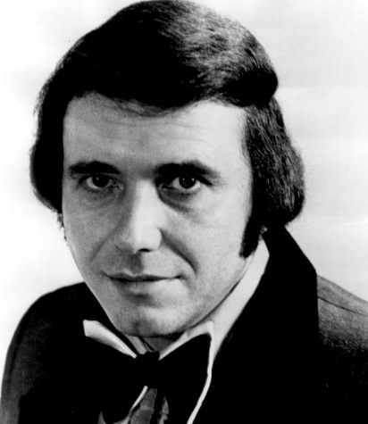

- The Angels Dear Waste Basket
- Jim Reeves Teardrops on the rocks
- Bob Luman I’m gonna write a song about you
- Bobby Bare Lonely town
- Leroy van Dyke Happy to Be Unhappy
- Lefty Frizzell Through the eyes of a fool
- Johnny Burnette It al depends on Linda
- Willie Nelson Let’s pretend we’re strangers
- Ruud Hermans Jeannie's Last Kiss
- Wanda Jackson Leave My Baby Alone
- Petula Clark He was a friend of mine
- Bobby Bare When I’m gone
- Glen Campbell Heartaches Can Be Fun
- BB & Skeeter Davis I love you
- Connie Smith House divided
- Dave Dudley Passin' Through
- Charley Crockett Motel Time Again
- Waylon Jennings Woman, don’t you ever laugh at me
- Flatt & Scruggs Shut your face, I’m talking to your head
- Billy Joe Shaver & John Anderson
Jesus is the Only One Who Loves Us
- Bob Dylan & the Band All American boy
Bonus
- Bobby Bare Streets of Baltimore
- Bobby Bare Come, kiss me love

Saturday morning CB uur 2
10:00-11:00: Bluegrass
Bruggen (5)
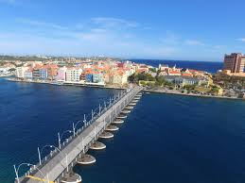
De brug in Willemstad, Curaçao
Intro
- James King Old swinging bridge
Bruggen in brand
- Tina Adair Bridge you’re gonna burn
- Limited Edition Burning the bridge
- Josh Williams We’ll burn that bridge
- Marvin Howell & Franklin County Boys
Another bridge to burn
- Patty Loveless You burned the bridge
- Bobby Osborne The last bridge you’ll burn
- Sullivan Family Every bridge is burned behind me
- Darrel Adkins Standing on a bridge (I thought I'd burned)
- Ragged Union Bridge on fire
Restanten
- Arthur Smith I stood on the bridge at midnight
- Toe River Valley Boys Natural bridge blues
- Nelson Young Burning bridges
- Wilburn Brothers Burning bridges
- Lewis Family He built a bridge
- Big Spike Bridge to Gloryland
- Rhonda Vincent Jesus built a bridge to heaven
- Glen Neaves Old swinging bridge
- Earl Scruggs Bridge over troubled water


De nieuwe brug bij Willemstad, Curaçao

Saturday morning CB uur 3
11:00-12:00: Bluegrass
Bluegrass Brothers – 9
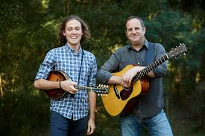
Colvin Brothers

- Fox Brothers You Can't Take It With You Go
- Richard Green & the Brothers Barton
Yearlings in the canebreak
- Louvat Brothers (Belg) Hopes and dreams
- Burke Brothers At last my dreams have come true
- Seven Rowe Brothers Polk County Two Step
- Rouse Brothers Orange blossom special
- Roe Brothers The ship that never returned
- Atkins Brothers Memories of J.F. Kennedy
- Shaw Brothers Somewhere between
- Doggone Brothers (Can) Cannonball blues
- Good Brothers (Canada) Banjo boy
- Lubben Brothers Big rock candy mountain
- Canote Brothers Won’t you come on and see me sometime
- Mosley Brothers Who showed who
- Currence Brothers I can almost see Houston from here
- Libbea Brothers (Truckee) Fair weather
- Simpkins brothers Golden Slippers
- Colvin Brothers (Austr) Colleen Malone
- Crutchers Brothers Wednesday night waltz
Bonus:
- Stanley Brothers Meet me tonight

Zondag 12 juli, 19:00-20:00
Bij RTV Purmerend
Waterland CB
Gardens


- BG Greg Blake & Hometown Gardens & Memories
- C Everly Brothers Down in the willow garden
- BG Jim & Jesse My Garden of Love
- BG Irene Kelley Garden of dreams
- C John Blek (Ierl) Lily in the garden
- BG Fiddlin Red Simpson & the Old Scratch String Band (Ierl)
Sally int he garden
- BG New Grown-Ups Saftah’s Garden
- C Lynn Anderson Rose garden
- BG Jim Eanes Rose Garden Waltz
- C Jimmie Rodgers English Country garden
- C Laura Boosinger Pretty Little Miss Out in the Garden
- C Jacqui & Bridie (Eng) Adam in the garden
- C Kris Delmhorst Ghosts in the Garden
- BG Wayne Raney The garden where mother prayed
- C Debra Cowan, Acie Gargill & Susan Brown
Keep Your Garden Clean
- BG Lowell Varney & Jim Horn - I'd Like To Walk In The Garden
- C Dubliners (Ierl0 Zoological Gardens
- BG Laurie Lewis Garden grow
- BG Maygen & the Birdwatcher - Take It To The Garden
- C Michael Johnathon Garden song
- BG Tylers His Healing Garden
- BG Wolfe Brothers Master’s Garden
- BG Grace Griiffith Garden Of Mysteries

Dinsdag 14 juli, 22:00-23:00
Bij Noordkop 247
Noordkop Country
De singles van 1940 en 1970 – 19

Bonnie Blue Eyes

1940
- Bonnie Blue Eyes Seven beers with the wrong man
- Carlisle Brothers Going Down The Valley One By One
- Fred Kirby Life's Railway To Heaven
- Bill Carlisle Beneath The Old Pine Tree
`1970
- Roy Acuff Each Season Changes You
- Burl Ives One more time, Billy Brown
- Hank Snow Francesca
- Pete Seeger America the beautiful
- Philomena Begley Here Today Gone Tomorrow
- Jimmy Martin Singing all day and dinner on the ground
- Gloria Belle Traveling the hi-way home
- Osborne Brothers Midnight angel
- Mac Wiseman Ring of fire
- Doc & Merle Watson Brown's ferry blues
- Orval Prophet Mile After Mile
- Bobby Bond Looking For My Tracks
- Carmol Taylor Someday I'll Leave You
- Howard Vokes It takes six men
- Tennessee Ernie Ford Let The Lovelight In Your Eyes Lead Me On
- Billy Joe Shaver Chicken On The Ground
- Carl Story A picture from life’s other side

Dinsdag 14 juli, 23:00-24:00
Bij Noordkop 247
Noordkop Bluegrass
Songs van albums waar ook
Angel Band op staat
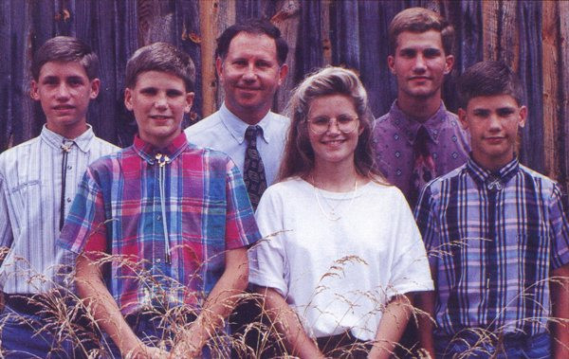
Cockman Family

- Bill Clifton Family & Hedy West – Angel Band
- Carl Story The tramp on the street
- Stanley Brother Could you love me one more time
- Ball Sisters Band Lorena
- Shady Grove String Band Another road
- Carl Butler & the Webster Brothers
Could you love me one more time
- Bradley Walker (Ft. Vince Gill & Sonya Isaacs Yeary)
Drifting Too Far From The Shore
- Old & In The Way Catfish John
- Hickory Hill Old man at the mill
- Emmylou Harris When they ring those golden bells
- Cockman Family It was all about love
- House Brothers & Canaan Valley Boys
I’m using my bible for a roadmap
- Charles River Valley Boys Victim of the tomb
- West Virginia BG Boys Faded Love
- Ralph Stanley & Iris Dement Ridin’ that midnight train
- Flatt & Scruggs When the angels carry me home
- Arvil Gearhart & the Southern Gospel Band
Uncloudy day
- Hamilton County BG Band Springtime In Dear Old Dixie

De vorige week
Wilt u luisteren naar het programma van de vorige week?
Control+klik op onderstaande links

Zaterdag 4 juli
Saturdaymorning Country: Truck(driver)s (8)
https://hans.vdveen.org/muziek/XYZ - CROSSROADS COUNTRY RADIO - Country/514x - Saturday morning Country - 2026-07-04 - Truck(driver)s (8).mp3

Saturdaymorning Country: 1967 (3)
https://hans.vdveen.org/muziek/XYZ - CROSSROADS COUNTRY RADIO - Country/514y - Saturday morning Country - 2026-07-04 - de hits en hitjes van 1967 (3).mp3

Saturdaymorning Bluegrass: Bluegras Brothers (8)
https://hans.vdveen.org/muziek/XYZ - CROSSROADS COUNTRY RADIO - Bluegrass/514z - Saturday morning Bluegrass - 2026-07-04 - Bluegrass Brothers (8).mp3

Zondag 5 juli
Waterland CB: Zoek het codewoord
https://hans.vdveen.org/muziek/W - WATERLAND CB/514w - Waterland CB - 2026-07-05 - zoek het codewoord.mp3

Dinsdag 7 juli
Noordkop Country: Jim Reeves (4)
https://hans.vdveen.org/muziek/B - NOORDKOP COUNTRY/514b - Noordkop Country - 2026-07-07 - Jim Reeves (4).mp3

Noordkop Bluegrass: IBMA awards 2001
https://hans.vdveen.org/muziek/C - NOORDKOP BLUEGRASS/514c - Noordkop Bluegrass - 2026-07-07 - IBMA awards 2001.mp3

