Saturdaymorning CB
Waterland CB


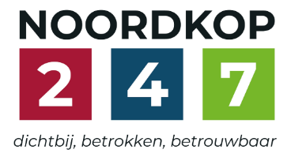
Noordkop Country & Bluegrass

Zaterdag 09:00-12:00: Saturday morning CB
www.Crossroadscountryradio.nl
luisteren kan alleen online via de website.
Herhaling: Donderdag 09:00-12:00
Zondag 19:00-20:00: Waterland CB
https://rtvpurmerend.nl
luisteren online kan via https://rtvpurmerend.nl/radio/live
Dinsdag 22:00-24:00: Noordkop CB
www.regionoordkop.nl
ether: 105.6 en 107.7 FM
luisteren online: www.noordkop247.nl/ live-radio/
Na de uitzending kan het programma worden beluisterd wanneer u maar wilt, via
http://hans.vdveen.org/muziek/
U vindt daar de uitzendingen van het laatste half jaar, waar u vrij uit kunt kiezen.
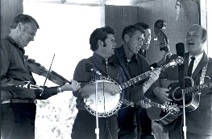

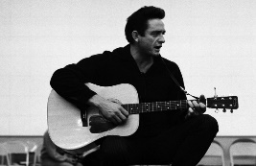
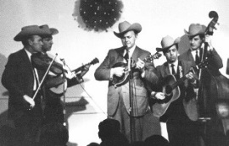
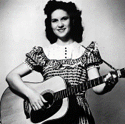
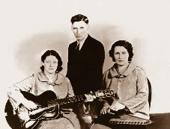
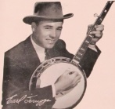
20, 21 & 23 juni 2026
Zondag 19:00-20:00 – Waterland Country & Bluegrass
Dinsdag 22:00-23:00 – Noordkop Country
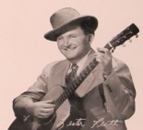
Dinsdag 23:00-24:00 – Noordkop Bluegrass
Zaterdag 09:00-12:00 – Crossroads Radio

samenstelling, montage & presentatie
Hans van der Veen

Door dat verdraaide voetbal zou je toch bijna vergeten om naar je eigen progamma te luisteren. Wat dat betreft is de zaterdagmorgen gemakkelijk. Maar gelukkig hebben we hans.vdveen.org nog, een uitvinding.
Deze week zijn het weer vier vervolgen op reeds begonnen series. Die over de Bluegrass Brothers bevalt me zelf wel erg goed. Dinsdag begint er een nieuwe, maar wie is nu Shelagh McDonald? Een Schotse Folk-zangeres, geboren in 1948. Ze maakte twee albums, maar toen ze 23 was, verdween ze plotseling van de aardbodem. Pas in 2005 maakte ze zelf contact met de Daily Mail om haar verhaal te vertellen. Het is te vinden op de website van The Guardian
Ik wens u weer veel luistergenoegen!

Zaterdag 20 juni
Herhaling: donderdag 25 juni
Bij CrossroadsCountryRadio.nl
Saturday morning CB uur 1
09:00-10:00: Country
Barbara (4)
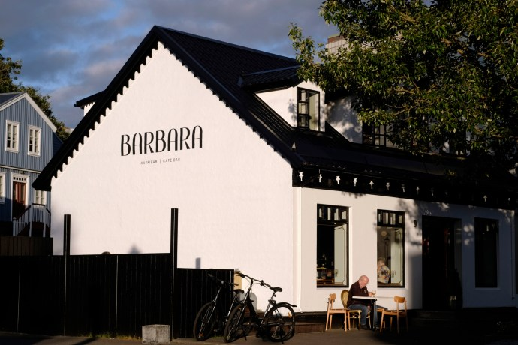
Koffietent in Hafnarfjörd, IJsland

- Barbara Clarkson Woman of love
- Barbara Dane Deportee
- Brenda of Barbara Joice There they go
- Fuzzy Mountain String Band Barbara’s fancy
- Sissy Spacek (& Barbara Bennett) - Old home town
- Wayne Albright (& Barbara Ruberton)
Somewhere between separate and single
- Kelly Clarkson Aunt Barbara throws you a birthday party
- Joe Melson Barbara
- Neil Sedaka My best friend Barbara
- Andy Statman For Barbara
- Ian Noe Barbara’s song
- Dave Dudley I was Country before
I met Barbara Mandrell
- Eddie Noack Barbara joy
- John Mc Euen & Jimmy Ibbotson (& Barbara Henry)
Blue Ridge cabin home
- Pine Box Boys No room for Barbara
- Kevin, J.B. & Barbara Spencer The Lord invited me to go
- Down Hill Strugglers Fate of Santa Barbara
- Andy Statman Barbara in the morning
- Ronnie Milsap Santa Barbara
- Bobby Vee Please don’t ask about Barbara
- Margot Eskens Bye bye Barbara

Saturday morning CB uur 2
10:00-11:00: Country
De hits en hitjes van 1967
(2) Nummer 1 hits in Canada

Eerst een restantje van de USA
- Bill Anderson & Jan Howard For loving you
Nummers 1 in Canada
- Mercey brothers Whistling on the river
- Gary Buck The weatherman
- Odie Workman Take this heart of mine
- Bambi Lynn Whirlpool
- Johnny Ellis Ten foot pole
- Jimmy Arthur Ordge Irena Cheyenne
- Mercey brothers Uncle Tom
- Johnny Burke I can’t even do wrong right
- Johnny Clark It’s just about over
- Bud Roberts The alcan run
- The Rainvilles I got what I wanted
- Lynn Jones Take the bad with the good
- Dian(n)e Leigh The sound that makes me blue
- Orval Prophet Human nature
- Lucille Starr Too far gone
- David Houston You mean the world to me
- Marty Robbins The girl with gardenias in her hair
- Carl Smith Deep water
- Tommy Hunter Mary in the morning
- Buck Owens It takes people like you
Toegift, ook uit ‘67
- Hank Locklin Country hall of fame

Saturday morning CB uur 3
11:00-12:00: Bluegrass
Bluegrass Brothers – 6
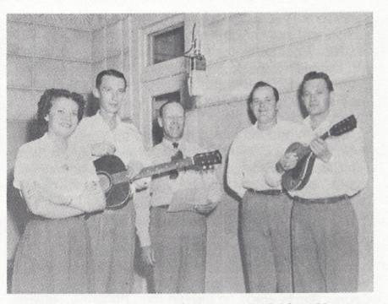
Eubanks Brothers

- Davidson brothers Don’t give your heart to a rambler
- Callaghan Brothers Somebody’s been using that thing
- Blankenship Brothers Tears I cried for you
- Mighton Brothers (Can) Walkin’, walkin’
- Brammer Tell me truly little darling
- Bobby Atkins & the True Brothers - Ring of fire
- Jones Brothers & Log Cabin Boys - My little girl in Tennessee
- Carl Story & Jones Brothers No stranger there
- Grant Brothers Tell to me
- Eubanks Brothers Message for pie
- Feinberg Brothers Your saddle is empty, old pal
- Goodwin Brothers Down to the mill
- Morris Brothers One little word
- Keen Mountain Brothers Angel band
- Sykes Brothers Twisting the strings
- Bing Brothers Band & Jake Krack - Kitchen girl
- Carter Brothers Take a whiff on me
- Walter Jacobs & Carter Brothers - Shieks special
- House Brothers I need the prayer of those I love
- Crook Brothers String Band My Wife Died Friday Night

Zondag 21 juni, 19:00-20:00
Bij RTV Purmerend
Waterland CB

Boeken – 1

Shelagh McDonald

- C George Strait The book
- BG Billy Renee Book of life
- C Doc & Chickie Williams Look In The Book
- BG Dick Unteed Book of etiquette
- C Shelagh McDonald Book of Rhyme (Demo)
- BG Wayne Raney The Book of Revelations
- C Waltons Book Of Golden Stories
- BG King James Boys The Best Selling Book of All Time
- C Dick Nolan The Liquor Book
- BG Bobby Atkins & the Countrymen
Book Of Memories
- BG Doug Dillard God's Record Book Of Life
- C Dolly Partin God's Coloring Book
- C Kitty Kallen My Coloring Book
- BG Mac Wiseman You Can't Judge A Book By Its Cover
- C Stuart Hamblen This Book
- BG Rhonda Vincent There's A Record Book
- C Mark Olson My One Book Philosophy
- C Hank Locklin Good book song
- BG Sharon Graeff & Lost Highway
Mom's Old Picture Book
Bonus
- C Eleanot Shenley Bell Book And Candle

Dinsdag 23 juni, 22:00-23:00
Bij Noordkop 247
Noordkop Country
Songs written by
Johnny Russell - 1
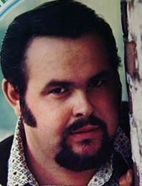

- Johnny Russell Catfish John
- Eddie Cochran Sweetie Pie
- Billy Crash Craddock Sweetie Pie
- Eddie Cochran Completely sweet
- Billy Fury One Kiss
- Jim Reeve In a Mansion Stands My Love
- Buck Owens Act Naturally
- Dolly-Linda-Emmylou Making Plans
- Johnny Russell The world’s meanest man
- Johnny Russell Mr. Fiddle man
- Wilburn Brothers My day won’t be complete
- Jean Shepard Too broke to break
- Charlie Walker I’d rather switch than fight
- Connie Smith Everybody’s gotta be somewhere
- Jean Shepard Day to day (tear to tear)
- Eddie Bond Someday I’ll sober up
- Loretta Lynn Two mules pull this wagon
- Burl Ives Mean, mean man
- Johnny Russell Our marriage was a failure
- Johnny Russell The new wore off
Bonus
- Jim Reeves He’ll have to go
- Buck Owens Over and Over again
- Voni Morrison Too broke to break
- Osborne Brothers Making plans

Dinsdag 23 juni, 23:00-24:00
Bij Noordkop 247
Noordkop Bluegrass
Wives (2)
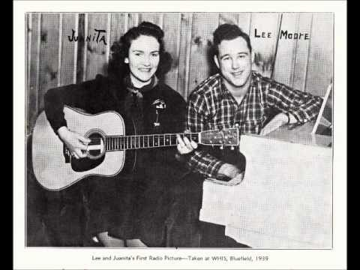

- Flatt & Scruggs I’ll be no man’s wife
- Lee Moore & Juanita My own sweet darling wife
- Estil C. Ball The farmer’s curst wife
- Randall Hylton The Mayor's Wife And Deputy Joe
- Feinberg Brothers The angry wife
- Paul Clayton Dirty wife
- Turning Ground Loving wife
- New Lost City Ramblers My wife died on Saturday night
- Hedy West The wife of usher’s well
- The Clydes Prisoner’s wife
- Wilma Lee & Stoney Cooper Big John’s wife
- Kim & Jim Lansford The house carpenter’s wife
- Grandpa Jones My little nagging wife
- McLain Family Married me a wife
- David Naiditch Shepherd's wife waltz
- Split Lip Rayfield Used to know your wife
- Gail Heil (& Bob Bovee The cowboy’s wife
- Rafe Stefanini The scolding wife

De vorige week
Wilt u luisteren naar het programma van de vorige week?
Control+klik op onderstaande links

Zaterdag 13 juni, Saturdaymorning Country: Barbara (3)
https://hans.vdveen.org/muziek/XYZ - CROSSROADS COUNTRY RADIO - Country/511x - Saturday morning Country - 2026-06-13 - Barbara (3).mp3

Zaterdag 13 juni, Saturdaymorning Bluegrass: Bruggen (3)
https://hans.vdveen.org/muziek/XYZ - CROSSROADS COUNTRY RADIO - Bluegrass/511y - Saturday morning Bluegrass - 2026-06-13 - Bruggen (3).mp3

Zaterdag 13 juni, Saturdaymorning Bluegrass: Bluegrass Brothers (5)
https://hans.vdveen.org/muziek/XYZ - CROSSROADS COUNTRY RADIO - Bluegrass/511z - Saturday morning Bluegrass - 2026-06-13 - Bluegrass Brothers (5).mp3

Zondag 14 juni, Waterland CB: Kate
https://hans.vdveen.org/muziek/W - WATERLAND CB/511w - Waterland CB - 2026-06-14 - Kate.mp3

Dinsdag 16 juni, Noordkop Country: Jim Reeves (3)
https://hans.vdveen.org/muziek/B - NOORDKOP COUNTRY/511b - Noordkop Country - 2026-06-16 - Jim Reeves (3).mp3

dinsdag 16 juni, Noordkop Bluegrass: Wives (1)
https://hans.vdveen.org/muziek/C - NOORDKOP BLUEGRASS/511c - Noordkop Bluegrass - 2026-06-16 - Wives (1).mp3

