Saturdaymorning CB
Waterland CB


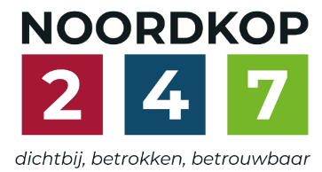
Noordkop Country & Bluegrass

Zaterdag 09:00-12:00: Saturday morning CB
www.Crossroadscountryradio.nl
luisteren kan alleen online via de website.
Herhaling: Donderdag 09:00-12:00
Zondag 19:00-20:00: Waterland CB
https://rtvpurmerend.nl
luisteren online kan via https://rtvpurmerend.nl/radio/live
Dinsdag 22:00-24:00: Noordkop CB
www.regionoordkop.nl
ether: 105.6 en 107.7 FM
luisteren online: www.noordkop247.nl/ live-radio/
Na de uitzending kan het programma worden beluisterd wanneer u maar wilt, via
http://hans.vdveen.org/muziek/
U vindt daar de uitzendingen van het laatste half jaar, waar u vrij uit kunt kiezen.
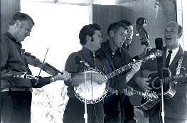

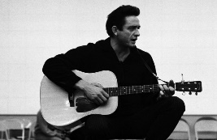
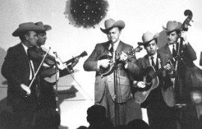
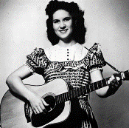
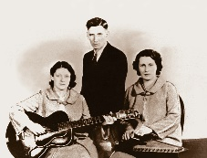
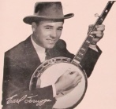
4, 5 & 7 april 2026
Zondag 19:00-20:00 – Waterland Country & Bluegrass
Dinsdag 22:00-23:00 – Noordkop Country
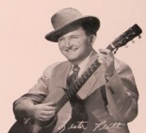
Dinsdag 23:00-24:00 – Noordkop Bluegrass
Zat
erdag 09:00-12:00 – Crossroads Radio

samenstelling, montage & presentatie
Hans van der Veen

Tot mijn verrassing kreeg ik de vorige week nog aardig wat felicitaties voor mijn 500ste radio-week. Hartelijk dank daarvoor!!
Week 501 begint met (Goede Vrijdag) en Pasen, met als hoogtepunt Dolly (zaterdag é zondag). Ik zal zondag niet kunnen luisteren, want we zitten in Noordpolderzijl…..
Aan Paasvakantie doen we niet meer, dus dinsdag is alles weer gewoon, maar wat staan er mooie plaatjes boven de dinsdaglijsten!
De muziek is weer net zo mooi, dus veel luisterplezier!

Zaterdag 4 april
Herhaling: donderdag 9 april
Bij CrossroadsCountryRadio.nl
Saturday morning CB
09:00-10:00: Country & Bluegrass
Goede Vrijdag
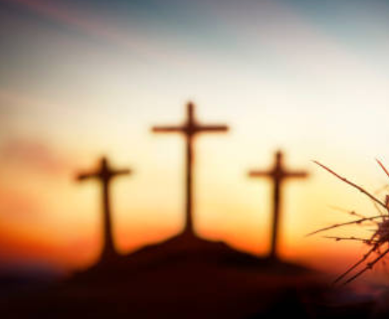

- Peasal Sisters & Emmylou Sea of Galilee
- Johnny Cash & Statler Brothers - The last supper
- Country Ham In The Garden
- Wilma Lee & Stoney Cooper I’m walking my Lord up Calvary hill
- Joyce Greene & Family Six hours on the cross
- Mountain Ramblers Calvary
- Slim Dusty (Austr) Calvary Hill
- Tennessee Ernie Ford Must Jesus Bear The Cross Alone
- Bob & Evelyne Beers The wandering Jew
- Jimmy Williams & Red Ellis Three crosses
- Bill Anderson & Jan Howard The Old Rugged Cross
- Janet McGary At the foot of the cross
- Roy Rogers & Dale Evans Near the cross
- Ernest Stoneman He was nailed to the cross for me
- Stonewall Jackson Kneel At The Cross
- Wabash Valley Boys After Calvary
- Slim Whitman He Bought My Soul At Calvary
- Hank Williams Jesus died for me
- Blue Sky Boys The blood of Jesus
- Doyle Lawson I live for him cause he died for me
- Easter Brothers The darkest hour

10:00-11:00: Country & Bluegrass
Pasen - 1
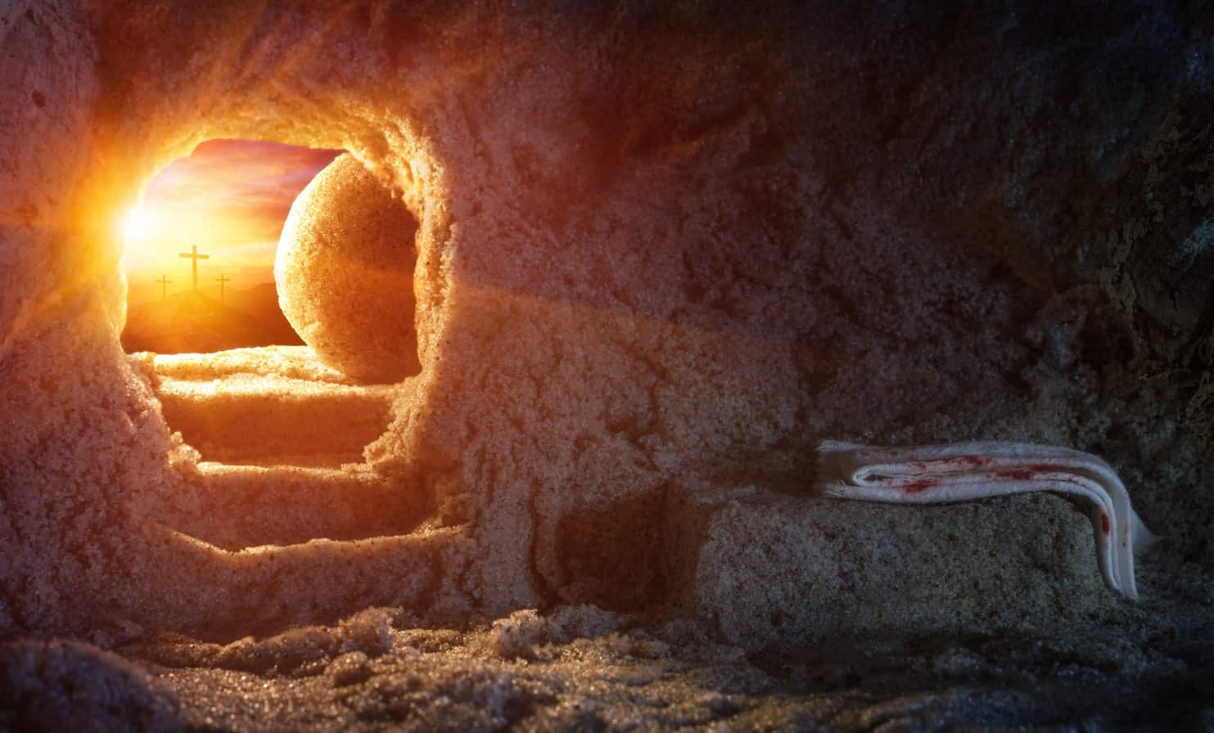

- Easter Brothers The darkest hour
- Chickie Williams Beyond the sunset
- Perry Duet Beyond the sunset
- Knight Family Beyond the sunset
- Ede Staal Het het nog nooit zo donker west
- Lewis Family The man of Galilee
- Stonemans A light lit up in Galilee
- Dolly Parton He’s Alive
- Yvonne Devaney Mary Magdalena
- Johnny Cash Mary Magdalena returns to Galilee
- Phil Wickham Christ is risen
- Wanda Jackson Because He Lives
- Elly & Rikkert Hij leeft
- Alan Jackson He Lives
- Cristy Lane I Know My Redeemer Lives
- Zoe & Cloyd Resurrection Day
- Early Grass Revival Resurrection morning
- Tom Russell Resurrection mountain
- Claire Lynch Who but man
- Carl Story Amazing grace
Bonus:
- Petersens Amazing Grace

11:00-12:00: Country & Bluegrass
Pasen - 2


- Carol Elizabeth Jones & Laurel Bliss Resurrection day
- Ray Wylie Hubbard Resurrection
- Rusty Draper Easter morning
- Dixon Brothers Easter day
- Corner House Easter Sunday
- June Tabor The Easter tree
- Jerry Earl & Robert van Eamon Easter snow
- Stroatklinkers Noordpolderziel
- Tom T Hall Easter is
- Ralph McTell Easter lillies
Jarigen
- Emmylou Harris (2/4) Who will sing for me
- Cliff Waldron (4/4) Brand new wagon
- Jr. Williams (4/4) Sled’ ridin’
- Daniel Grindstaff (4/4) Jesse James
- Bill Clifton (5/4) Old cottage home
- Mike Burns (5/4) Are you ready
- Charlie Collins (5/4) I've Been On The Road Too Much
- Merle Haggard (6/4) Mama tried
- Missy Raines (6/4) Cold wind
- April Verch (7/4) Light in the window

Zondag 5 april, 19:00-20:00
Bij RTV Purmerend
Waterland CB
Pasen

- Elly & Rikkert & kinderkoor Pasen, pasen
- Carl Story Near the cross
- Rhonda Vincent Walking my Lord up Calvary Hill
- Sullivan Family Lonely Lonely Road To Calvary
- Lewis Family Calvary
- Suzanne Prentice The old rugged cross
- Roy Acuff Jesus died for me
- Elly & Rikkert Alles wordt donker
- John Fahey Jesus Christ Is Risen Today
- Paul Williams Jesus had rose from the dead
- Dolly Parton He’s Alive
- Johnny Cash Mary Magdalena returns to Galilee
- Matt Maher Because he lives
- Don Reno & Bill Harrell My redeemer lives
- Cristy Lane I know that my redeemer lives
- Early Grass Revival The resurrection morning
- Matraca Berg The resurrection
- Jiri Pavlica & Hradistan (Tsj) Velikonochi cas
- Tom T Hall Easter is
- John Hartford Springtime all over again
Bonus:
- Johnny Horton When it’s springtime in Alaska

Dinsdag 7 april, 22:00-23:00
Bij Noordkop 247
Noordkop Country
Canadian Country Music Hall of Fame Inductees
1: 1984-1993
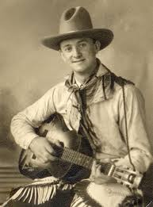
Wilf Carter

- Wilf Carter It makes no difference now (1938)
- Tommy Hunter Mary in the morning
- Orval Prophet The traveling kind
- Don Messer On the road to Boston
- Hank Snow My memories of you
- “Papa” Joe Brown (& the Hillbilly Jewels) - You’re a little doll
- Lucille Starr Back to you
- Charlie Chamberlain (Messer's "Singing Lumberjack)
Yesterday’s roses
- Al Chern(e)y Bonnie Bell Schottische
- King Ganam May you never see sunshine
- Dallas Harms Too good to stop now
- Earl Heywood The Donnelly Circle
- Marg Osburne Sweet Betsy from Pike
- Ian Tyson Navajo rug
- Mercey Brothers The ordinary peeping tom
- Maurice Bolyer Hey Mr. Banjo
- Gordie Tapp If you have the time
- Rhythm Pals Gentle on my mind
- Carroll Baker This is it
- Ward Allen Mountain girl
Bonus:
- Hank Snow The Girl Who Loved The Man Man Who
Robbed the Bank at Santa Fe
- Hank Snow Jamaica Farewell (instr)

Dinsdag 7 april, 23:00-24:00
Bij Noordkop 247
Noordkop Bluegrass
De zee – 1


- Flatt & Scruggs Going across the sea
- Woodlanders Sea song
- John Lilly & Ralph Blizard In the dear old sunny south by the sea
- Ed Helton Singers A Storm on the Sea
- Bill Clifton Sailor on the deep blue sea
- Blue Sky Boys What does the deep sea say
- Carl Story Beyond the dark sea
- Kingston Trio Sea fever
- Verne Koenig On The Sea Of Galilee
- Wade Mainer’s Mountaineers Bring me a leaf from the sea
- Tim & Mollie O'Brien Home by the Sea
- The Carter Family Little Log Cabin By The Sea
- Johnson Mountain Boys The Waves on the Sea
- Wade Hemsworth (Can) My Mother is the Ocean Sea
- Ralph Stanley II Sea of regret
- Baker Family On the sea of life
- Winding Creek Sea Of Heartbreak
- Lilly Brothers The storms are on the ocean
- Jimmy Martin Ocean of diamonds
Bonus
- Greg Cornell & Cornell Brothers Deep ocean blues

De vorige week
500
Wilt u luisteren naar het programma van de vorige week?
Control+klik op onderstaande links

Zaterdag 28 maart, Saturdaymorning Country: Country Jubilee (1967)
https://hans.vdveen.org/muziek/XYZ - CROSSROADS COUNTRY RADIO - Country/500x - Saturday morning Country - 2026-03-28 - Country Jubilee (1967).mp3

Zaterdag 28 maart, Saturdaymorning Bluegrass: Bill (3)
https://hans.vdveen.org/muziek/XYZ - CROSSROADS COUNTRY RADIO - Bluegrass/500y - Saturday morning Bluegrass - 2026-03-28 - Bill (3).mp3

Zaterdag 28 maart, Saturdaymorning Bluegrass: Springtime
https://hans.vdveen.org/muziek/XYZ - CROSSROADS COUNTRY RADIO - Bluegrass/500z - Saturday morning Bluegrass - 2026-03-28 - Springtime.mp3

Zondag 29 maart, Waterland CB: Beroepen (1)
https://hans.vdveen.org/muziek/W - WATERLAND CB/500w - Waterland CB - 2026-03-29 - Beroepen (1).mp3

Dinsdag 31 maart, Noordkop Country: Folk revival (slot)
https://hans.vdveen.org/muziek/B - NOORDKOP COUNTRY/500b - Noordkop Country - 2026-03-31 - Folk Revival van 1960 (13, slot).mp3

dinsdag 31 maart, Noordkop Bluegrass: Red Dinges (3)
https://hans.vdveen.org/muziek/C - NOORDKOP BLUEGRASS/500c - Noordkop Bluegrass - 2026-03-31 - Red Dinges (3).mp3

