Saturdaymorning CB
Waterland CB


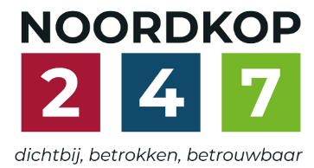
Noordkop Country & Bluegrass

Zaterdag 09:00-12:00: Saturday morning CB
www.Crossroadscountryradio.nl
luisteren kan alleen online via de website.
Herhaling: Donderdag 09:00-12:00
Zondag 19:00-20:00: Waterland CB
https://rtvpurmerend.nl
luisteren online kan via https://rtvpurmerend.nl/radio/live
Dinsdag 22:00-24:00: Noordkop CB
www.regionoordkop.nl
ether: 105.6 en 107.7 FM
luisteren online: www.noordkop247.nl/ live-radio/
Na de uitzending kan het programma worden beluisterd wanneer u maar wilt, via
http://hans.vdveen.org/muziek/
U vindt daar de uitzendingen van het laatste half jaar, waar u vrij uit kunt kiezen.
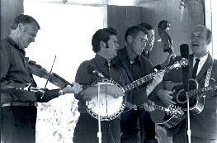

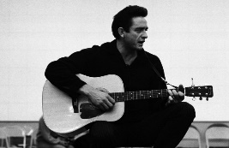
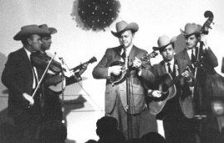
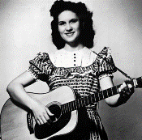
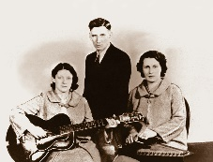
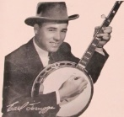
21, 22 & 24 maart 2026
Zondag 19:00-20:00 – Waterland Country & Bluegrass
Dinsdag 22:00-23:00 – Noordkop Country
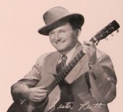
Dinsdag 23:00-24:00 – Noordkop Bluegrass
Zat
erdag 09:00-12:00 – Crossroads Radio

samenstelling, montage & presentatie
Hans van der Veen

21 maart, begin van de lente, daar had ik wel wat mee kunnen doen, maar het gaat over allerlei andere zaken. Natuurlijk zijn we nieuwsgierig naar die mooiste 30 Bluegrass songs volgens Americana Music Appreciation Crossroads, die geen familie is van onze Crossroads. Ach, u moet maar zien. Ik bedoel: horen.

Veel luisterplezier!

Zaterdag 21 maart
Herhaling: donderdag 26 maart
Bij CrossroadsCountryRadio.nl
Saturday morning CB
09:00-10:00: Country
Beste CD’s in februari 1989
Volgens het tijdschrift Music Row
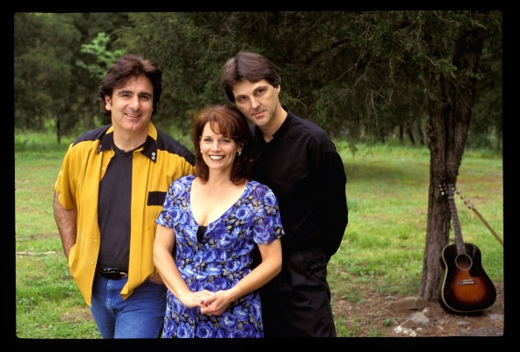
Baillie & the Boys

- Randy Travis Written in stone
- Emmylou Harris I still miss someone
- Ricky van Shelton Swimming upstream
- Desert Rose Band Hello trouble
- Dwight Yoakam Send me the pillow
- Bellamy Brothers Rebels without a clue
- Alabama Southern star
- Dan Seals Those
- K.T. Oslin Where is a woman to go
- Charlie Daniels Band Get me back to Dixie
- Patty Loveless Go on
- Waylon Jennings Grapes on the vine
- Nitty Gritty Dirt Band Workin’ band
- Highway 101 Desperate road
- T. Graham Brown The best love I never had
- Tanya Tucker Strong enough to bend
- Buck Owens Second fiddle
- Reba McEntire I know how he feels
- Baillie & the Boys She deserves you

10:00-11:00: Bluegrass
His name is Bill (2)
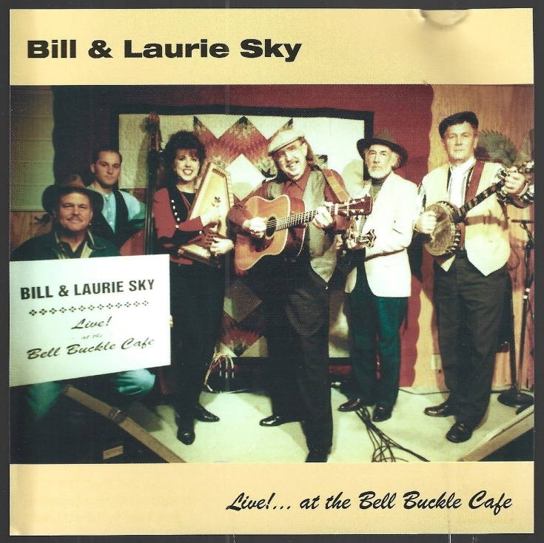

- Crystals intro
- Bill & Belle Reed Old lady and the devil
- Bill & Bonnie Hearne Sweet desert rose
- Bill & Ed & the Mt Music Boys My West Virginia Rose
- Ellis & Bill (the Green Mt Boys) My little home in West Virginia
- Bill & Earl Bolick (Blue Sky Boys) Pictures from life’s other side
- Bill & Laurie Sky Fallen leaves
- Bill & Maggie Anderson I don’t believe
- Bill & Mary Reid Your sweet loving man
- Bill & Mary Nell Parker Whoa Mule
- Bill & Paul & the BG Travelers Cumberland valley special
- Bill Anderson (& Dolly Parton) My perfect reason
- Bill Blaylock & the Modern Sounds of BG
Fair weather friends
- Bill Blevins Honeymoon Waltz
- Bill Box & the Dixie Drifters I’ve walked many miles in these shoes
- Bill Browning & his Echo Valley Boys Love left over
- Bill Carlisle’s Kentucky Boys Unclouded sky
- Bill Carpenter My old cottage home
- Bill Carroll The sweetest gift
- Bill Castle Ballad of Charlie Dill
- Bill Clifton Give me your love

11:00-12:00: Bluegrass
De mooiste 30 Bluegrass songs
volgens Americana Music Appreciation Crossroads
- de nummers 30 tot en met 15
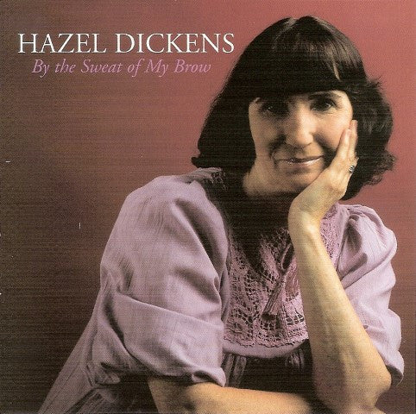

- Jimmie Dale Gilmore & The Wronglers
I’m Thinking Tonight Of My Blue Eyes
- Junior Sisk Just Load The Wagon
- Rhonda Vincent I’m Not Over You
- John Hartford Gentle On My Mind
- The Cox Family I Am Weary (Let Me Rest)
- Merle Haggard Mama’s Hungry Eyes
- Seldom Scene My Better Years
- Steve Earle And The Del McCoury Band
The Mountain
- Doc and Merle Watson Roll in My Sweet Baby’s Arms
- Old & In the Way Catfish John
- Emmylou Harris Angel Band
- The Stanley Brothers The White Dove
- Old & In The Way Lonesome L.A. Cowboy
- Steve Earle And The Del McCoury Band
Dixieland
- Ricky Skaggs & Tony Rice Bury Me Beneath the Weeping Willow
- Hazel Dickens Hills of Home

Zondag 22 maart, 19:00-20:00
Bij RTV Purmerend
Waterland CB
Old men (1)
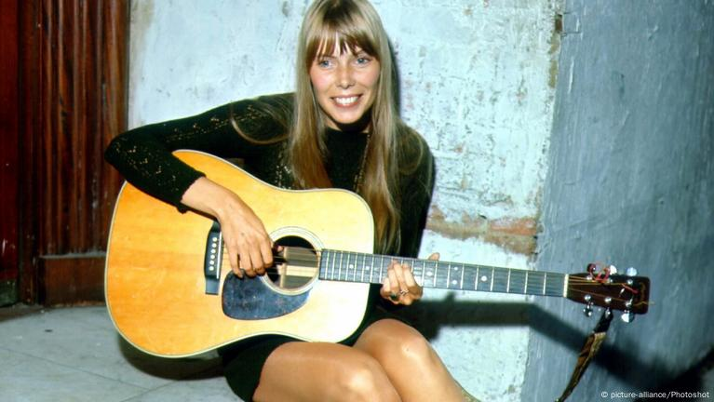
Joni Mitchell

- C Joni Mitchell Maids, when you’re young
never wed an old man
- BG Springfield (Fr) The old man
- C Ernie Lieberman My old man
- BG Angry Zeta (Argent.) Old man Norman
- C JohnnynPaycheck The Old Man and the River
- BG Billy Droze Words from an old man
- C George Hamilton IV Dirty old man
- BG Doyle Lawson Old man winter
- C Lance James (Z.Afr,) Don’t let the old man in
- BG Feller & Hill The old Kentucky man
- C Merle Haggard Old man from the mountain
- BG Special Consensus The old man walked away
- C Brothers Osborne Old man’s boots
- BG Samantha Casey & the Bluegrass Jam
Old Man's Ride
- C Waylon Jennings Same old lover man
- BG J.D. Crowe Old man from the mountain
- C Vernon Dalhart Get away , old man
- BG Ralph Stanley & Emmylou Harris
Old man’s tears
- C Boxcar Willie Reflections of an old man

Dinsdag 24 maart, 22:00-23:00
Bij Noordkop 247
Noordkop Country
Old men (2)
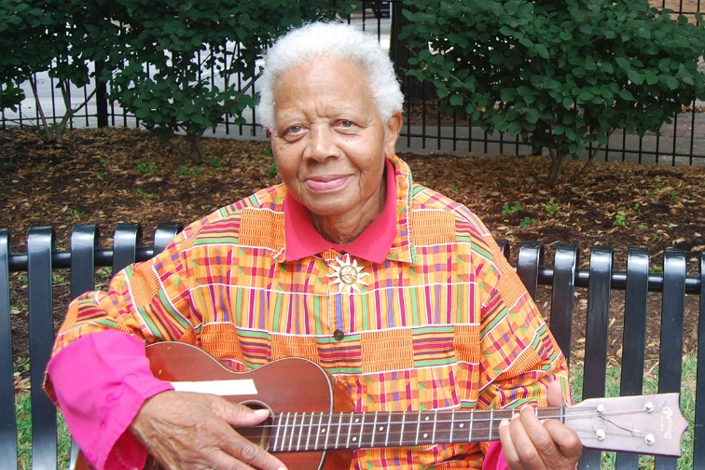
Ella Jenkins

- Ella Jenkins This old man
- Smothers Brothers My old man
- Chris Gaffney I’m an old, old man
- Slim Dusty (Austr) Old man drought
- John Williamson (Austr) Old man Emu
- Joni Mitchell My old man
- Rod McKuen My old man
- Preston Ward Old man in the moon
- Paul Ricketts Just like my old man
- Tony Douglas Old man love
- Kelly Harrell Charley, he’s a good old man
- Lefty Frizzell I’m an old, old man
- Lonnie Donegan My old man’s a dustman
- Alan Mills Old man i n the world
- Kenny Butterell Old man and the kid
- Uncle Dave Macon The old man’s drunk again
- Rob McHale Old man on the road
- Kate Rusby The old man
- Dean Perrett My old man’s guitar

Dinsdag 24 maart, 23:00-24:00
Bij Noordkop 247
Noordkop Bluegrass
Old men (3)
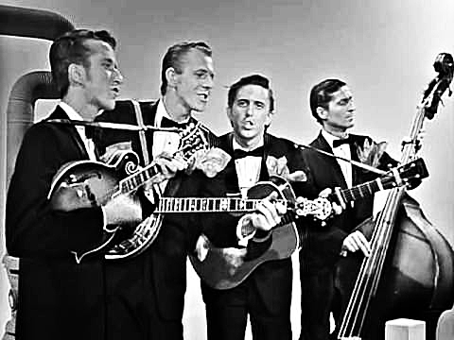
The Dillards

- Tommy Brown Old man’s story
- Ruth & Max Bloomquist Daddy Was An Old Man
- Good Brothers An Old Man's Tears
- Clarence Kelly Old Man's Fiddle And Bow
- Meridian Old man in the shanty
- Eric Brace & Peter Cooper Nice old man
- Virginia Creepers Old man gone
- Carroll Best Say old man, can you play the fiddle
- Richard Dobson Old man collecting cans
- Sharon Graeff Old man in the park
- Dillards Old man at the mill
- Ashley Cook The Chestnut, The Old Man And Heeler
- Clabe McGuire Old man Clark
- Jim Eanes Old man Joe
- Lilly Brothers The old man’s story
- Smiley Bates The old man and the old woman
- Feller & Hill The old Kentucky man
- Robbie Fulks Molly and the old man

De vorige week
Wilt u luisteren naar het programma van de vorige week?
Control+klik op onderstaande links

Zaterdag 14 maart uur 1, Saturdaymorning Country: Australië
https://hans.vdveen.org/muziek/XYZ - CROSSROADS COUNTRY RADIO - Country/498x - Saturday morning Country - 2026-03-14 - Minder bekende Australische artiesten.mp3

Zaterdag 14 maart uur 2, Saturdaymorning Bluegrass: Zaterdagavond
https://hans.vdveen.org/muziek/XYZ - CROSSROADS COUNTRY RADIO - Bluegrass/498y - Saturday morning Bluegrass - 2026-03-14 - Zaterdag(avond).mp3

Zaterdag 14 maart uur 3, Saturdaymorning Country: Slim
https://hans.vdveen.org/muziek/XYZ - CROSSROADS COUNTRY RADIO - Country/498z - Saturday morning Country - 2026-03-14 - Slim.mp3

Zondag 15 maart, Waterland CB: Happy birthday
https://hans.vdveen.org/muziek/W - WATERLAND CB/498w - Waterland CB - 2026-03-15 - Happy birthday.mp3

Dinsdag 17 maart, Noordkop Country: Jim Reeves (1)
https://hans.vdveen.org/muziek/B - NOORDKOP COUNTRY/498b - Noordkop Country - 2026-03-17 - Jim Reeves' originele opnamen (1).mp3

dinsdag 17 maart, Noordkop Bluegrass: Randal Hylton (2)
https://hans.vdveen.org/muziek/C - NOORDKOP BLUEGRASS/498c - Noordkop Bluegrass - 2026-03-14 - Randall Hylton (2).mp3

