Saturdaymorning CB
Waterland CB


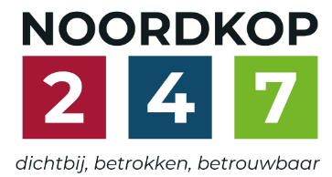
Noordkop Country & Bluegrass

Zaterdag 09:00-12:00: Saturday morning CB
www.Crossroadscountryradio.nl
luisteren kan alleen online via de website.
Herhaling: Donderdag 09:00-12:00
Zondag 19:00-20:00: Waterland CB
https://rtvpurmerend.nl
luisteren online kan via https://rtvpurmerend.nl/radio/live
Dinsdag 22:00-24:00: Noordkop CB
www.regionoordkop.nl
ether: 105.6 en 107.7 FM
luisteren online: www.noordkop247.nl/ live-radio/
Na de uitzending kan het programma worden beluisterd wanneer u maar wilt, via
http://hans.vdveen.org/muziek/
U vindt daar de uitzendingen van het laatste half jaar, waar u vrij uit kunt kiezen.
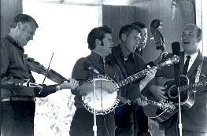

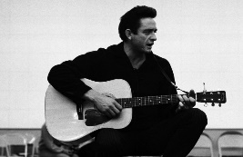
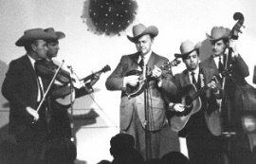
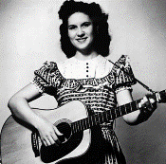
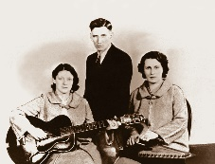
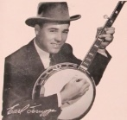
7, 8 & 10 maart 2026
Zondag 19:00-20:00 – Waterland Country & Bluegrass
Dinsdag 22:00-23:00 – Noordkop Country
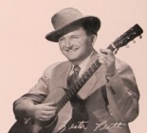
Dinsdag 23:00-24:00 – Noordkop Bluegrass
Zat
erdag 09:00-12:00 – Crossroads Radio

samenstelling, montage & presentatie
Hans van der Veen

Gisteravond – donderdag – hadden we een mooi BG concert van de Italiaanse Truffle Valley Boys in Bergen of Zee. Prachtig oud kerkje in de duinen, waar we nog in banken moesten zitten, maar wel met kussens. En een heerlijke avond die ons doet uitzien naar zondag de 15de: Johanna’s Mountain Boys in Hoogwoud. In het reclamespotje aan het eind van mijn programma’s wordt abusivelijk 13 maart gezegd, maar men zal het wel begrijpen.
De radio deze week: er valt weinig over op te merken, u ziet – ik bedoel: hoort het wel!
Veel luisterplezier!

Zaterdag 7 maart
Herhaling: donderdag 12 maart
Bij CrossroadsCountryRadio.nl
Saturday morning CB
09:00-10:00: Bluegrass
Woods
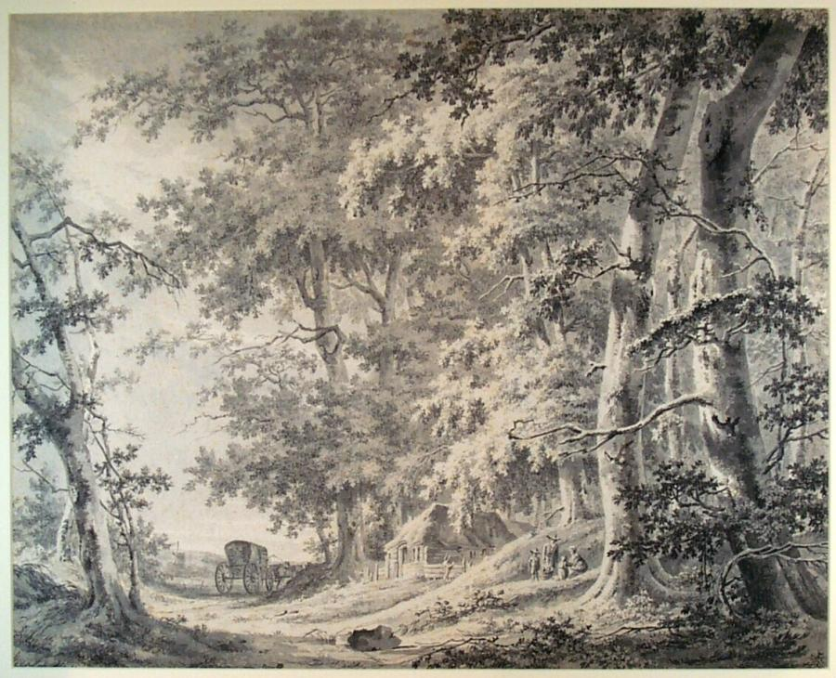

- Al Wood & the Smokey Ridge Boys
Sing me a bluegrass song
- Four Chords of Wood (Austr) The last time
- Wires & Wood Another night
- Wood & Wire Summertime rolls
- Wood, Wire and Words I’m going home
- Wood Family Cabin in the hills of Carolina
- Wood Family Tradition A fool such as I
- Wood Flower Mountain dew
- Wood Street Bloodhounds Some old day
- Wooden Sleepers, The Pockets
- Woodettes, The (met de Goins Brothers)
Just a little talk with Jesus
- Les Woodie & Friends Break clean (and come out swinging)
- Woodies Best of me
- Woods Tea Company High cost of living
- Woodlawn’s Warheads Every single time
- The Woodpickers (Austr) One more mile
- The Woodlanders Sea song
- Wood Smoke Rising Rosa Lee McFall
- Wooden Grass (Tsjech) Love’s gonna live here
- Woodstock Mountains Revue Interest on the loan
- Floodwood Side by side

Zaterdag 7 maart 10:00-11:00: Bluegrass
Zaterdag (3)
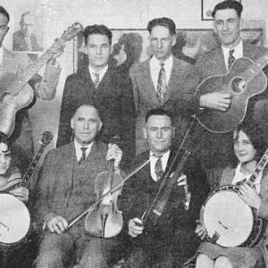
Fiddlin’ Bob larkin & his Music Maker

- Faron Young I’ve got five dollars and it’s Saturday night
- Dudley Connell & Don Rigsby Another Saturday night
- CMH Studio Band She knows what to do with Saturday night
- Dewey, Pickette & Howe Heart of Saturday Night
- Roger Cline Saturday shuffle
- Fiddlin’ Bob Larkin & family Saturday night waltz
- Mason Williams Saturday night banjo
- Roy McMillan Saturday night at the hoedown
- Wright Brothers Overland Stage Company
Gospel singing Saturday night
- Lou Osborne & Family Television Saturday night
- Buncombe Turnpike Asheville summertime Saturday night
- Paul Clayton Saturday night at sea
- Ian Calford Saturday night at Hickman County
- Osborne Brothers Banjo ringing Saturday night
- Joe & Rose Lee Maphis Black Mountain rag on a Saturday night
- Gene Parker Saturday night dance man
- Scott Miller & the Commonwealth
Ciderville Saturday night
- Hamilton County BG Band Down the hall on Saturday night
- The Masters Saturday night fish fry
- Al Dexter Saturday night boogie
- Zeke Clements with His Men from Music Mountain
Payday Saturday Night
Outro/Bonus:
- Homer & the Barnstormers Grandfather’s clock

Zaterdag 7 maart 11:00-12:00: Country
Go North
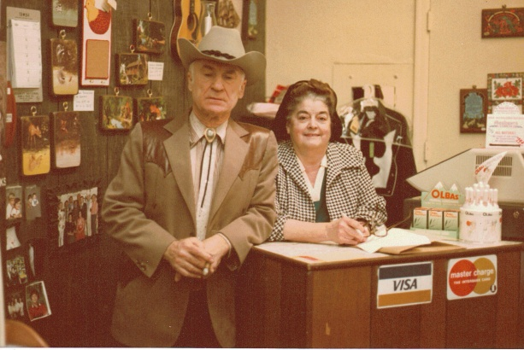
Doc & Chickie Williams

- Johnny Horton Go North (5-7-1960)
- Johnny Horton North to Alaska ( (14-7-1960)
- Johnny Horton North to Alaska (9-8-1960)
- Waylon Jennings Girl from the north country
- Slim Dusty (Austr) Sunny northern rose
- Smilin' Johnnie & his Prairie Pals (Can)
Northern lites waltz
- Wade Mainer’s Mountaineers North Carolina moon
- Hank Snow (Can) North to Chicago
- Rod McKuen Fly me to the north
- Alberta Slim (Can) North of the border
- Mary MacCaslin Northfield
- Vernon Dalhart Out in the great northwest
- Gordon Lightfoot (Can) Whispers of the north
- George Hamilton IV Commerce Street and Sixth Avenue North
- Ian Hamilton (UK) North street (instr)
- Slim Whitman North wind
- Doc & Chickie Williams Northwinds
- Cal Smith The nordth won the war again last night
- Doc & Chickie Williams Echo of the north
- Dave Dudley George and the north woods
- Harold Morton North East Creek swimming hole

Zondag 8 maart, 19:00-20:00
Bij RTV Purmerend
Waterland CB
Een dagje naar het strand
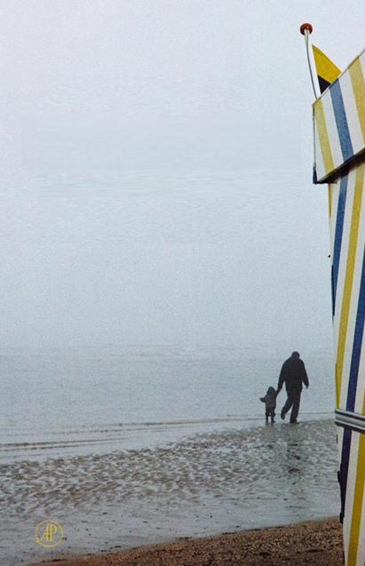

- C Jan & Sylvia Long beach
- BG Lee Moore Beach at Waikiki
- C Dick Unteed & the Pine Mountain Boys
Beach of Bali Bali
- BG Blue Mountain Hermit of the hidden beach
- C John D. Loudermilk The bully of the beach
- C Mac Beattie The beaches of Dieppe
- C Ben Colder The bottomless topless beach
- BG Done Gone Band Idaho sands
- BG Frank Wakefield White silver sands
- C Slim Dusty Sands of Tanami
- C Webb Pierce Sands of gold
- BG Baucom, Bibey & Blueridge
Shifting sands
- C The Overlanders Summer skies and golden sands
- C Johnny Cash & Lorne Greene
The shifting whispering sands
- BG Hickory Project Waves in the sand
- BG Balsam Range Lines in the sand
- C Carl Smith Love letters in the sand
- BG Mac Wiseman I’ll still write your name in the sand
- BG Darren Beachley Lovin' Ain't Been Easy On My Mind
- BG White Sands Panhandle Band
Good woman blues
- C Crystal Sands More than gas
Bonus
- C Hank Snow On the beach of Waikiki

Dinsdag 10 maart, 22:00-23:00
Bij Noordkop 247
Noordkop Country
Joan Baez (2)


- Joan Baez & Pete Seeger Turn, turn, turn
- Mark Weigle Love song to a stranger
- Kim Nalley I shall be released
- Joan Baez & Johnny Cash Gospel ship
- Joan Baez & Jeffrey Shutleff Angel band
- Joan Baez & Mimi Farina Catch the wind
- Peter, Paul & Mary Pack up your sorrows
- Joan Baez & Janis Joplin In the quiet morning
- Joan Baez & Kris Kristofferson Hello in there
- Joan Baez & Donovan Colors
- Joan Baez & Paul Simon The boxer
- Joan Baez, Emmylou Harris & Jackson Browne
Deportee
- Joan Baez & Bob Dylan Chimes of freedom
- Joan Baez & Jackson Browne Guantanamera
- Joan Baez We shall overcome
Bonus:
- Joan Baez & Ear Scruggs Love is just a four letter word
- Joan Baez And th e band played Waltzing
Mathilda
- Joan Baez Mary Hamilton

Dinsdag 10 maart, 23:00-24:00
Bij Noordkop 247
Noordkop Bluegrass
Red Dinges – 2
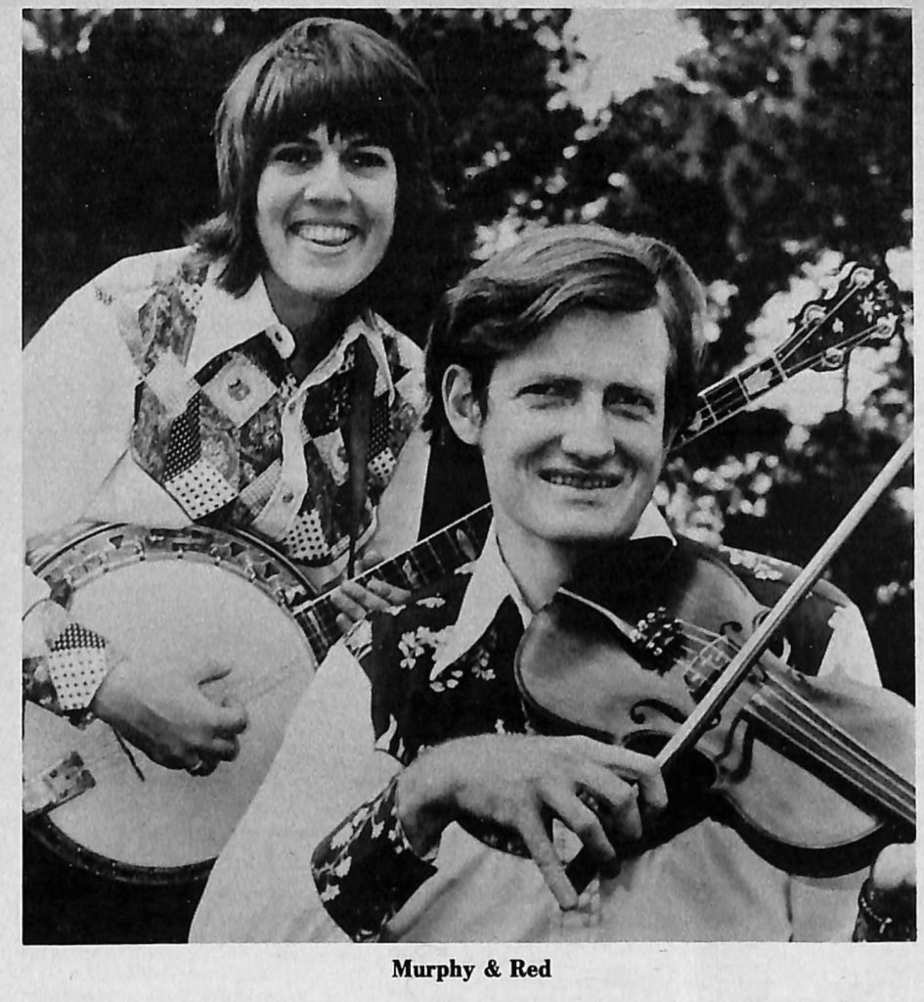

- The Read Heads You’ll always be untrue
- Red Perkins & his Kentucky Red Heads
I’m so happy I could cry
- Red & Murphy & Co My every day silver is plastic
- Red Herring Fall on my knees
- Fiddlin’ Red Herron Soldier’s joy
- Red Hill Rollers The ballad of Willie White
- Bobby Gee (Horn)& Redd Cornbread and buttermilk
- Red Hot (Bluegrass Band) Chilly winds
- Jussi Syren & Red Hot You’ll never give me my heart back
- Peter Rowan & Richard Greene & The Red Hot Pickers
Willow garden
- Red Ingle Cigardust
- Red June Ancient dreams
- Red Kirk Walking round in circles
- Redlands BG Boys Neil’s reel
- Red Letter Edition Any old wind
- Audie Blaylock & Redline I was left on the street
- Bluegrass Redliners Home in the mountains
- Red Mountain Bluegrass Band Nellie Kane
- Red Mountain Boys The phone call
- Red Mountain White Trash Step around Johnny
Bonus:
- Red Mountain White Trash Jump in the well

De vorige week
Wilt u luisteren naar het programma van de vorige week?
Control+klik op onderstaande links

Zaterdag 28 februari uur 1, Saturdaymorning Country: Jarigen
https://hans.vdveen.org/muziek/XYZ - CROSSROADS COUNTRY RADIO - Country/496x - Saturday morning Country - 2026-02-28 - Jarigen.mp3

Zaterdag 28 februari uur 2, Saturdaymorning Bluegrass: Zaterdag
https://hans.vdveen.org/muziek/XYZ - CROSSROADS COUNTRY RADIO - Bluegrass/496y - Saturday morning Bluegrass - 2026-02-28 - Zaterdag.mp3

Zaterdag 28 februari uur 3, Saturdaymorning Country: Beste 200 (slot)
https://hans.vdveen.org/muziek/XYZ - CROSSROADS COUNTRY RADIO - Country/496z - Saturday morning Country - 2026-02-28 - De beste 200 (slot).mp3

Zondag 1 maart, Waterland CB: 1 maart
https://hans.vdveen.org/muziek/W - WATERLAND CB/496w - Waterland CB - 2026-03-01 - 1 maart.mp3

Dinsdag 2 maart, Noordkop Country: Folk revival (12)
https://hans.vdveen.org/muziek/B - NOORDKOP COUNTRY/496b - Noordkop Country - 2027-03-03 - Folk revival van 1960 (12).mp3

dinsdag 2 maart, Noordkop Bluegrass: Jones
https://hans.vdveen.org/muziek/C - NOORDKOP BLUEGRASS/496c - Noordkop Bluegrass - 2026-03-03 - Bluegrass Jones.mp3

