Saturdaymorning CB
Waterland CB


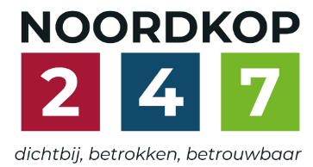
Noordkop Country & Bluegrass

Zaterdag 09:00-12:00: Saturday morning CB
www.Crossroadscountryradio.nl
luisteren kan alleen online via de website.
Herhaling: Donderdag 09:00-12:00
Zondag 19:00-20:00: Waterland CB
https://rtvpurmerend.nl
luisteren online kan via https://rtvpurmerend.nl/radio/live
Dinsdag 22:00-24:00: Noordkop CB
www.regionoordkop.nl
ether: 105.6 en 107.7 FM
luisteren online: www.noordkop247.nl/ live-radio/
Na de uitzending kan het programma worden beluisterd wanneer u maar wilt, via
http://hans.vdveen.org/muziek/
U vindt daar de uitzendingen van het laatste half jaar, waar u vrij uit kunt kiezen.
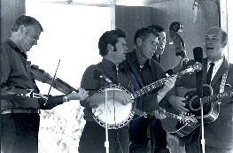


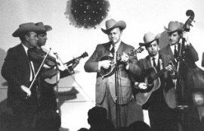

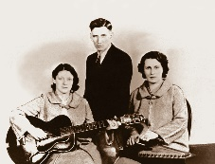
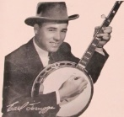
17, 18 & 20 januari 2026
Zondag 19:00-20:00 – Waterland Country & Bluegrass
Dinsdag 22:00-23:00 – Noordkop Country

Dinsdag 23:00-24:00 – Noordkop Bluegrass
Zat
erdag 09:00-12:00 – Crossroads Radio

samenstelling, montage & presentatie
Hans van der Veen

Twee mooie foto’s van Kimmie Rhodes. Haar stem doet me denken aan Iris Dement, daar moet u maar eens op letten. Haar CD is overigens een soort Greatest Hits, want zingen doet ze alleen nog in bad.
Verder moet u maar even naar de lijsten kijken, want ik ben al weer te laat!

Veel luisterplezier!!

Zaterdag 17 januari
Herhaling: donderdag 22 januari
Bij CrossroadsCountryRadio.nl
Saturday morning CB
09:00-10:00: Country
De meest gedraaide songs van 1976
1
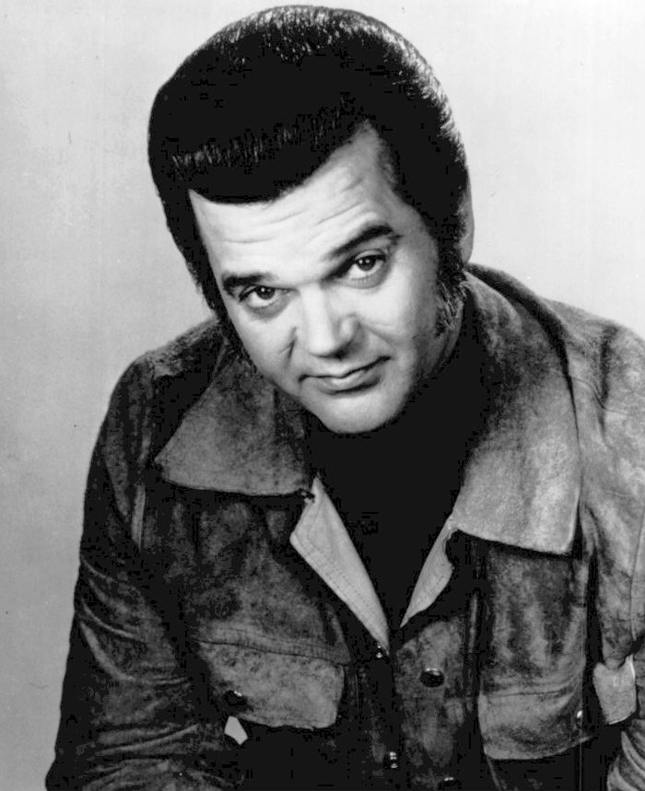
Conway Twitty

- Conway Twitty This Time I've Hurt Her More than She Loves Me
- Bill Anderson and Mary Lou Turner Sometimes
- Cledus Maggard The White Knight
- Waylon & Willie Good Hearted Woman
- Merle Haggard The Roots of My Raising
- Tom T. Hall Faster Horses (The Cowboy and the Poet)
- Don Williams 'Til the Rivers All Run Dry
- Freddy Fender You'll Lose a Good Thing
- Tammy Wynette 'Til I Can Make It on My Own
- Eddie Rabbitt Drinkin' My Baby (Off My Mind)
- Emmylou Harris Together Again
- Mickey Gilley Don't the Girls All Get Prettier at Closing Time
- Charley Pride My Eyes Can Only See as Far as You
- Ronnie Milsap What Goes On When the Sun Goes Down
- Conway Twitty After All the Good is Gone
- Johnny Cash One Piece at a Time
- Crystal Gayle I'll Get Over You
- Marty Robbins El Paso City
- Joe Stampley All These Things
- Dave & Sugar The Door Is Always Open

10:00-11:00: Bluegrass
Bluegrass singles uit 1965
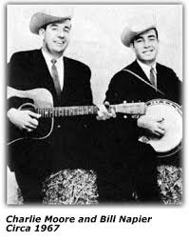

- Bill & Ed & the Mountain Music Boys
Crossing the mountain
- Jimmy Martin Sunny side of the mountain
- Bill Carroll Sweetest gift a mother's smile
- Charlie Moore & Bill Napier Ballad of Christopher Columbus
- Lester Flatt & Earl Scruggs The ballad of Jed Clampett
- Bill Perry & Paul Chaney Cherished memories
- Lone Oak Mountain Boys Lone Oak breakdown
- Al Jones How the story had to end
- Lee Nolan & Ed Carroll Blue snow flakes
- Country Gentlemen Bringing Mary home
- Lowell Varney My daddy was a preacher
- Moore Brothers Darkness falls upon my life
- Larry Richardson Sad and lonesome day
- Bill Monroe Jimmy Brown, the newsboy
- Wally Horton Where were you last night
- Golden State Boys I'll fly away
- Kentucky Colonels Ballad of Farmer Brown
- Frank Wakefield The convict and the child
- The Kentuckians Hello city limits
- The Kentucky Cut-Ups Blue Ridge cabin home
- Buzz Busby The dream
- Mac Wiseman Maple sugar sweetheart
- Bluegrass Blackjacks Get right with God

11:00-12:00: Country
Te laag geplaatst in de
Beste country songs aller tijden volgens het tijdschrift Rolling Stone

Johnny Rodriguez

- Johnny Rodriguez Ridin’ my thumb to Mexico
- Iris Dement Let the mystery be
- Linda Ronstadt Long long time
- Hank Snow I’m moving on
- Jim Reeves He’ll have to go
- Emmylou Harris Border to Birmingham
- Don Williams Tulsa time
- Crystal Gayle Don’t it my brown eyes blue
- Kris Kristofferson Sunday morning coming down
- John Denver Take me home, country roads
- Louvin Brothers Louvin Brothers
- Marty Robbins El Paso
- Roger Miller King of the road
- Roy Acuff Wabash cannonball
- Tom T. Hall Old dogs, children and watermelon wine
- Waylon Jennings Are you sure Hank done it this way
- Erverly Brothers Bye bye love
- Porter Wagoner A satisfied mind
- Stoney Edwards Hank and Lefty Raised My Country Soul
bonus
- George & Tammy Golden ring

Zondag 18 januari, 19:00-20:00
Bij RTV Purmerend
Waterland CB
Sneeuwstormen

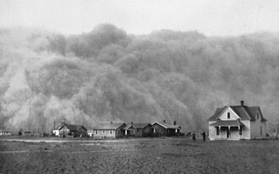

- C Harlan Howard The blizzard
- BG Mac Odell Blizzard seven seven
- C The Browns The big blizzard
- BG Nahuysen brothers (Austr) Summer blizzard
- C The Tallest Men On Earth (Zweden)
The blizzard’s never seen
the desert sands
- BG Bluegrass Family (Tsj) Blizzard
- C Johnny Bond Winter blizzard
- BG Banner Mountain Boys Black Blizzard
- C Rattlesnakes Black blizzard
- BG Bawn in the Mash Blizard of 2003 (Denver)
- C Dusty Spittle The great snow storm
- BG Ray Legere & Roger Williams- Snowy afternoon
- C Slim Dusty (Austr) When Snowy sings of home
- BG Footworks Percussive Dance Ensemble
Snowy path
- BG Lochwood Cold snowy morning
- F Tim McNamara (Austr) Snowy River riders
- C Laura Downing (Austr) Snowy River yodel
- C Frankie Davidson (Austr) The man from Snowy River
- C Slim Dusty (Austr) The man from Snowy River’s
coming home
Bonus
- BG Ralph Blizzard Hand me down my walking cane
- C Jim Reeves The blizzard

Dinsdag 20 januari, 22:00-23:00
Bij Noordkop 247
Noordkop Country
De singles uit 1940 en 1970 – 13

Lucie Monroe

1940
- Red Foley Old shep
- Arthur GB Smith There are no disappointments in heaven
- Tex Ritter When it's lamplightning time in the valley
- Lucy Monroe America the beautiful
1970
- Margaret Whiting I’ll tell him today
- Doug Kershaw Cajun Joe
- George Morgan Lilacs and Fire
- Johnny Bush Warmth Of The Wine
- Bonnie Owens That Little Boy Of Mine
- Tommy Overstreet If You're Lookin' For A Fool
- Jerry Reed Talk about the good times
- Margie Bowes That’s more than you can say
- Jimmie Rodgers Dum dum song
- Jack Greene Just a little while ago
- Merle Haggard The Fightin' Side of Me
- Harlow Wilcox Sad is the lonely
- Johnny Darrell Bed Of Roses
- Bonnie Guitar Allegheny
- Jim Ford To Make My Love Beautiful
1940
- Clyde Moody No Letter In The Mail Today

Dinsdag 20 januari, 23:00-24:00
Bij Noordkop 247
Noordkop Bluegrass
Eilanden


- Darrell Winkelman & Jerry Lewis
Rocky Island
- The Charles River Valley Boys Rocky island
- Crooked Jades Train on the island
- Danny Paisley Alcatraz Island Blues
- Stephen Wade Rhode Island Reel
- Della Mae The Shetland Islands
- Eleanor Moorehead (Can) Bell Island Jig
- Mac Wiseman Prince Edward Island (is Heaven to me)
- Jimmy Chapman Todd's Island Breakdown
- The Wright Brothers Island Creek Mine Fire
- Reg Hill Allumette Island Hornpipe
- Nothin Fancy Little Island Love
- Oscar Brand (Can) Wake Island
- Pine Island Pine Island Breakdown
- Milan Miller Spike Island Blues
- Ian Simpson & John Kane (Austr)
Torres Straight Island Tunes
- Patty Larkin Island of time
- Don Messer and His Islanders (Can)
Leprachaun's Jig,Harp Solo,Erin Go Braugh
- Ned & Rebecca Spurlock Staten Island Hornpipe
- Mike Mullins Rhode Island Bride
- The Olde Boston Tea Party Duck Island
- Reed Island Rounders White Rose Waltz

De vorige week
Wilt u luisteren naar het programma van de vorige week?
Control+klik op onderstaande links

Zaterdag 10 januari uur 1, Saturdaymorning C: Hits van 1960
https://hans.vdveen.org/muziek/XYZ - CROSSROADS COUNTRY RADIO - Country/489x - Saturday morning Country - 2026-01-10 - Country hits van 1966.mp3

Zaterdag 10 januari`uur 2, Saturdaymorning BG: singles 1060
https://hans.vdveen.org/muziek/XYZ - CROSSROADS COUNTRY RADIO - Bluegrass/489y - Saturday morning Bluegrass - 2026-01-10 - BG singles van 1960.mp3

Zaterdag 10 januari uur 3, Saturdaymorning C&BG: Recent verschenen
https://hans.vdveen.org/muziek/XYZ - CROSSROADS COUNTRY RADIO - Country/489z - Saturday morning C&Bg - 2026-01-10 - Recent verschenen.mp3

Zondag 11 januari, Waterland CB: Armen mensen (1)
https://hans.vdveen.org/muziek/W - WATERLAND CB/489w - Waterland CB - 2026-01-11 - Arme mensen (1).mp3

Dinsdag 13 januari, Noordkop Country: Arme mensen (2)
https://hans.vdveen.org/muziek/B - NOORDKOP COUNTRY/489b - Noordkop Country - 2026-01-13 - Arme mensen (2).mp3

dinsdag 13 januari, Noordkop Bluegrass: Arme mensen (3)
https://hans.vdveen.org/muziek/C - NOORDKOP BLUEGRASS/489c - Noordkop Bluegrass - 2026-01-13 - Arme mensen (3).mp3

