Saturdaymorning CB
Waterland CB



Noordkop Country & Bluegrass

Zaterdag 09:00-12:00: Saturday morning CB
www.Crossroadscountryradio.nl
luisteren kan alleen online via de website.
Herhaling: Donderdag 09:00-12:00
Zondag 19:00-20:00: Waterland CB
https://rtvpurmerend.nl
luisteren online kan via https://rtvpurmerend.nl/radio/live
Dinsdag 22:00-24:00: Noordkop CB
www.regionoordkop.nl
ether: 105.6 en 107.7 FM
luisteren online: www.noordkop247.nl/ live-radio/
Na de uitzending kan het programma worden beluisterd wanneer u maar wilt, via
http://hans.vdveen.org/muziek/
U vindt daar de uitzendingen van het laatste half jaar, waar u vrij uit kunt kiezen.
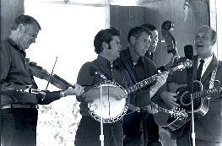


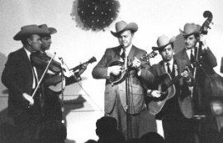
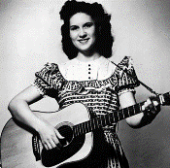
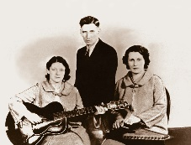
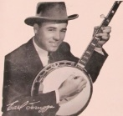
10, 11 & 13 januari 2026
Zondag 19:00-20:00 – Waterland Country & Bluegrass
Dinsdag 22:00-23:00 – Noordkop Country
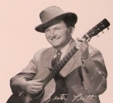
Dinsdag 23:00-24:00 – Noordkop Bluegrass
Zat
erdag 09:00-12:00 – Crossroads Radio

samenstelling, montage & presentatie
Hans van der Veen

Soms gok je goed. Ik had de programma’s van de vorige week al maanden geleden ingepland, maar blijkbaar met een vooruitziende blik want er zat nogal wat sneeuw in mijn zes uurtjes. En in de lucht. Zou het so zijn dat de weergoeden ook naar mijn programma luisteren en daar dan maar op inspelen? In dat geval ga ik snel een paar uur vullen met sunny summers.
Deze week: terug naar 1966 en naar 1960. Toch maar weer eens recent verschenen spul; ik heb een hele stapel liggen, ook bluegrass. En uitgebreid over arme mensen. Ik las vandaag in Trouw een mooi artikel over het leven Latino’s in het rijkste land ter wereld.
Ik wens u weer veel luisterplezier.

Zaterdag 10 januari
Herhaling: donderdag 15 januari
Bij CrossroadsCountryRadio.nl
Saturday morning CB
09:00-10:00: Country
De meest gedraaide songs van 1966
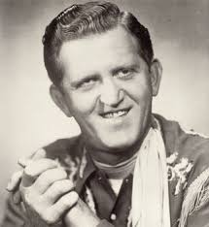
Red Sovine

- Red Sovine Giddyup Go
- Buck Owens Waitin' in Your Welfare Line
- Eddy Arnold I Want to Go with You
- Jim Reeves Distant Drums
- Sonny James Take Good Care of Her
- Buck Owens Think of Me
- David Houston Almost Persuaded
- Jim Reeves Blue Side of Lonesome
- Bill Anderson I Get the Fever
- Eddy Arnold Somebody Like Me
- Jack Greene There Goes My Everything
- Connie Smith Ain't Had No Lovin'
- Sgt. Barry Sadler Ballad of the Green Berets
- Jeannie Seeley Don't Touch Me
- Statler Brothers Flowers on the Wall
- Buddy Starcher History Repeats Itself
- Billy Walker A Million and One
- Johnny Cash The One on the Right Is on the Left
- Sonny James Room in Your Heart
- The Harden Trio Tippy Toeing
- Jim Reeves Snowflake

10:00-11:00: Bluegrass
Bluegrass singels uit 1960
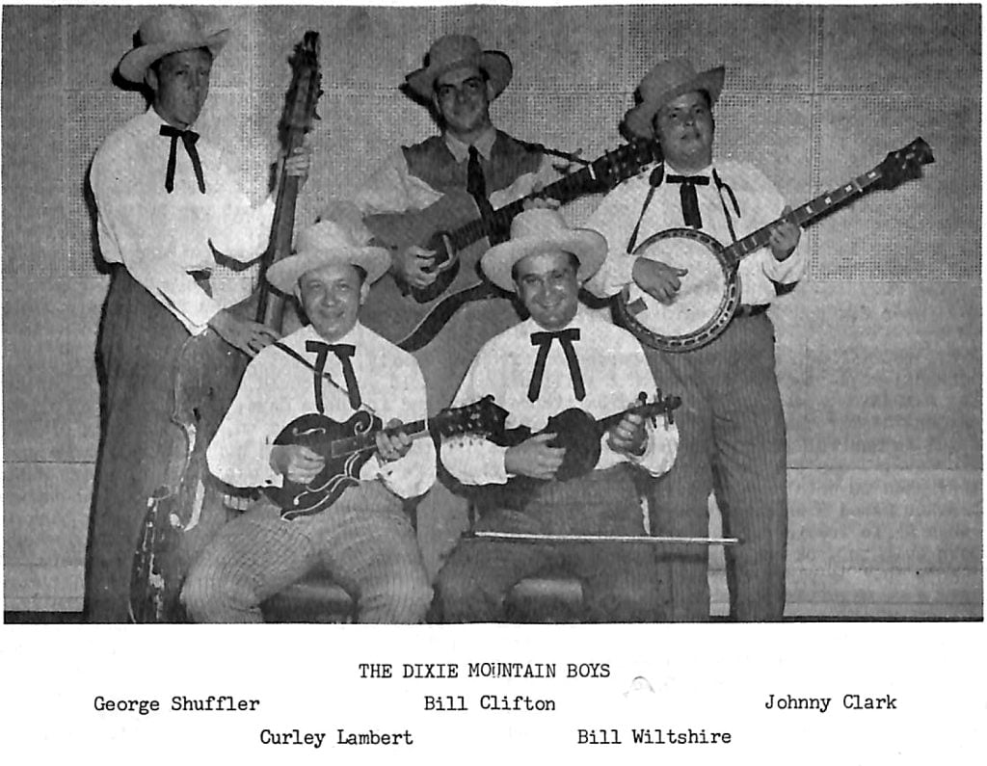

- Bill Clifton Bed on the floor
- Grandpa Jones Are you from Dixie?
- Jimmy Martin You don't know my mind
- Easter Brothers Bible on the table
- Don Reno & Red Smiley Bringin' in the Georgia mail
- Jim Eanes Road of no return
- Barrier Brothers Please don't leave me here alone
- Pete Pike Making love to a stranger
- The Wright Brothers Darlin' I'm so blue
- Stanley Brothers Daybreak in Dixie
- Buzz Busby Cold and windy night
- Carl Story Sweeter than the flowers
- Pop Stoneman Hand me down my walking cane
- Bill Harrell A heart never knows
- The Osborne Brothers At the first fall of snow
- Carl Sauceman I walk a lonely street
- Denver Duke & Jeffrey Null Dear Lord, let me die
- The Country Gentlemen Darling Alalee
- Cecil Surratt & Smitty Smith Do you mean the words you sa
- Connie & Joe Lonely years
- Jimmie Williams & Red Ellis No depression in Heaven
- Delmer Sexton I will not be denied
- Benny Martin- Her baby girl

11:00-12:00: Country
Recent verschenen Country CD’s

The Foreign Landers

- Brian Moon & Leona Williams We Must Have Been Out Of Our Minds
- Kent Thompson Two steppin’ song
- The Foreign Landers Flying back to you
- Jake Worthington Not like I used to
- Briscoe Mexican eagles
- Josh Ritter I’m listening
- Colbie Caillat Lucky
- Josh Ross My side of town
- Dallas Burrow Black rock desert blues
- Annie Bosko Bright blue sky
- Clover County Blue suede eyes
- Nicholas Jamerson I can’t, never could
- Carter Faith Bar Star
- Suzanne Vega Chambermaid
- Eric Schmidt Buckets
- Colby Acuff Most lonesome sound
- Roy Acuff Once more (niet nieuw!)
- Joyce Ramgate Memories are all we have
- Pat Garrett OldTimers
Bonus:
Roy Acuff Wreck on the highway

Zondag 11 januari 19:00-20:00
Bij RTV Purmerend
Waterland CB
Arme mensen (1)


Country & Folk
- Bill Anderson Po' Folks
- Bobby Bare More Than A Poor Boy Could Give
- Burl Ives Poor Boy In A Rich Man’s Town
- Hank Snow Poor little Jimmie
- Coon Creek Girls Poor Naomii Wise
- Blind Alfred Reed How Can a Poor Man Stand
Such Times and Live
- Benny Barnes Poor old me
- Paul Clayton Poor old maid
- John Carter Cash & Sarah Peasall McGuffey
Poor Boy and the Captain's Daughter
- Pete Seeger Poor Boy
Bluegrass & Old Time
- Doc & Merle Watson Poor Boy Blues
- Earl Taylor, Jim McCall & The Stoney Mountain Boys
Over The Hill To The Poor House
- Ralph Stanley Poor Rambler
- Stonemans Remember The Poor Tramp Has To Live
- Tenneva Rambl;ers Miss Lisa, Poor Girl
- Tyler Williams Poor Man in Richmond
- Lawrence Lane & Kentucky Grass
Just A Poor Country Boy
- Flatt & Scruggs Poor rebel soldier
- Henhouse Prowlers Poor old boy like me
- Carter Family Poor Little Orphaned Boy
- Shadow Mountain Band Poor Wayfaring Stranger

Dinsdag 13 januari, 22:00-23:00
Bij Noordkop 247
Noordkop Country
Arme mensen (2)


- Benny Barnes Poor man’s richess
- Faron Young I'm a Poor Boy
- Frankie Miller Richest Poor Boy
- George Jones Poor little rich boy
- Glen Campbell Poor Boy Lookin' For A Home
- John D Loudermilk Poor Little Pretty Girl
- Johnny Cash Poor Valley Girl
- Paul Baribeau Poor Girls
- Stonewall Jackson Life Of A Poor Boy
- Woody Guthrie Poor Boy
- Oscar Brand Poor little Angeline
- Ricky Nelson Poor little fool
- Bonnie Sloan Poor Paper Kite
- Lulu Belle Poor Little Heartbroken Rose
- Lemuel Jones Poor farmers
- Sandy Selsie The Poorest Girl In Town
- Annie Whittle (Nw.Zeel.) Poor old Rose
- Mark Olson Poor Michael’s Boat
- Ronnie King Band Poor white trash
- Burl Ives Poor Little Jimmie
- Stan Coster (Austr) Wealth made us poor
- Stoney Edwards Poor folks stick together
- Infamous Stringdusters Poor Boy's Delight

Dinsdag 13 januari, 23:00-24:00
Bij Noordkop 247
Noordkop Bluegrass
Arme mensen (3)


- Bill Wicker & Ralph Stanley Best girl this poor boy ever had
- Walter Forbes Poor Little Ellen
- Cindy G Poor Girl
- Dailey & Vincent Poor Boy Workin' Blues
- Daughters of Bluegrass Poor Little Sadie
- David Olney Poor clothing
- Jim Hurst Poor Hobo
- Junior Sisk Poor Sister Cry
- Laurie Lewis & Tom Rozum Poor Country Boy
- Leroy Mack Poor Willie
- Louisiana Honeydroppers Poor Man
- Osborne Brothers Poor Old Cora
- Whitetop Mountaineers Poor sinners fare thee well
- Whitetop Mountain Band Sally Was A Poor Girl
- Donna Ulisse Poor Mountain Boy
- Po’ Rambling Boys Back to the mountain
- Radio Flyer Poor old Mary Beth
- Cumberland County Line Bluegrass
Poor boy blues
- Bill Clifton & Paul Clayton Poor boy
- Ron Spears Poor Monroe
- Ginny Hawker Poor solder
Bonus:
- New Lost City Ramblers Poor old dirt farmer
- Don Rigsby Poor little rich man
- New Lost City Ramblers Who killed poor Robin
- New Lost City Ramblers Willie poor boy

De vorige week
Wilt u luisteren naar het programma van de vorige week?
Control+klik op onderstaande links

Zaterdag 3 januari, Saturdaymorning C: Country nr 1 hits van 1951
https://hans.vdveen.org/muziek/XYZ - CROSSROADS COUNTRY RADIO - Country/488x - Saturday morning Country - 2026-01-03 - De meest gedraaide songs van 1951.mp3

Zaterdag 3 januari, Saturdaymorning C: Bluegrass singles van 1955
https://hans.vdveen.org/muziek/XYZ - CROSSROADS COUNTRY RADIO - Bluegrass/488y - Saturday morning Bluegrass - 2026-01-03 - BG singles uit 1955.mp3

Zaterdag 3 januari, Saturdaymorning C: Sneeuw
https://hans.vdveen.org/muziek/XYZ - CROSSROADS COUNTRY RADIO - Country/488z - Saturday morning Country - 2025-01-03 - Snow.mp3

Zondag 4 januari, Waterland CB: Nieuwjaar/januari (1)
https://hans.vdveen.org/muziek/W - WATERLAND CB/488w - Waterland CB - 2026-01-04 - January snow.mp3

Dinsdag 6 januari, Noordkop Country: Nieuwjaar/januari (2)
https://hans.vdveen.org/muziek/B - NOORDKOP COUNTRY/488b - Noordkop Country - 2026-01-06 - Happy New Year (1).mp3

dinsdag 6 januari, Noordkop Bluegrass: Nieuwjaar/januari (3)
https://hans.vdveen.org/muziek/C - NOORDKOP BLUEGRASS/488c - Noordkop Bluegrass - 2026-01-06 - Happy New Year (2).mp3

