Saturdaymorning CB
Waterland CB


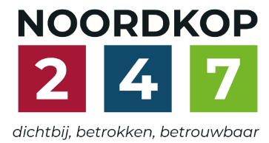
Noordkop Country & Bluegrass

Zaterdag 09:00-12:00: Saturday morning CB
www.Crossroadscountryradio.nl
luisteren kan alleen online via de website.
Herhaling: Donderdag 09:00-12:00
Zondag 19:00-20:00: Waterland CB
https://rtvpurmerend.nl
luisteren online kan via https://rtvpurmerend.nl/radio/live
Dinsdag 22:00-24:00: Noordkop CB
www.regionoordkop.nl
ether: 105.6 en 107.7 FM
luisteren online: www.noordkop247.nl/ live-radio/
Na de uitzending kan het programma worden beluisterd
wanneer u maar wilt, via
http://hans.vdveen.org/muziek/
U vindt daar de uitzendingen van het laatste half jaar, waar u vrij uit kunt kiezen.
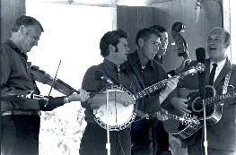
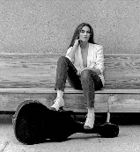
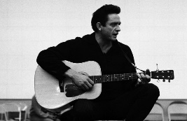
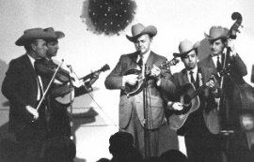
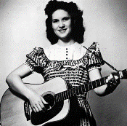
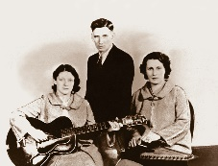
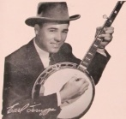
26, 27, 28 & 30 december 2025
Zondag 19:00-20:00 – Waterland Country & Bluegrass
Dinsdag 22:00-23:00 – Noordkop Country
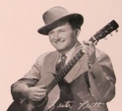
Dinsdag 23:00-24:00 – Noordkop Bluegrass
Zat
erdag 09:00-12:00 – Crossroads Radio

samenstelling, montage & presentatie
Hans van der Veen

De week begint deze keer op donderdag, eerste Kerstdag, want die dag kunt ’s morgens de herhaling van zaterdag horen. Vrijdag, Tweede Kerstdag heb ik 5 uur extra mogen maken, vsn 10:00 tot 15:00.
Ik wens u prettige kerstdagen en een heel Goed, Gelukkig, Gezond, Zonnig, Vreedzaam en Muzikaal nieuwjaar toe!
En veel luisterplezier.
Crossroads Country Radio
Donderdag 25 december, Eerste Kerstdag, 9:00-12:00
Herhaling van zaterdag

Vrijdag 26 december, Tweede Kerstdag, 10:00-11:00
Kerst 2025 extra – 1
Recent verschenen
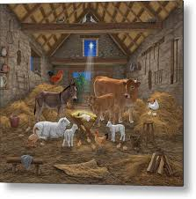
- Williamson Branch Christmas time’s a comin’
- Pentatonix Caroling caroling
- Twangtown Paramounts Waiting for Christmas to come
- Randy C. Moore Born in a barn
- Sascha Happy X-mas, war is over
- Glen Campbell Blue Christmas
- Joy Adams (Nw.Zeel.) The Book
- Mickey Guyton Save a little Christmas for me
- Trisha Yearwood Simple gifts
- Gary R. Farmer (Nw. Zeel.) O Come All Ye Faithful
- Brad Paisley O holy night
- Irene Kelley Gloria in excelsis deo
- Sarah MacLachlan (Can) The Christmas Song
- Batson Haines Santa's Having a Tailgate
- Kelly Colby Mary Did You Know
- Celtic Woman Don Oíche Úd i mBeithil
- LeAnn Rimes Happy Christmas, war is over
- Carpenters Christ is born
- Dylan Scott Two Christmas trees
- Gabby Barrett When Christmas comes to town

Vrijdag 26 december, Tweede Kerstdag, 11:00-12:00
Kerst 2025 extra – 2
Misschien wel de allermooiste Christmas songs
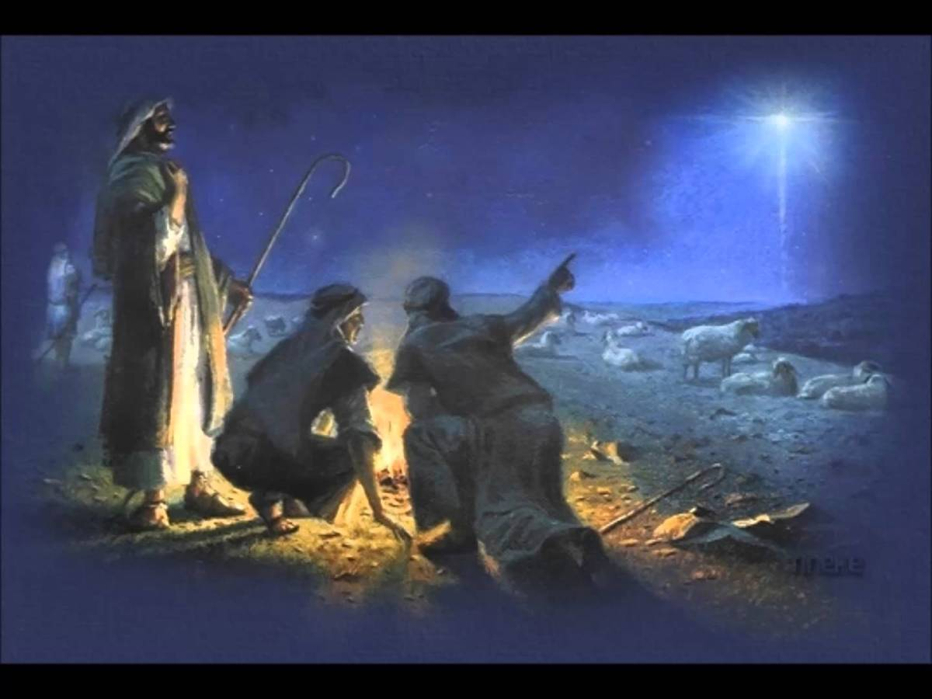

- Forester Sisters A Carpenter, a Mother and a King
- Burl Ives Little Drummer Boy
- Marty Robbins Little stranger (in a manger)
- Neil Diamond Mary's boy child
- Patty Loveless Christmas Day At My House
- Donna Ulisse I See The Light Of The World
- Wayne Warner If I believed in Santa Claus
- Statler Brothers The Carols Those Kids Used To Sing
- John Michael Montgomery December '43
- Joni Harms The Little Gray Donkey
- Emmylou Harris Light of the stable
- Wayne Taylor & friends Silent night
- Darin & Brooke Aldridge Christmas time back home
- Simon & Garfunkel The seven o’clock news
- Louvin Brothers While Shepherds Watched
- Robin & Linda Williams Old toy trains
- Tommy Edwards The Christmas Letter
- John McCutcheon Christmas in the trenches
- Vince Gill It came upon a midnight clear
- Craig Duncan Ding dong merrily on high

Vrijdag 26 december, Tweede Kerstdag, 12:00-13:00
Kerst 2025 extra – 3
Kerst die ik eigenlijk nooit draai
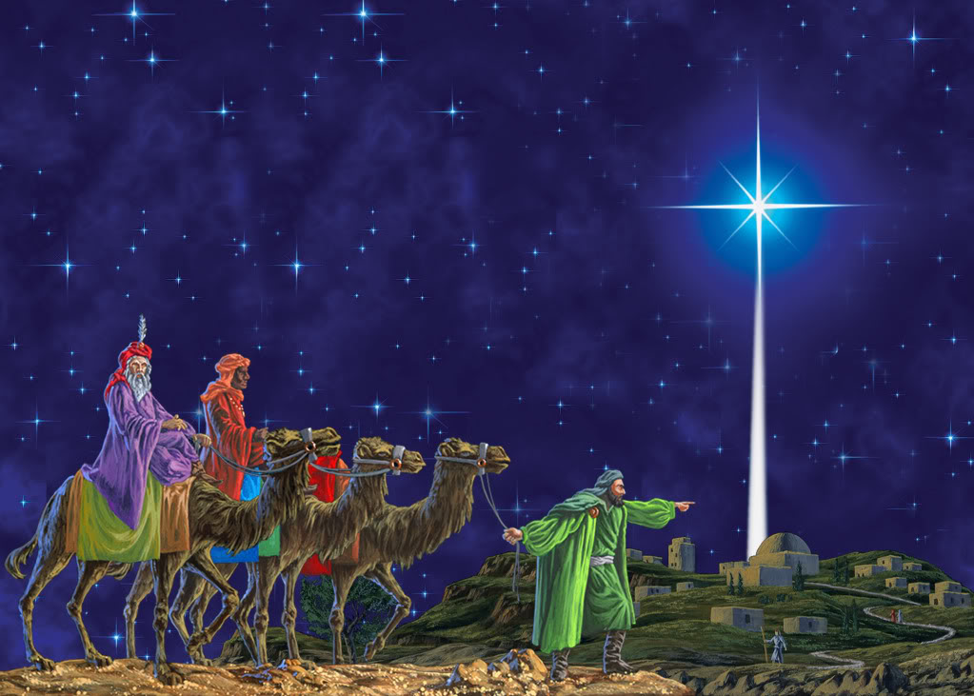

- Chris Roberts & Ashley Campbell It's Christmas
- Brian Blaylock Country Christmas
- Bluegrass Cardinals Little boy from the carpenter shop
- Village Singers Glory days are coming
- Troy Engle Sleepy town of Bethlehem
- Kingston Trio Mary mild
- Trail Band New baby king
- Kevin Williamson Good tidings of great joy
- Tammy Rogers Dancing in the snow
- Flashback The greatest gift
- Steve Ivey Celebrate
- Alica Jones Wall God rest ye merry gentlemen
- Wildwood Valley Boys When it’s snowing in the mountains
- Jimmy Dickens No place like home on Christmas
- Osborne Brothers Christmas time on Rocky Top
- Buddy Melton Carolina Christmas
- Tex Ritter Christmas carols by the old coral
- Theo & Brenna Work on Christmas
- Peter, Paul & Mary Light one candle
- Terry Gordon Give her one for Christmas
- Spinney Brothers Merry Christmas everybody
- Andrew Collins We wish you

Vrijdag 26 december, Tweede Kerstdag, 13:00-14:00
Kerst 2025 extra – 4
Recent verschenen
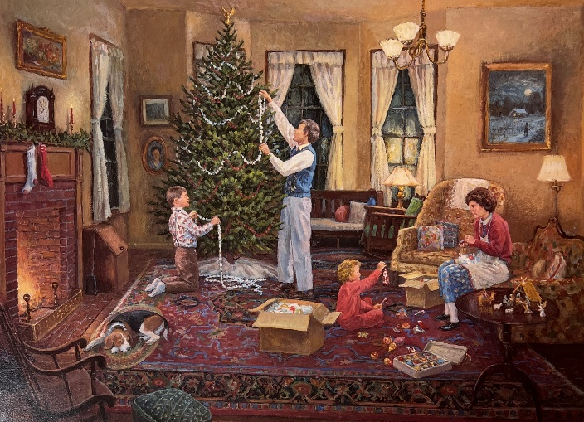

- Spinney Brothers Merry Christmas everybody
- Beers Family The peace carol
- Hubba Deeba Country Candlelit Christmas carol waltz
- McCoury Brothers Bluegrass Christmas
- Hunter Hayes Winter wonderland
- Mark & Maggie O’Connor The holy and the ivy
- Mountain Rio It’s Christmas
- Old Crow Medicine Show December 26
- Jake Shimabukuro Mele Kkalikimaka
- Fallon Franklin God rest ye merry gentlemen
- Jacob Underwood I heard the bells on Christmas day
- Davis Bradley The amazing Johnny Cash Christmas
shoping song
- Kristy Cox Christmas without you
- Buddy & Ina Gore His sweetest gift
- Monroe Crossing Holly jolly Christmas
- Morgan Wade Christmas in my dreams
- Danielle Bradberry O holy night
- Marty Falle The snow sang Hallelujah
- Brett Young Silver bells
- Fiddle Express A Christmas medley

Vrijdag 26 december, Tweede Kerstdag, 14:00-15:00
Kerst 2025 extra – 5
Recent verschenen
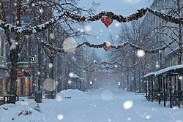

- High Fidelity Christmas time back home
- Abby Anderson No snow in Texas
- Roy Cost Santa bring mommie back to me
- Becky Buller boodschap
- Becky Buller The Savior is born #
- Harp Twins Angels we have heard on high
- Christopher Bonn (?) Bethlehem sky
- Christopher Bonn (?) Ring the Christmas bells
- Hillbilly Thomists On Jordan’s bank
- J.J. Heller -+Christmas every day.
- Sheryl Crowe There’s a star that shines tonight #
- Chris Young Christmas ain’t Christmas
- Tori Martin Jolly old st Nicholas – Hey Santa
- Anthony Baxter Christmas day at Hanging Rock
- Dave Stanley Daoust There Ain't No Jingle Round Here
- Shaun Connery Send my angel back for Christmas
- Brand New Box of Matches Silent night
- Joe Mullins & the Radio Ramblers Because it's Christmas time
- Butch Baldassari Beautiful star of bethlehem #

# niet recent verschenen

Zaterdag 27 december: 09:00-10:00
Herhaling: donderdag 1 januari
Kerst Drie Show (1)
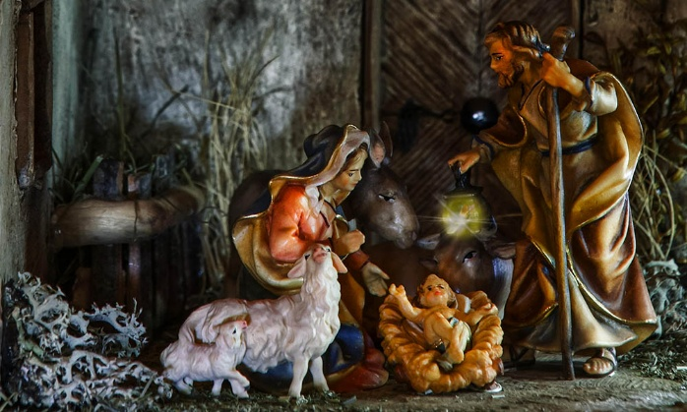

- Patty Loveless Christmas Time's A Comin'
- Donna Ulisse Morning In Bethlehem
- Stroatklinkers (Ned) As snaivlokjes dwarreln
- Lee Kernaghan (Austr) Away In A Manger
- Bobby Bare Christmas In The Eyes Of A Child
- Anna-Lena Löfgren (Zwed) Dotter Sion, fröjda dig
- Royal Guardsmen Snoopy And The Red Baron; Christmas bells
- Vince Gill One Bright Star
- Wilf Carter (Can) Ting-a-Ling-a Jingle
- Emmylou Harris There's a light
- Gene Autry & the Pinafores Rudolph de red nosed reindeer
- Balsam Range I'm Going Home It's Christmas Time
- John Denver Christmas for cowboys
- Lost Highway Christmas eve in the Ozarks
- Mary McCaslin Good King Wenceslas
- Cockman Family In The Stable
- Dolly Parton Christmas On The Square
- Gene Parsons, Joe Craven & Bill Douglas
The First Noel
- Del Mccoury Band Bluegrass Christmas
- Ian McRae & the Joe Gordon Skiffle Group
The Day We Went to Rothsay o
- Kimmie Rhodes Wake up sleepy town
- Charley Pride O holy night

Zaterdag 27 december: 10:00-11:00
Kerst Drie Show (2)
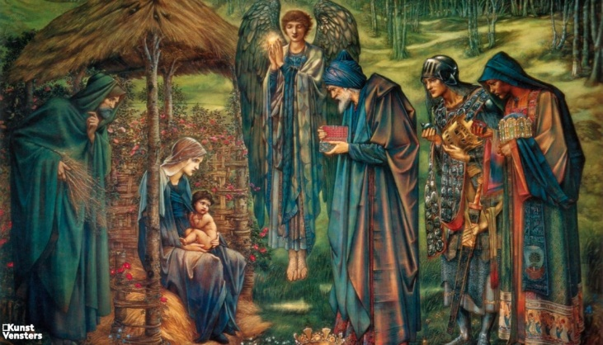

- Peter Rowan Christmas time's a-coming
- The Roys Bluegrass Kinda Christmas
- Claire Lynch Band All Through The Night
- Brothers Four The night is christmas eve
- Amber Digby What Child Is This
- Sonny James A Pocketful Of Mistletoe
- Ralph Stanley Jesus Christ is Born
- Johnny Cash We Are The Shepherds
- Choirs From Russian Religious Orders
Bright Dawn Shines In Heaven
- Bill Carroll To hear the angels sing
- Buck Owens Christmas Morning
- Jimmie Rodgers I Heard the Bells On Christmas Day
- Patty Loveless Little Drummer Boy
- Hugh Moffatt Christmas In The Saddle
- John Denver Mary's Boy Child
- Freddy Fender Christmas In The Valley
- Charley Pride Santa And The Kids
- Slim Dusty Old Time Christmas
- Emmylou Harris O Little Town Of Bethlehem
- Ann & Pete Sibley Gloucester wassail
- Barbara Ray Away in a manger

Zaterdag 27 december: 11:00-12:00
Kerst Drie Show (3)
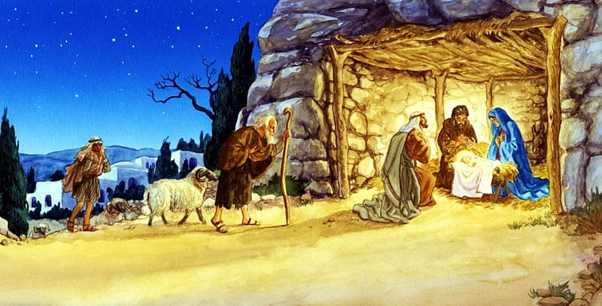

- Dolly Parton Christmas Time's A Comin'
- Jimmy Martin Will We Have Room For Jesus
- Singing Post Family Christmas Cannon Ball
- Statler Brothers While Shepherds Watched Their Flocks
- Wayne Warner If I believed in Santa Claus
- Kate and Anna McGarrigle Ca Bergers
- Patty Loveless Christmas Day At My House
- Carpenters I Heard The Bells On Christmas Day
- Stanley Brothers Christmas Is Near
- Hylo Brown Christmas In The Hills
- Rick Lang Sailing On
- Isla Grant Going Home To Ireland For ChristmAs
- Charlie Moore & Bill Napier My Christmas Dream
- Slim Whitman Hark the herald angels sing
- Johnny Cash Who Kept the Sheep
- Garth Brooks Mary Had a Little Lamb
- Harry Belafonte Mary's boy child
- Iron Horse Looking for Christmas day
- Emmylou Harris Golden craddle
- Dan Fogelberg This endris night
- Marie Laforet Non dirmi cosa pensi
- Vince Gill O holy night
- Floyd Cramer Medley Silent Nigh

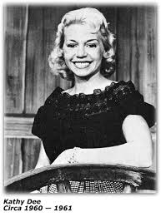
Zondag 28 december, 19:00-20:00
Bij RTV Purmerend
Waterland CB
Vergeten sterren
&
Meiden aan de leiding

Country: Vergeten sterren
- Laverne Downs What have I done
- Lou Smith My name is Lou
- Earl Scott Tonight’s the night for love
- Vernon Stewart You’re not all here
- Kathy Dee Only as far as the door
- Ott Stephens Snow white cloud
- Leroy Pullins World what have I done
- Van Trevor Luziana River
- Robert Mitchum Coconut water
- Jeanne Black Just a little bit lonely
Bluegrass: Meiden aan de leiding
- Valerie Smith Second fiddle to an old guitar
- Rhonda Vincent Keep your feet on the ground
- Alison Krauss Rain please go away
- Emmylou Harris Timberline
- Lynn Morris Gonna have love
- Laurie Lewis Blow big wind
- Claire Lynch Hard times
- Alecia Nugent The last Greyhound
- Hazel Dickens & Alice Gerard The first whippoorwill
- Sally Jones Angels by my side
Bonus:
- Ola Belle Reed Six feet of eart

Dinsdag 30 december, 22:00-23:00
Bij Noordkop 247
Noordkop Country
Beste country songs aller tijden
volgens het tijdschrift Rolling Stone
een selectie van de top-30
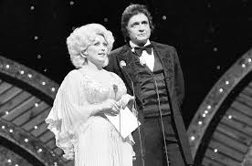
De nummers 1 en 2

- Faron Young Hello Walls (1961)
- Johnny Cash Ring of fire (1963)
- Charlie Rich Behind closed doors (1973)
- Stanley Brothers Man of constant sorrow (1951)
- Kenny Rogers The gambler (1978)
- Charley Pride Kiss an angel good morning (1971)
- Lefty Frizzell If you’ve got the money, I’ve got the time (1950)
- Ernest Tubb Walking the floor over you (1941)
- Buck Owens I’ve got a tiger by the tail (1964)
- Carter Family Can the circle be unbroken (1935)
- Loretta Lynn Coal miner’s daughter (1970)
- Glen Campbell Wichita lineman (1968)
- Kitty Wells It wasn’t God who made honky tonk angels (1952)
- George Strait Amarillo morning (1982)
- Merle Haggard Mama tried (1968)
- Tammy Wynette Sztand by your man (1968)
- George Jones He stopped loving her today (1980)
- Hank Williams I’m so lonesome I could cry (1949)
- Patsy Cline Crazy (1961)
- Johnny Cash I walk the line (1956)
- Dolly Parton Jolene (1973)

Dinsdag 30 december, 23:00-24:00
Bij Noordkop 247
Noordkop Bluegrass
2025 IBMA Industry Award winners
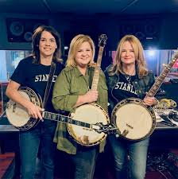
Kristin Scott, Alison brown & Gena britt

- Kristin Scott Benson Sink or swim
- Maddie Denton My window faces the sun
- Sierra Hull Don’t pick me up
- Trey Hensley The old family table
- Justin Moses My baby’s gone
- Della Mae (met Vickie Vaughn) Dry town
- Billy Strings Freedom
- Greg Blake Other side of the world
- Allison Krauss Richmond on the James
- Travelin’ McCourys Lonely night
- Authentic Unlimited Fall in Tennessee
- Red Camel Collective Dear to dream
- Jason Carter & Michael Cleveland Outrun the Rain
- Kristin Scott Benson, Gena Britt & Alison Brown Ralph’s Banjo Special
- Jaelee Roberts He’s gone
- Kody Norris Show The Auctioneer
- Leroy Van Dyke The Auctioneer

De vorige week
Wilt u luisteren naar het programma van de vorige week?
Control+klik op onderstaande links

Zaterdag 20 december, Saturdaymorning C: Kerstshow (1)
https://hans.vdveen.org/muziek/- KERST/- KERST 2025/486x - Saturday morning C-BG - 2025-12-20 - Kerst (1).mp3

Zaterdag 20 december, Saturdaymorning C: Kerstshow (2)
https://hans.vdveen.org/muziek/- KERST/- KERST 2025/486y - Saturday morning C-BG - 2025-12-20 - Kerst (2).mp3

Zaterdag 20 december, Saturdaymorning C: Kerstshow (3)
https://hans.vdveen.org/muziek/- KERST/- KERST 2025/486z - Saturday morning C-BG - 2025-12-30 - Kerst (3).mp3

Zondag 21 december, Waterland CB: Kerstshow (4)
https://hans.vdveen.org/muziek/- KERST/- KERST 2025/486w - Waterland CB - 2025-12-21 - Kerst (4).mp3

Dinsdag 23 december, Noordkop Country: Kerstshow (5)
https://hans.vdveen.org/muziek/- KERST/- KERST 2025/486b - Noordkop Country - 2025-12-23 - Kerst (5).mp3

dinsdag 23 december, Noordkop Bluegrass: Kerstshow (6)
https://hans.vdveen.org/muziek/- KERST/- KERST 2025/486c - Noordkop Bluegrass - 2025-12-23 - Kerst (6).mp3

