Saturdaymorning CB
Waterland CB


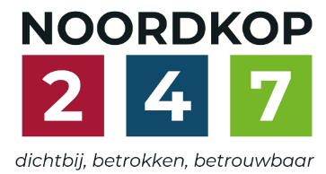
Noordkop Country & Bluegrass

Zaterdag 09:00-12:00: Saturday morning CB
www.Crossroadscountryradio.nl
luisteren kan alleen online via de website.
Herhaling: Donderdag 09:00-12:00
Zondag 19:00-20:00: Waterland CB
https://rtvpurmerend.nl
luisteren online kan via https://rtvpurmerend.nl/radio/live
Dinsdag 22:00-24:00: Noordkop CB
www.regionoordkop.nl
ether: 105.6 en 107.7 FM
luisteren online: www.noordkop247.nl/ live-radio/
Na de uitzending kan het programma worden beluisterd
wanneer u maar wilt, via
http://hans.vdveen.org/muziek/
U vindt daar de uitzendingen van het laatste half jaar, waar u vrij uit kunt kiezen.
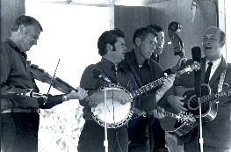

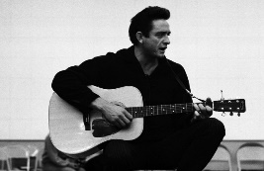
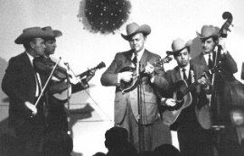
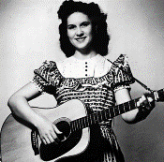
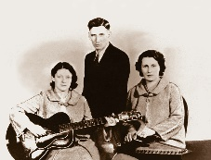
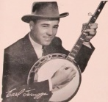
20, 21 & 23 december 2025
Zondag 19:00-20:00 – Waterland Country & Bluegrass
Dinsdag 22:00-23:00 – Noordkop Country
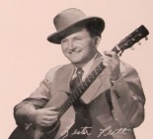
Dinsdag 23:00-24:00 – Noordkop Bluegrass
Zat
erdag 09:00-12:00 – Crossroads Radio

samenstelling, montage & presentatie
Hans van der Veen

Eindelijk is het zo ver. Ik heb de afgelopen dagen al een paar prékerst-shows gedraaid, maar nu komt het echte werk.
Ik krijg waarschijnlijk bij Crossroads Country Radio tijdens de kerstdagen nog wat extra uren. Ik zal daarom proberen de volgende week woensdag mijn nieuwe lijst te versturen.
Na uitzending komen ze allemaal op hans.vdveen.org. Daar staan nu al de programma’s van de afgelopen paar jaar. Voor echte kerstliefhebbers en eenzamen, want die zijn er ook genoeg, en die hebben Flappie en War is Over misschien wel vaak genoeg gehoord…….
Ik wens u prettige kerstdagen!!!!

Zaterdag 20 december
Herhaling: donderdag 25 december
Bij CrossroadsCountryRadio.nl
Saturday morning CB
09:00-10:00: Kerstspecial 93
Crossroads Kerst Show (1)
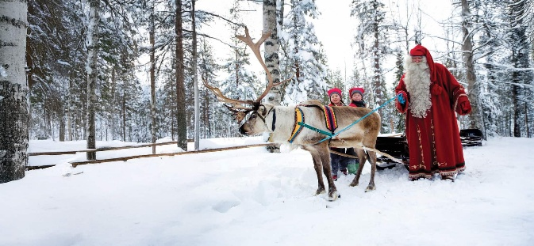

- Bill Anderson Christmas Time's A Comin'
- Donna Ulisse I See The Light Of The World
- Burl Ives Shout The Glad Tidings (Andrew Jackson)
- Ron Block Angels We Have Heard on High
- Statler brothers Somewhere In The Night
- Three Fox Drive Watching Over The Soldiers At Chr
- Irish Rovers Bells Over Belfast
- Dottsy Silver Bells
- Craigh Duncan Ding dong merrily on high
- Bobby Bare Christmas In My Smokey Mountain Home
- Mickey Burke Jesus Is Born In Bethlehem
- New Christy Minstrels Here We Come a-Caroling
- Roger Miller Old toy trains
- Slim Whitman Sleep my child (all through the night)
- Patty Loveless Santa Train
- Johnny Cash I Heard The Bells On Christmas Day
- Dennis Cash The first Christmas tree
- John Denver Christmas for cowboys
- Charlie Cushman We wish you a merry christmas
- Robin & Linda Williams On a quiet Christmas morn
- Kingston Trio The white snow of winter
- Gretchen Peters December child
- Maddy Prior While shepherds watched

10:00-11:00: Kerstspecial 94
Crossroads Kerst Show (2)
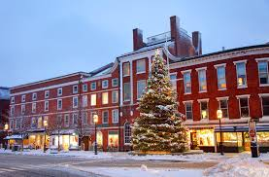

- Emmylou Harris Christmas Times a Coming
- Sonny James The Star Still Shines
- Kitty Wells Country Christmas
- Barry & Holly Tashian Long Long Ago
- Don Williams O Come All Ye Faithful
- Jerry Douglas O Holy Night
- John D. Loudermilk Mary's Boy Child
- Reno & Smiley Frosty The Snowman
- Sandra Mooy Arms of Xmas
- Slim Dusty Christmas, When I Was As Big As You
- Janet _McGarry Two Step Round the Christmas Tree
- Kate and Anna Mcgarrigle Rebel Jesus
- Village Singers A Carpenter, a Mother and a King
- Shenandoah & Marty Raybon There's a Way in the Manger
- Country Gentlemen Jingle Bells
- Jillian Jacqueline Kid at Christmas
- Burl Ives O little town of bethlehem
- R J Moneypenney - Two Thousand Years Ago
- Kitty Wells Old Kris Kringle
- Valerie Smith Shut in at Christmas

11:00-12:00: van Kerstspecial 95
Crossroads Kerst Show (3)
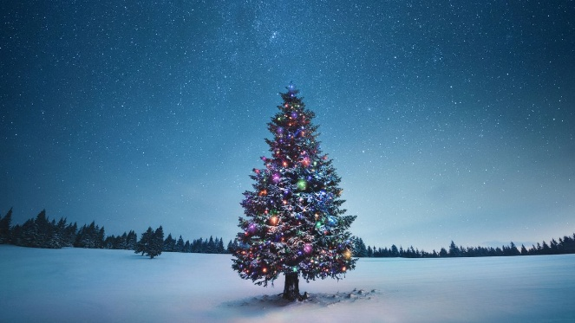

- The Petersens Christmas Time's a-Comin'
- Bill Monroe That's Christmas Time To Me
- The Roys Santa And The Kids
- Mike McAdoo The First Christmas Gift
- Johnny Cash The Gifts They Gave
- Jim Eanes Christmas Doll
- Tommy Edwards The Christmas Letter
- Lettermen Mary's little boy child
- Change of Key Away in a Manger
- Joan Baez Cantique De Noel [Sung In French]
- Irene Kelley Happy birthday little baby Jesus
- Bob Dick More Than a Child
- Brenda Lee A Marshmallow World
- Lorne Buck & friends Will You Remember Christmas
- Suzy & Maggie Roches Here we come a carolling
- John Denver The Children Of Bethlehem
- Carol Singers of the Cheshire Cheese Public House, Derbyshire
The Peace O're the World
- Ewan McColl The Ballad of Jesus Christ
- Amanda Rheaume Jesus joy of man’s desiring
- Jerry Salley Morning in Bethlehem
Red Ellis & Huron Valley Boys - Home for Christmas

Zondag 21 december, 19:00-20:00
Bij RTV Purmerend
Waterland CB
Kerstspecial 96
Waterland Kerst Show
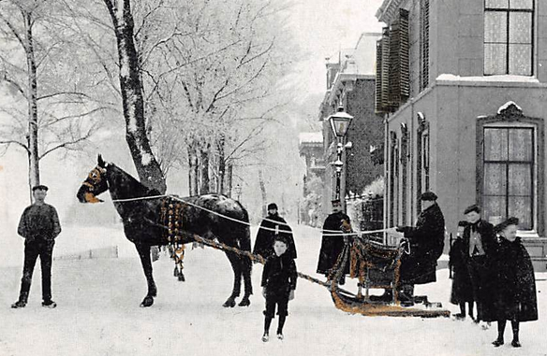

- Greg Craigh Christmas Time's A-Comin'
- Hank Snow The Christmas Cannonball
- Paul Brandt A gift
- Josh Turner Soldier's Gift
- Kate & Ann McGarrigle Il est né
- Maureen Haworth I heard the bells on Christmas day
- Statler brothers Brahm's Bethlehem Lullaby
- Guylaine Tanguay La Bastringue
- Stroatklinkers As ik met kerst de klokken
van Martinitoren heur
- Kingston trio Goodnight My Baby
- Wayne Warner If I believed in Santa Claus
- Ron Block Brightest and Best (Star in the East)
- Marty Robbins Little Stranger (In A Manger)
- John Prine Christmas in Prison
- Dolly Parton O little town
- Donna Ulisse & Rick Stanley All the way to Bethlehem
- Vin Bruce Christmas on the Bayou
- Self Rising Flour Santa Gave Me A Banjo
- Melba Montgomery Hark the herald angels sing
- Bobby Bare What a merry Christmas this would be

Dinsdag 23 december, 22:00-23:00
Bij Noordkop 247
Noordkop Country
Kerstspecial 97
Noordkop Kerst Show
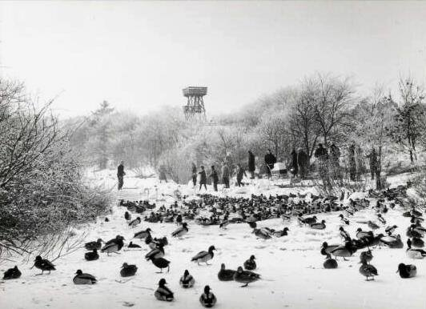

- Christmas Grass Christmas Time's A Comin'
- Louie Setzer Christmas In Tennessee
- Rick Lang & friends A seasons’s greating
- Jody Adams Goin' To Grandma's House
- John McCutcheon Christmas in the trenches
- Emmylou Harris Beautiful Star of Bethlehem
- Doug Smith Ding dong merrily on high
- Balsam Range Christmas Lullaby
- Johnny Horton They shined up rudolph's nose
- Jim Reeves C-H-R-I-S-T-M-A-S
- Sandy Posey I heard the bells on Christmas day
- Rhonda Vincent Jingle Bells
- Statler brothers I Never Spend a Christmas
That I Don't Think of You
- Jim Croce It Doesn't Have To Be That Way
- Elisabeth Andreassen Na tennes tusen julelys
- Pete Seeger 't Was on a night like this
- Ralph Stanley I en II Christmas time
- Lulu Belle & Scotty The Empty Christmas Stocking
- Stonewall Jackson Mammy Look, Santa Is Crying
- Carpenters O come Emmanuel
- Cash Family Christmas with you
- Mary Kaye Goin Home For Christmas

Dinsdag 23 december, 23:00-24:00
Bij Noordkop 247
Noordkop Bluegrass
Kerstspecial 98
Noordkop Kerst Show
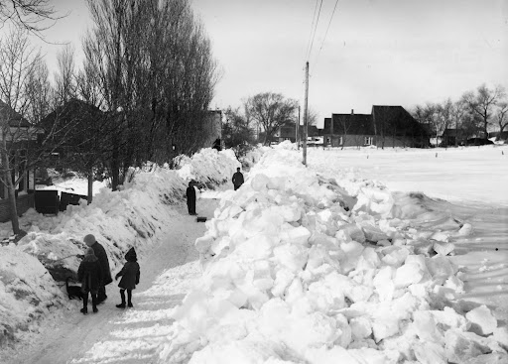

- James Monroe Christmas Time's A Comin'
- Ralph Stanley I'm Goin' Home, It's Christmas Time
- Crystal Gayle Little Drummer Boy
- Jim Reeves Silent Night
- Ron Block Gentle Annie
- Stompin' Tom Connors Christmas Angel
- Country Gentlemen Christmas time back home
- Brothers Four The borning day
- Betty Jean Robinson - Joy to the world
- Nial Toner Waltzing at Christmas
- Statler Brothers Who Do You Think
- Kingstonm Trio Follow Now, Oh Shepherds
- Joni Harms Christmas In The Country
- Dusty Springfield Bambino
- Bob & Annelies van Pottelbergh& vrienden
How Far Is't to Bethlehem
- Special Consensus Go Tell It On The Mountain
- Joan Morrissey Christmas In Killarney
- Blue Diamonds The Shepherds Song
- Earl Scruggs Jingle bells
- Slim Dusty Old time Christmas
- Floyd Cramer Medley

De vorige week
Wilt u luisteren naar het programma van de vorige week?
Control+klik op onderstaande links

Zaterdag 13 december, Saturdaymorning C: Randy Scruggs
https://hans.vdveen.org/muziek/XYZ - CROSSROADS COUNTRY RADIO - Country/485x - Saturday morning Country - 2025-12-13 - Randy Scruggs.mp3

Zaterdag 13 december, Saturdaymorning C: Banjo (2)
https://hans.vdveen.org/muziek/XYZ - CROSSROADS COUNTRY RADIO - Bluegrass/485z - Saturday morning Bluegrass - 2025-12-13 - Bluegrass uit 1963 (3).mp3

Zaterdag 13 december, Saturdaymorning C: De singles van 1963 (3)
https://hans.vdveen.org/muziek/XYZ - CROSSROADS COUNTRY RADIO - Country/484z - Saturday morning Country - 2025-12-06 - de keus van Thieu.mp3

Zondag 14 december,Waterland CB: Pré Kerst Show - 1
https://hans.vdveen.org/muziek/- KERST/- KERST 2025/485w - Waterland CB - 2025-12-14 - Pr%c3%a9 kerst show (1).mp3

Dinsdag 16 december, Noordkop Country: Pré Kerst Show - 2
https://hans.vdveen.org/muziek/- KERST/- KERST 2025/485b - Noordkop Country - 2025-12-16 - Pr%c3%a9 kerst show (2).mp3

dinsdag 16 december, Noordkop Bluegrass: Pré Kerst Show - 3
https://hans.vdveen.org/muziek/- KERST/- KERST 2025/485c - Noordkop Bluegrass - 2025-12-16 - Pr%c3%a9 kerst show (3).mp3

