Saturdaymorning CB
Waterland CB


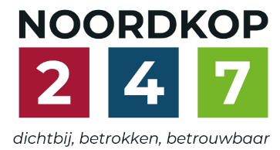
Noordkop Country & Bluegrass

Zaterdag 09:00-12:00: Saturday morning CB
www.Crossroadscountryradio.nl
luisteren kan alleen online via de website.
Herhaling: Donderdag 09:00-12:00
Zondag 19:00-20:00: Waterland CB
https://rtvpurmerend.nl
luisteren online kan via https://rtvpurmerend.nl/radio/live
Dinsdag 22:00-24:00: Noordkop CB
www.regionoordkop.nl
ether: 105.6 en 107.7 FM
luisteren online: www.noordkop247.nl/ live-radio/
Na de uitzending kan het programma worden beluisterd wanneer u maar wilt, via
http://hans.vdveen.org/muziek/
U vindt daar de uitzendingen van het laatste half jaar, waar u vrij uit kunt kiezen.
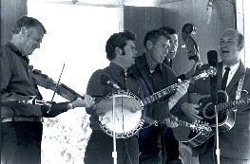

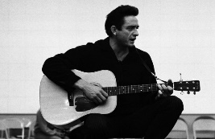
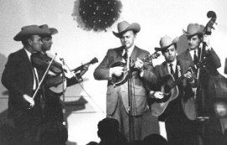
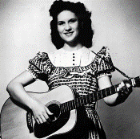
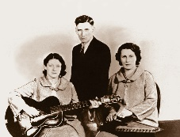
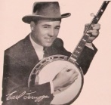
13, 14 & 16 december 2025
Zondag 19:00-20:00 – Waterland Country & Bluegrass
Dinsdag 22:00-23:00 – Noordkop Country
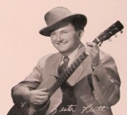
Dinsdag 23:00-24:00 – Noordkop Bluegrass
Zaterdag 09:00-12:00 – Crossroads Radio

samenstelling, montage & presentatie
Hans van der Veen

De Kerstdagen komen nu toch wel erg dicht bij. Zaterdag is het programma nog algemeen, maar zondag is al de eerste pré-kerst-show te horen. Voor de liefhebbers: ik heb voor dit jaar maar liefst 16 uur klaar staan, en het zou best nog eens kunnen dat het er 17 worden. In totaal heb ik er nu 105 gemaakt, toch ook wel een beetje gekkigheid natuurlijk.
Maar wie weet komt Santa Claus dit jaar wel met een lege slee en neemt hij dit jaar wel alle ellende mee die we hier op aarde hebben.
Veel luisterplezier!!

Zaterdag 13 december
Herhaling: donderdag 18 december
Bij CrossroadsCountryRadio.nl
Saturday morning CB
09:00-10:00: Country & Bluegrass
Randy Scruggs


- Gary & Randy Scruggs Black mountain rag
- Gary & Randy Scruggs The lowlands
- Earl Scruggs Review Bye bye love
- Flatt & Scruggs Randy Lynn Rag
- Emmylou Harris & Randy Scruggs Wildwood flower
- Randy Scruggs Both sides now
- Tom T. Hall Chattanooga dog
- John Hartford Doin’ my time
- Marty Stuart You can walk all over me
- Ricky Skaggs All I ever loved was you
- Charlie Daniels Maggie’s farm
- Nitty Gritty Dirt Band Will the circle be unbroken
- Dolly Parton Coat of many colors
- George Jones & Tammy Wynette They’re playing our song
- Flatt & Scruggs Don’t think twice it’s all right
- Pam Gadd Acoustisizer
- Loretta Lynn On my own again
- Emmylou & NGD Band Oh Cumberland
Bonus
- Waylon Jennings Lisa’s only seven
- Randy Scruggs & Mary Chapin Carpenter It's Only Love
- Dale Ann B radley Passin thru

10:00-11:00: Bluegrass
Bluegrass Banjo (2)
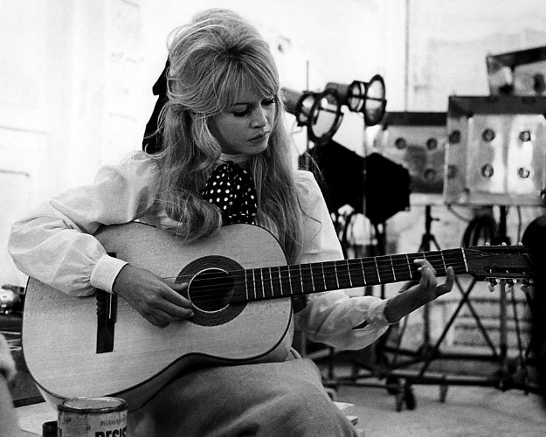
BB speelt gitaar

- Brigitte Bardot Sidonie (fragment)
- Stringbean Hey old man (fragment)
- Jan & Kjeld Banjo Boy (fragment)
- Songs From The Road Band Banjo pickin’ truck drivin’ farmer
- Oren Jenkins Hey mr. Banjo
- Wade Mainer Gonna lay down my old banjo
- Don Reno & Red Smiley & Ten CU Banjo Special
- Osborne Brothers The banjo boys
- Dan Crary Banjo signal
- Bill Emerson Grandpa Emory’s banjo
- Dillards Banjolina
- Crowe Brothers Legend of Smoky Mountain Banjo
- Carl Story Banjo on the mountain
- Spinney Brothers “Gitup”, the banjo man
- Kentucky Colonels Mockin’ banjo
- Betty Amos & Judy & Jean Pennsylvania banjo
- Eddie Adcock Sing, banjo sing
- Larry Stephenson Me and my old banjo
- Jim & Jennie & the Pinetops Banjo Boy Chimes
- Grandpa’s Cough Medicine A song for bass and banjo
- Doyle Lawson Tennessee banjo man
- Bluegrass Travelers Banjo stretch
- Foggy Bottom Fiddle and an old banjo
- Buzz Busby Talking banjo
Bonus
- Flatt & Scruggs Mocking banjo
- Bradley Kincaid How the banjo was invented
- Louisiana Lou With my banjo on my knee

11:00-12:00: Bluegrass
Bluegrass uitgebracht in 1963 (3)
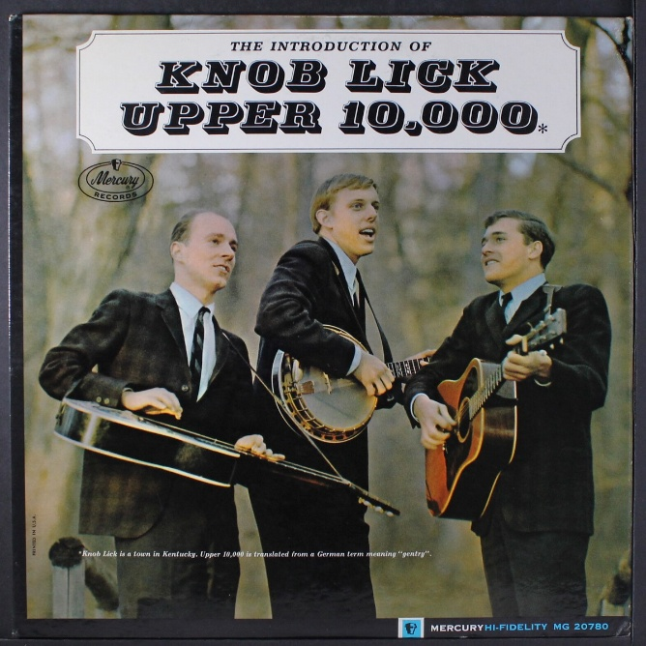

- Red Allen & Frank Wakefield Little Birdie
- Flatt & Scruggs Pearl, Pearl, Pearl
- Stanley Brothers Six months ain’t long
- Country Gentlemen Copper Kettle
- Jim & Jesse Las Cassas Tennessee
- Rose Lee & Joe Maphis Maple on the hill
- Benny & Vallie Cain Angel band
- Yates brothers & Bill Emerson Love’s change again
- Osborne Brothers Lovely told me goodbye
- Roy Acuff Once more
- Nelson Young Burning bridges
- Knob Lick Upper 10.000 Train 45
- Charlie Tomlinson & Billy Baker & the Shady Valley Boys
Baker’s hornpipe
- Dillards Polly Vaughn
- Dixie Gentlemen What can I say
- Green River Boys Divorce me C.O.D.
- Charlie Moore & Bill Napier In a world of broke hearts
- Curly Dan, Wilma Ann & the Danville Mountain Boys
South on no 23
- Windy Mountain Boys High, wide and handsome
- Fred Richardson & Monroe Fields & the Mississippi Travelers
Locked away
- Bill Clifton The sinking of the Maine
- Red Allen Faded memory
- Carter Family Two sweethearts
- Adrian Farmer (Ned) Blue eyes (niet uit 1963)

Zondag 14 december, 19:00-20:00
Bij RTV Purmerend
Waterland CB
Waterland Pré Kerst Show (1)
(Kerstspecial 90)
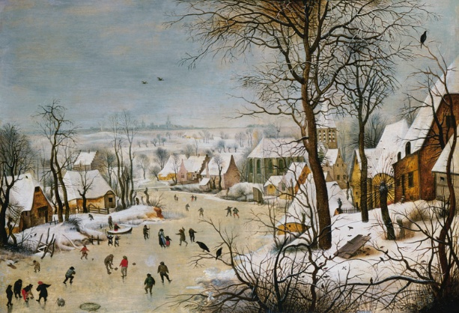

- Antique Persuasion Christmas time’s a-comin’
- Russell Moore Christmas is near
- Wilf Carter (Can) The Night Before Christmas In Texas That Is
- Dailey & Vincent (feat. Dolly Parton)
Road to Bethlehem
- Sheryl Crow There Is A Star That Shines Tonight
- Statler Brothers Carols those kids used to sing
- The Johnson Mountain Boys The Friendly Beasts
- Vince Gill A cradle in Bethlehem
- Tammy Rogers & Thomm Jutz
Welcome the baby
- Doyle Lawson Christmas lullaby
- Louvin Brothers While Shepherds Watched Their Flocks
- Marty Robbins O little town of Bethlehem
- Appalachian instruments I saw three ships
- Buck Owens & Susan Raye Tomorrow is Christmas day
- Anne Murray O Holy Night
- Emmylou Harris Cherry tree carol
- Peter, Paul & Mary & New York Choral Singers
We wish you a merry Christmas
- Tammy Wynette One happy Christmas
- Lee Ann Womack Nothing But A Child

Dinsdag 16 december, 22:00-23:00
Bij Noordkop 247
Noordkop Country
Noordkop Pré Kerst Show (2)
(Kerstspecial 91)
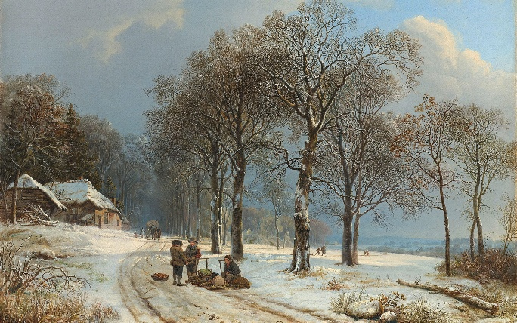

- Bates Family Christmas Time's A Comin
- Johnny Cash Hark the Herald Angels Sing
- Jesse Lee Campbell Angels We Have Heard On High
- Ball Sisters Band What child is this
- John Michael Montgomery December 1943
- Southern Dogwood In Bethlehem
- Statler Brothers The Carols Those Kids USed To Sing
- Walter Brennan A Farmer's Christmas Prayer
- Weavers Poor little Jesus
- Jimmy Dickens No Place Like Home For Christmas
- Connie Francis Baby's first Christmas
- Bobby Bare Daddy, Would You Tell Me About Jesus
- Change of Keys Dear footprints in the snow
- David Houston Silent night
- Joni Harms The Little Gray Donkey
- Stonemans Let's Put Christ Back Into Christmas
- Butch Baldassari O holy night - instr
- Faron Young Happy Birthday Jesus
- John Denver Please, Daddy (Don't Get Drunk
This Christmas)
- Johnny Cash Little drummer boy
- Loretta Lynn Good old country Christmas

Dinsdag 16 december, 23:00-24:00
Bij Noordkop 247
Noordkop Bluegrass
Noordkop Pré Kerst Show (3)
(Kerstspecial 92)
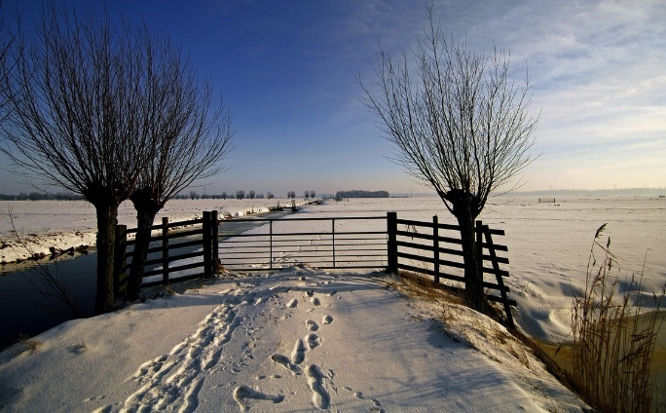

- Bill Monroe Christmas Time's a-Comin'
- Tommy Edwards The Christmas train is coming
- Jim Reeves Senor Santa Clause
- Hank Snow Little stranger
- Jeannie Kendall Smoky Mountain Christmas
- Petula Clark Il Est Ne Le Divin Enfant [version one]
- Larry Sparks The Birthday Of Our King
- Emmylou Harris Light Of The Stable
- Connie Smith Joy to the world
- Bill Carroll Slowly Fall The Snowflakes
- Becky Buller Our Gingerbread House
- Charley Pride Christmas And Love
- Georgette Jones Lonely Christmas Call
- Slack Family Bluegrass Band Hillbilly Santa Claus
- Spinners The Twelve Days of Christmas
- Stompin' Tom Connors An Orphan’s Christmas
- Randall Franks & the Whites Let's Live Every Day Like It Was Christmas
- Everly Brothers God rest ye merry gentlemen
- Jack Cooke & Ralph Stanley Just a moment now to pray
- Bluegrass Brethern Almost Christmas Time
- Johnny Cash Ringing the bells for JIm
- Statler Brothers An Old Fashioned Christmas

De vorige week
Wilt u luisteren naar het programma van de vorige week?
Control+klik op onderstaande links

Zaterdag 6 december, Saturdaymorning C: Jim Reeves tributes
https://hans.vdveen.org/muziek/XYZ - CROSSROADS COUNTRY RADIO - Country/484x - Saturday morning Country - 2025-12-06 - Jim Reeves tributes.mp3

Zaterdag 6 december, Saturdaymorning BG: Bluegrass singles uit 1963 (2)
https://hans.vdveen.org/muziek/XYZ - CROSSROADS COUNTRY RADIO - Bluegrass/484y - Saturday morning Bluegrass - 2025-12-06 - Bluegrass uit 1963.mp3

Zaterdag 6 december, Saturdaymorning C: De keus van Thieu
https://hans.vdveen.org/muziek/XYZ - CROSSROADS COUNTRY RADIO - Country/484z - Saturday morning Country - 2025-12-06 - de keus van Thieu.mp3

Zondag 7 december, Waterland CB: Zondag
https://hans.vdveen.org/muziek/W - WATERLAND CB/484w - Waterland CB - 2025-12-07 - Zondag.mp3

Dinsdag 9 december, Noordkop Country: Betty Sue Perry
https://hans.vdveen.org/muziek/B - NOORDKOP COUNTRY/484b - Noordkop Country - 2025-12-09 - Betty Sue Perry.mp3

dinsdag 9 december, Noordkop Bluegrass: Grootmoeder
https://hans.vdveen.org/muziek/C - NOORDKOP BLUEGRASS/484c - Noordkop Bloegrass - 2025-12-09 - Grootmoeder.mp3

