Saturdaymorning CB
Waterland CB


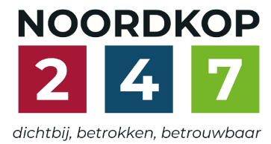
Noordkop Country & Bluegrass

Zaterdag 09:00-12:00: Saturday morning CB
www.Crossroadscountryradio.nl
luisteren kan alleen online via de website.
Herhaling: Donderdag 09:00-12:00
Zondag 19:00-20:00: Waterland CB
https://rtvpurmerend.nl
luisteren online kan via https://rtvpurmerend.nl/radio/live
Dinsdag 22:00-24:00: Noordkop CB
www.regionoordkop.nl
ether: 105.6 en 107.7 FM
luisteren online: www.noordkop247.nl/ live-radio/
Na de uitzending kan het programma worden beluisterd wanneer u maar wilt, via
http://hans.vdveen.org/muziek/
U vindt daar de uitzendingen van het laatste half jaar, waar u vrij uit kunt kiezen.
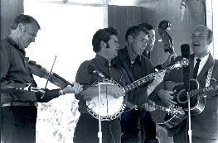

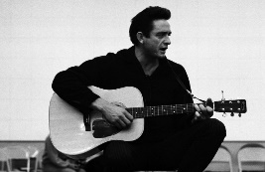
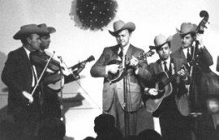
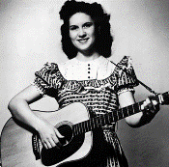
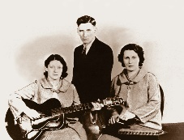
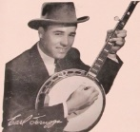
6, 7 & 9 december 2025
Zaterdag 09:00-12:00 – Crossroads Radio
Zondag 19:00-20:00 – Waterland Country & Bluegrass
Dinsdag 22:00-23:00 – Noordkop Country
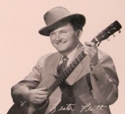
Dinsdag 23:00-24:00 – Noordkop Bluegrass

samenstelling, montage & presentatie
Hans van der Veen

Zaterdag 6 december…. Ik had wel een uurtje met allemaal Sinten kunnen maken. Ik heb in 2017 eens een paar uur gevuld over Sint Maarten en een paar weken later over Sinterklaas, maar dat is iedereen toch vergeten. Maar volgend jaar valt 5 december op een zaterdag, dus komt het dan nog beter van pas.
Belangrijker is wat we wél hebben: Jim Reeves tributes, ouwe Bluegrass, de keus van mijn goede vriend Thieu van de Vorst. Daar blijf ikzelf de zaterdagochtend voor thuis. Maar zondag en dinsdag is het ook de moeite waard, hoor.
Veel luisterplezier!!

Zaterdag 6 december
Herhaling: donderdag 11 december
Bij CrossroadsCountryRadio.nl
Saturday morning CB
09:00-10:00: Country
Tribute to Jim Reeves
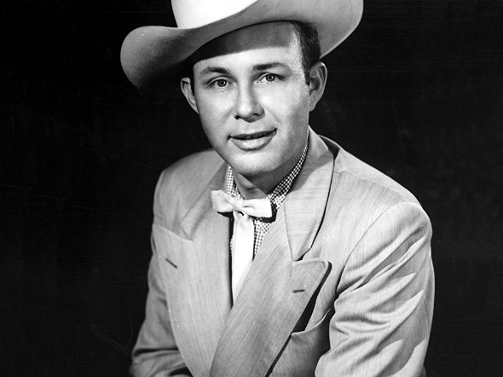

- Loretta Lynn I won’t forget you
- Carolyn Bradshaw (The marriage of) Mexican Joe
- Sonny James Bimbo
- Bill Anderson Yonder comes a sucker
- Jim Reeves Waltzing on top of the world
- Hank Locklin Anna Marie
- Roger Miller Billy Bayou
- Chris Coole & Ivan Rosenberg A fool such as I
- Katie Laur Band He’ll have to go
- Del Reeves Stand at your window
- Webb Pierce Am I Losing You
- Burl Ives The blizzard
- Kristin Scott Danny boy
- Jim Reeves Blue Boy
- Daryl Mosley & Tim Graves Blue side of lonesome
- Rick Nelson Welcome to my world
- Hank Snow Adios Amigo
- Charley Pride I’m gonna change everything
- Faron Young Is this me
- Arne Benoni & Blue Boys I guess I’m crazy
- Kitty Wells Is it really over
- Wilburn Brothers Distant drums
- Hank Locklin I love you because
- Charley Pride There’s a heartache
- Jurrie Els But you love me daddy

10:00-11:00: Bluegrass
Bluegrass singles uit 1963 (2)
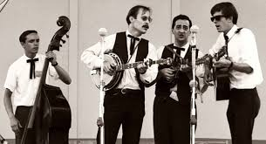
Charles River Valley Boys

- Benny Martin Down in the shinnery
- Bill Monroe Danny boy
- Stanley Brothers He went to sleep and the hogs ate him
- Country Gentlemen Ain’t gonna work tomorrow
- Lonesome Pine Fiddlers Hello Mr. Banjo
- Carter Family Jimmie Brown the newsboy
- Wilma Lee & Stoney Cooper Satisfied
- Bluegrass Partners One little tear for me
- Carl Story Rank strangers
- Dian James & the Greenbriar Boys
Brown’s Ferry Blues
- Rose Lee & Joe Maphis Whiskey is the devil
- Benny & Vallie Cain Ragtime Annie
- Dillards Dooley
- Mike Miller & Jack Casey & the Star Mountain Boys
Blue grass country
- Knob Lick Upper 10.000 The cuckoo
- Tip Sharp (met J D Crowe) When the blue grass is covered
with snow
- Elvin Rooks & the Blue Grass Ramblers
Salty dog blues
- Charles River Valley Boys Rocky island
- Mac Wiseman Your best friend and me
- Hylo Brown Take a Look at that rain
- Frank Wakefield & Red Allen Musicians waltz
- Jimmie Skinner Yesterday’s wrong

11:00-12:00: Country
De keus van Thieu van de Vorst
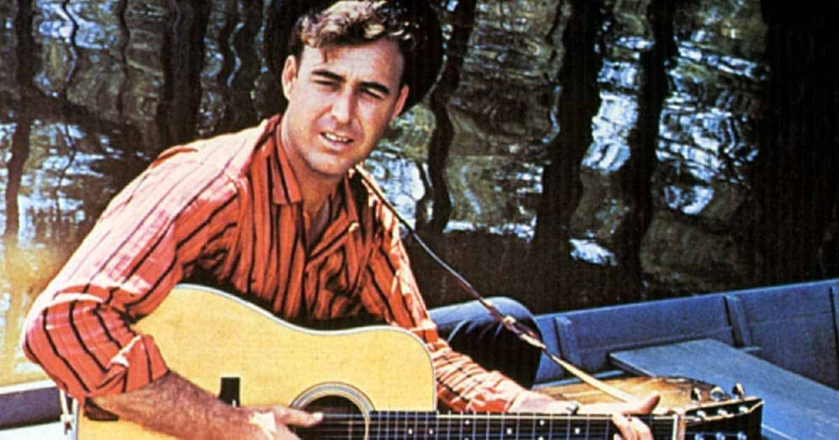
Johnny Horton

- Kitty Wells It wasn’t God who made honky tonk angels
- Connie Smith Once a day
- Linda Ronstadt (& ELH) I can’t help it
- Dolly Parton Coat of many colors
- Rose Maddox Sing a little song of heartache
- Emmylou Harris Two more bottles of wine
- Hank Williams Cold cold heart
- Delmore brothers Blues stay away from me
- John D. Loudermilk Blue train
- Frankie Miller Blackland Farmer
- Burl Ives A little bitty tear
- Louvin Brothers When I stop dreaming
- Bill Clifton Bringing Mary home
- Ned Miller Do what you do do well
- Carl Smith Hey Joe
- Hank Snow The rhumba boogie
- Johnny Horton North to Alaska
- Johnny Cash (& RC & EB) Ballad of a teenage queen
- George Hamilton IV Abilene
- Flatt & Scruggs The ballad of Jed Clampett
- Marty Robbins Singing the blues
- Jim Reeves Mexican Joe
- Buck Owens Sam’s place
- Cowboy Copas Alabam
- Dave Dudley Six days on the road

Zondag 7 december, 19:00-20:00
Bij RTV Purmerend
Waterland CB
Zondag
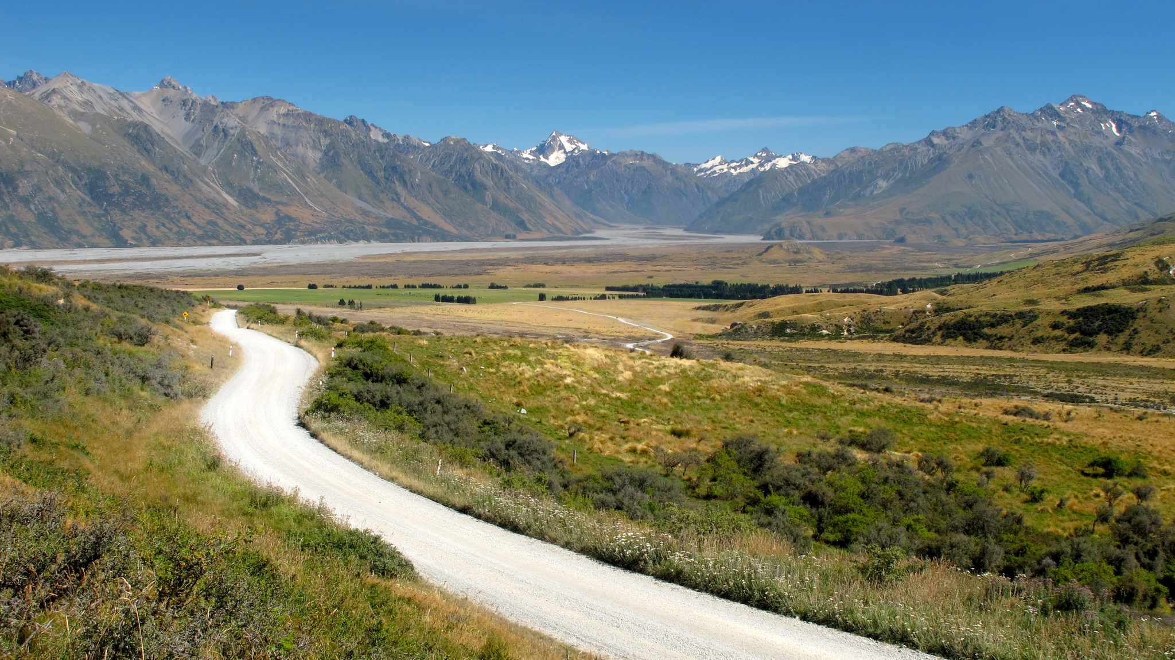
Molunt Sunday, Nieuw Zeeland

- David Olney Saturday night and Sunday morning
- Arlene Harden Country Sunday
- Roland White Band Sunday Sunrise
- Connie Smith & Nat Stuckey Sunday Morning
- Darrell Scott It must be Sunday
- Country Fried Grass Must Be Sunday Morning
- Kris Kristofferson Sunday Mornin' Comin' Down
- Charlie Moore Next Sunday is my birthday
- Country Gazette Roses For A Sunday Morning
- Cranford Nix & Frank Buchanan
Sweet 16 Next Sunday
- Harry Cox Seventeen Come Sunday
- Osborne Brothers Will You Visit Me On Sundays
- Sullivan Family I'll Meet You In Church Sunday Morning
- Wat deed Dolly op zondag?
- Privette Family Bluegrass Sunday Porch Picking’
- Oscar Brand (Can) Sunday School
- Kitty Wells Singing on Sunday
- Justin Tubb As Long As There's A Sunday
- Jim & Jesse Never On Sunday
- Looping Brothers (Dl) We all smell good on Sundays

Dinsdag 9 december 22:00-23:00
Bij Noordkop 247
Noordkop Country
Songs written by
Betty Sue Perry
(4-6-1935 – 21-10-1974)
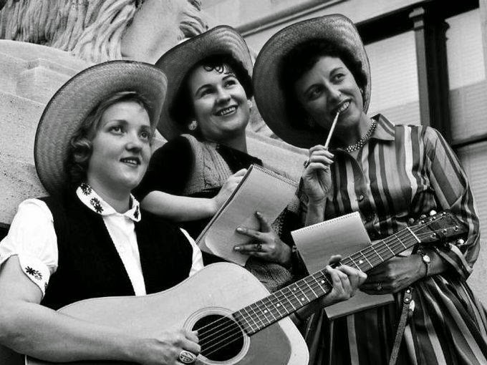
Drie songwriters uit de jaren ’50 en ’60:
Anita McCune, Betty Sue Perry en Jody Bancino

- Kitty Wells The man I used to know
- George IV The wrong side of the tracks
- Bobby Helms Lonely river Rhine
- Porter Wagoner My greatest weakness
- Wilburn brothers Young but true love
- Hank Locklin Before I'm over You
- Hamilton County Bluegrass Band - Roll Muddy River
- Loretta Lynn The beginning of the end
- Loretta Lynn The other woman
- Ann Breen Medals for Mother(s)
- Wilburn Brothers Something about you
- Patty Loveless Wine, Women and Song
- Loretta Lynn Go on and go
- Skeeter Davis Ask me
- Connie Smith It’s just my luck
- Eddie Bond I can’t fight this much longer
- The Osborne Brothers Hey, Hey Bartender
- Jean Stafford (Austr) The Home You're Tearin' Down
- Jean Shepard Our past is in my way
- Dave Woolum & Laural County Partners (Sandy Kaye)
Saint to a sinner
- Loretta Lynn & Ernest Tubb The thin grey line
- Loretta Lynn Six feet of sod
Bonus:
- Farm Hands Medals for mother

Dinsdag 9 december, 23:00-24:00
Bij Noordkop 247
Noordkop Bluegrass
Grootmoeder


- Pearly “Grandma” Davis Old-time reel
- The Boohers Grandma’s song
- Joe Maphis & Merle Travis Grandma’s favorites
- The Barfields Grandma’s kitchen table
- Wilma Lee & Stoney Cooper Grandma’s diary
- Billy Jacobs Grandma’s quilt
- Wayne Raney Grandma’s mini skirt
- Dale Ann Bradley Grandma’s gift
- Sandy Shortridge Grandma’s gate
- The Tylers Grandma’s bible
- Wood Family Tradition Grandma’s bowl
- Tallgrass Express String Band Grandma’s flat tire
- New Tradition Grandma’s garden
- Village Singers Grandma whistled
- Jody Adams Seeing grandma’s driveway from here
- Muddy River Boys My grandma’s home
- Osborne Brothers Tell it to your old grandma
- Leroy Mack Grandma’s feather bed
- Bill Emerson & Sweet Dixie Grandma’s tattoos
Bonus
- Crowe Brothers Grandma’s little cabin
- Nothin Fancy Grandma bought a hog
- Leroy Eyler & the Carroll Count Ramblers - Grandma And Me
- Rugged Little Thing Grandma’s farm
- Brad Apple Grandma danced with the Arkansas traveler
- Heidi & Ryan Grandma’s knees

De vorige week
Wilt u luisteren naar het programma van de vorige week?
Control+klik op onderstaande links

Zaterdag29 november uur 1, Saturdaymorning C: Country Judy (2)
https://hans.vdveen.org/muziek/XYZ - CROSSROADS COUNTRY RADIO - Country/483x - Saturday morning Country - 2025-11-29 - Judy.mp3

Zaterdag 29 november uur 2, Saturdaymorning BG: Banjo (1)
https://hans.vdveen.org/muziek/XYZ - CROSSROADS COUNTRY RADIO - Bluegrass/483y - Saturday morning Bluegrass - 2025-11-29 - Banjo (1).mp3

Zaterdag 29 november uiue 3. SaturdaymorningBG: Singles van 1963 (1)
https://hans.vdveen.org/muziek/XYZ - CROSSROADS COUNTRY RADIO - Bluegrass/483z - Saturday morning Bluegrass - 2025-11-29 - BG singels uit 1963 (1).mp3

Zondag 30 november, Waterland CB: November
https://hans.vdveen.org/muziek/W - WATERLAND CB/483w - Waterland CB - 2025-11-30 - November.mp3

Dinsdag 2 december, Noordkop Country: Wayland Holyfield (6)
https://hans.vdveen.org/muziek/B - NOORDKOP COUNTRY/483b - Noordkop Country - 2025-12-01 - Wayland Holtfield (6, slot).mp3

dinsdag 2 december, Noordkop Bluegrass: moeders
https://hans.vdveen.org/muziek/C - NOORDKOP BLUEGRASS/483c - Noordkop Bluegrass - 2025-12-01 - Moeders.mp3

