Saturdaymorning CB
Waterland CB


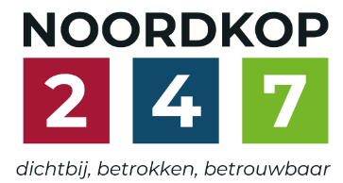
Noordkop Country & Bluegrass

Zaterdag 09:00-12:00: Saturday morning CB
www.Crossroadscountryradio.nl
luisteren kan alleen online via de website.
Herhaling: Donderdag 09:00-12:00
Zondag 19:00-20:00: Waterland CB
https://rtvpurmerend.nl
luisteren online kan via https://rtvpurmerend.nl/radio/live
Dinsdag 22:00-24:00: Noordkop CB
www.regionoordkop.nl
ether: 105.6 en 107.7 FM
luisteren online: www.noordkop247.nl/ live-radio/
Na de uitzending kan het programma worden beluisterd wanneer u maar wilt, via
http://hans.vdveen.org/muziek/
U vindt daar de uitzendingen van het laatste half jaar, waar u vrij uit kunt kiezen.
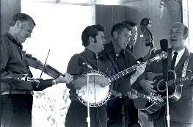

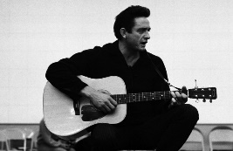
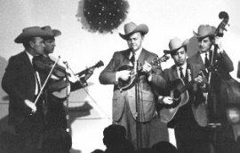
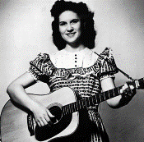
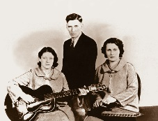
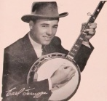
29 & 30 november, 2 december 2025
Zondag 19:00-20:00 – Waterland Country & Bluegrass
Dinsdag 22:00-23:00 – Noordkop Country
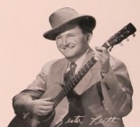
Dinsdag 23:00-24:00 – Noordkop Bluegrass
Zaterdag 09:00-12:00 – Crossroads Radio

samenstelling, montage & presentatie
Hans van der Veen

Spannende tijden voor wie nog in Sinterklaas gelooft en voor de liefhebbers van Goede Muziek, want wat zal er deze week weer tussen zitten. Ach, kijkt u maar in de lijst.
Mocht u de afgelopen week een oud programma willen beluisteren van Waterland CB, dan kwam u van een koude kermis thuis, want de hele map bleek zo maar verdwenen. Oorzaak nog steeds onbekend, maar intussen staan ze er weer in.
Ik wens u weer veel luisterplezier!

Zaterdag 29 november
Herhaling: donderdag 4 december
Bij CrossroadsCountryRadio.nl
Saturday morning CB
09:00-10:00: Country
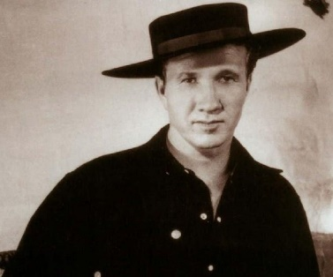
Country Judy – 2
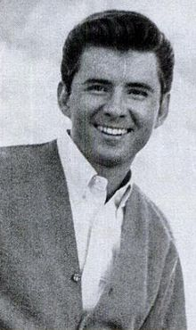

Marty Robbins Johnny Tillotson

- Everly Brothers What ever happened to Judy
- Marty Robbins Judy
- Teddy Redell Judy
- Elvis Presley Judy
- Jimmie Skinner Judy on my mind
- Junior Sisk Judy Lou
- David Houston Sweet sweet Judy
- Red Sovine Father of Judy Ann
- Ray Sanders Judy
- Jacqui & Bridie Punch and Judy Man
- Wayne Taylor Dancin’ with Judy
- Johnny Tillotson Judy, Judy, Judy
- Jim Hurst Trio Daisies for Judy
- Dr Hook Judy
- Wynn Stewart Judy
- Charles Hardiman Darling Judy, 1977
- Jodi Warren O I want to see
- Jodie & Odie Unpuckered
- Jody Miller Love, love, love
- Jody Adams Asher County Morning
- Jody Wisecup Blackjack
- Jody Stecher, Kate Brislin & Holly Tashian
- Home
- David West Suite: Judy blue yes

10:00-11:00: Bluegrass
Bluegrass Banjo – 1
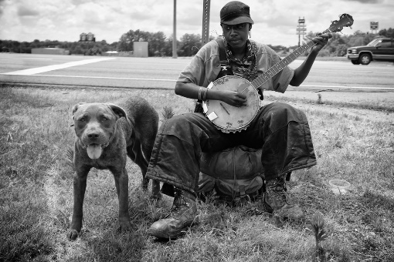

Inleiding:
- Brigitte Bardot Sidonie
- Jan & Kjeld Banjo Boy
programma:
- Jim & Jesse Bluegrass Banjo
- Stanley brothers Banjo in the hills
- Sunny Side Me and my old banjo
- Hylo Brown & Timberliners Banjo on the mountain
- Stephen Wade Once I had an old banjo
- Roni Stoneman Lonesome banjo
- Coon Creek Girls Banjo Pickin’ girl
- Mason Williams Saturday night banjo
- Steve Martin (= Tim O’Brien & Earl Scruggs)
Daddy played the banjo
- Don Reno & Bobby Thompson Dueling banjos
- Spinney brothers Pick the banjo
- Roger McGuinn Banjo Bach
- Allan Taylor Banjo man
- Four Wheel Drive Yakety axe
- Charley Pride (& Sonny Osborne) Best banjo picker
- Ken Grandjean Willin’ (Muted banjo)
- Danny Ellison & West By East Banjo Picker from West Virginia
- Carl Jackson Slewfoot banjo
- Slim Dusty Banjo’s man
- Dan Paisley Banjo boy chimes
- Doyle Lawson Polka on the banjo
- Lonesome Pine Fiddlers Hello mr. Banjo

11:00-12:00: Bluegrass
Bluegrass uitgebracht in 1963 – 1
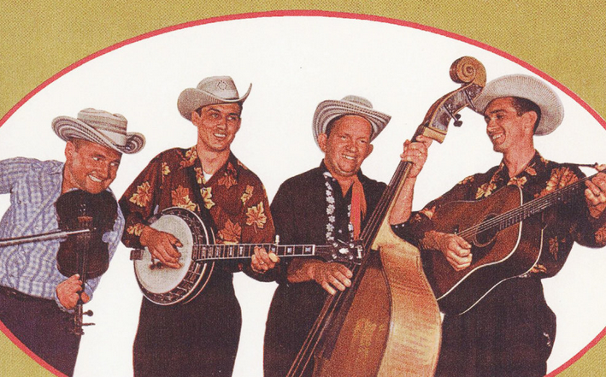

- Lonesome Pine Fiddlers (plaatje) Y’all come
- Bill Monroe Big Sandy River
- Flatt & Scruggs New York town
- Jim & Jesse The voice of my darling
- Osborne Brothers Don’t even look at me
- Elvin Rooks & the Blue Grass Ramblers
It’s goin’ to cost you
- Stinson Barth & the Kentucky Mountain Boys
I’ll forget you, woman
- Benny & Vallie Cain & the Country Clan New River Train
- Blue Sky Boys Kentucky
- Roy Acuff The great Titanic
- McCormick Brothers Red hen boogie
- Dian James & the Greenbriar Boys If I were free
- Charlie Moore & Bill Napier Metracal, same old gal
- Carl Story Picture of life’s other side
- Boutilier Brothers Wild side of life
- Esco Hankins & Jackie Mother left me her bible
- Curly Dan & Wilma Ann & the Danville Mountain Boys
I guess I’m going insane
- Walter Forbes Jack Daniel
- Cecil Surratt & Smitty Smith Riding the roads
- Jimmy Martin & the Sunny Mountain Boys
The old man’s drunk again
- Don Reno & Red Smiley Grandfather’s clock

Zondag 30 november, 19:00-20:00
Bij RTV Purmerend
Waterland CB
November
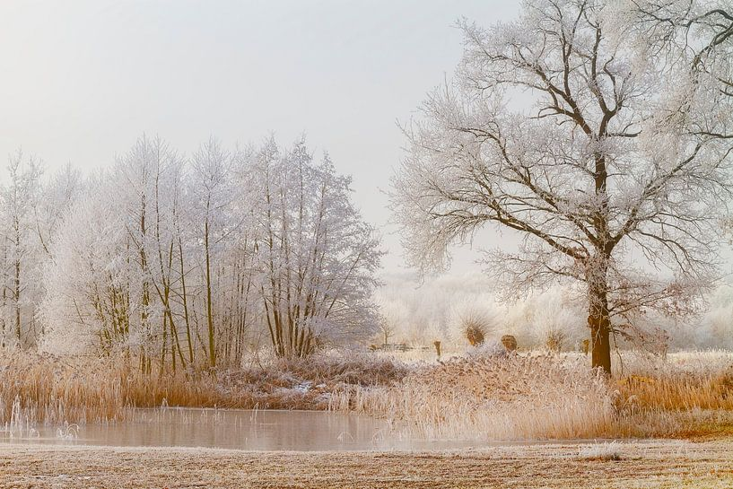

- True Colors Collective (Ned) November (van Bloem)
- Bob & Sarah Amos November
- Jaeleee Roberts November
- Miles Miller Always November
- Lost Highway November Rain
- Bill Harrell & Virginians Cold November Rain
- Dick van Altena (Ned) Novemberwind
- Kathi & Kelli Hinton November Wind
- Larry Cordle November_Wind
- Seth Sawyer band November Rose
- Gene Autry Old November Moon
- Max McNown Freezing in November
- Grandpa Jones 10th Of November
- Kimmie Rhodes November December
- John Williamson (Austr) Papa Whisky November
- Michael Johnathon Bells of cold November
- Charlie Treat Swimming in November
- Gordon Bok A tune for November

Dinsdag 2 december, 22:00-23:00
Bij Noordkop 247
Noordkop Country
Songs (co-)written by
Wayland Holyfield – 6 (slot)
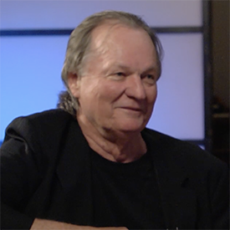

- Tim Ryan Seasons of the heart
- Linda Davis Love happens
- George Jones The Love in Your Eyes
- The Tams Making true love
- Tracy Byrd Anybody else’s heart but mine
- George Strait I met a friend of yours today
- Barry Berrier I keep putting off getting over you
- Liv Marit Wedvik Meanwhile
- Brooks & Dunn When she’s gone, she’s gone
- Ronan Keating When the world was mine
- Cindy Church The only star I see
- Randy Travis The Blues In Black And White
Twee bijna vergeten
- Don Williams Where the Arkansas river leaves Oklahoma
- Vernon Oxford I feel chained
De ere-ronde
- Ben Steneker Some broken hearts never mend
- Doyle Lawson Chapman Family
- Don Williams Over Wayland Holyfield
- Don Williams You’re my best friend
- Don Williams Till the rivers all run dry
reserve
- Pacific Bluegrass You’re my best friend

Dinsdag2 december, 23:00-24:00
Bij Noordkop 247
Noordkop Bluegrass
Moeders


- Ma Crow & the Lady Slippers Have a feast here tonight
- Mama Danger & the Newgrass Republic
Soul of man
- Mama Ain't Dead Benton’s dream
- Mamma’s Marmalade Run right over me
- Mama Said String Band The person you get
- Mama & Papa Reece Owens & friends
Bringing Mary home
- Pioneer Mother Get along
- Lynn Morris Mama’s hand
- Williard Gayheart & Bobby Patterson
Mother old and gray
- Wayne Erbsen & Laura Boosinger
Old mother Flanagan
- Travers Chandler Mother knows best
- Zink & Company Let old mother Nature have her way
- Whitstein brothers If I could hear my mother pray again
- Gibson Brothers God bless her, cause she’s my mother
- Carter Sisters & Mother Maybelle
Wildwood flower
- Blue Sky Boys The sweetest gift a mother’s smile
- Doc & Rose Lee Watson I heard my mother weeping
- Trey Hensley Give mother my crown
Bonus:
- Lilly Brothers No mother or dad
- Carl Story Shake my mother’s hands for me
- Rebe & Rabe Mother, sweet mother
- Emmylou & Linda This is to mother you
- George Jones Mama’s hands

De vorige week
Wilt u luisteren naar het programma van de vorige week?
Control+klik op onderstaande links

Zaterdag 22 november uur 1, Saturdaymorning C: Townes Van Zandt (2)
https://hans.vdveen.org/muziek/XYZ - CROSSROADS COUNTRY RADIO - Country/482x - Saturday morning C - 2025-11-22 - Towns Vanzandt (2).mp3

Zaterdag 22 november uur 2, Saturdaymorning BG: Dixie (2)
https://hans.vdveen.org/muziek/XYZ - CROSSROADS COUNTRY RADIO - Bluegrass/482y - Saturday morning BG - 2025-11-22 - Dixie (2).mp3

Zaterdag 22 november uur 3, Saturdaymorning C: Country Judy (1)
https://hans.vdveen.org/muziek/XYZ - CROSSROADS COUNTRY RADIO - Country/482z - Saturday morning C - 2025-11-22 - Judy (1).mp3

Zondag 23 november, Waterland CB: Brother duetten
https://hans.vdveen.org/muziek/W - WATERLAND CB/482w - Waterland CB - 2025-11-23 - Brother duets.mp3

Dinsdag 25 november, Noordkop Country: Folk revival (10)
https://hans.vdveen.org/muziek/B - NOORDKOP COUNTRY/482B - Noordkop Country - 2025-11-24 - Folk revival (10).mp3

dinsdag 25 november, Noordkop Bluegrass: Vaders
https://hans.vdveen.org/muziek/C - NOORDKOP BLUEGRASS/482C - Noordkop Bluegrass - 2025-11-24 - Vader.mp3

