Saturdaymorning CB
Waterland CB


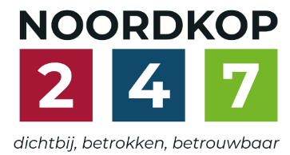
Noordkop Country & Bluegrass

Zaterdag 09:00-12:00: Saturday morning CB
www.Crossroadscountryradio.nl
luisteren kan alleen online via de website.
Herhaling: Donderdag 09:00-12:00
Zondag 19:00-20:00: Waterland CB
https://rtvpurmerend.nl
luisteren online kan via https://rtvpurmerend.nl/radio/live
Dinsdag 22:00-24:00: Noordkop CB
www.regionoordkop.nl
ether: 105.6 en 107.7 FM
luisteren online: www.noordkop247.nl/ live-radio/
Na de uitzending kan het programma worden beluisterd wanneer u maar wilt, via
http://hans.vdveen.org/muziek/
U vindt daar de uitzendingen van het laatste half jaar, waar u vrij uit kunt kiezen.
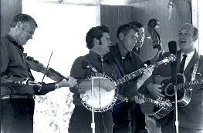

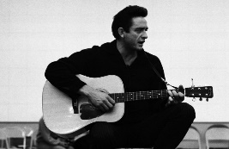
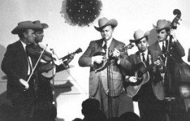
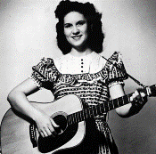
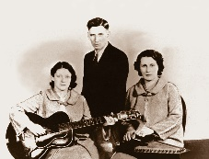
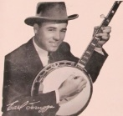
22, 23 & 25 november 2025
Zondag 19:00-20:00 – Waterland Country & Bluegrass
Dinsdag 22:00-23:00 – Noordkop Country
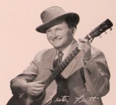
Dinsdag 23:00-24:00 – Noordkop Bluegrass
Zaterdag 09:00-12:00 – Crossroads Radio

samenstelling, montage & presentatie
Hans van der Veen

Oef! Vriend Thieu maakte me erop attent dat ik de playlisten nog niet had verstuurd. Zonder die man zou het helemaal een puinhoop worden bij mij. Enfin, hier zijn ze!
Veel luisterplezier!!!

Zaterdag 22 november
Herhaling: donderdag 27 november
Bij CrossroadsCountryRadio.nl
Saturday morning CB
09:00-10:00: Country
Songs written by Towns Vanzandt
2
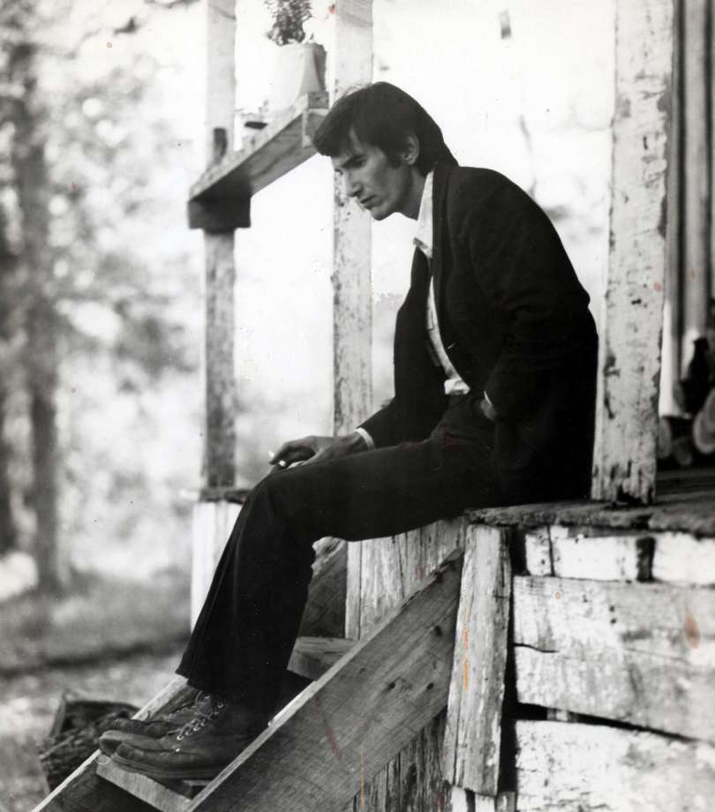

- Emmylou Harris Snowin’ on Raton
- John Prine Loretta
- Nanci Griffith Tower song
- Cowboy Junkies Lungs
- Christian Kjellvander Heavenly houseboat blues
- Emmylou Harris I’ll be your San Antone Rose
- Don Williams Come from the heart
- Steve Earle Colorado girl
- Buffy Sainte Marie Mister can’t you see
- Karl Broadie Like a summer thru
- Wanda Jackson Two hands
- Red Dog Run No lonesome tune
- Jonell Mosser All your young servants
- Townes Van Zandt & Kathy Mattea At my window
- Emmylou Harris & Don Williams If I needed you
- Emmylou Harris & Willie Nelson Pancho and Lefty

10:00-11:00: Bluegrass
Dixie – 2
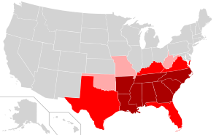

- Tom Morgan Are you from Dixie
- Lizzy Long & Little Roy My Dixie darling
- Jimmy Martin Sweet Dixie
- Lorraine Jordan Dixie road
- Bluegrass Brothers Flying south to Dixie
- Hank Locklin Flyin’ south
- Rich Rainey Daybreak in Dixie
- Bass Mountain Boys Back to Dixie
- Bill Clifton Dixie cannonball
- Flatt & Scruggs Dear old Dixie
- Marty Raybon Dixie in my eyes
- King Brothers & Virginia Mountaineers A true loving Dixie
- Norman & Nancy Blake I’m going to leave Dixie
- Dick Smith Dear old Dixie
- Dry Brand Fire Squad Dixie cowboy
- Buzz Busby Marching through Dixie
- Randy Waller Home in Dixieland
- Red Clay Ramblers While the band is playing D.

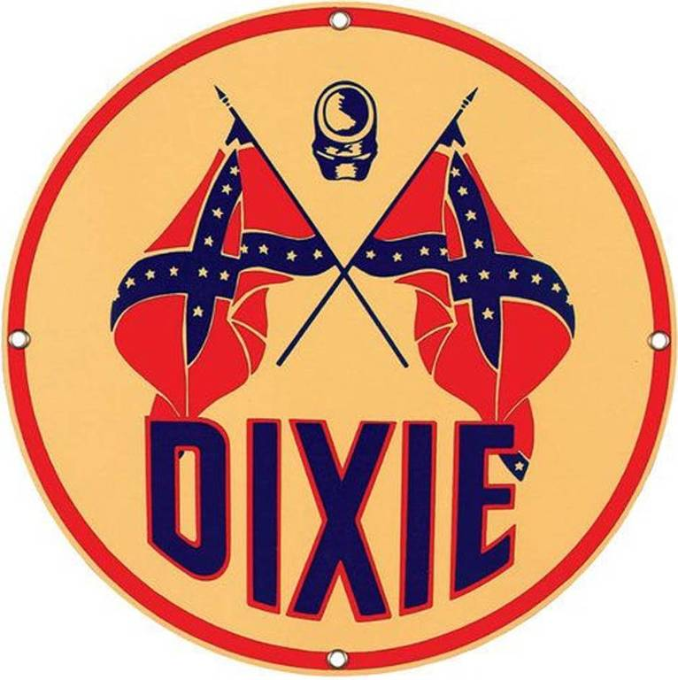

11:00-12:00: Country
Country Judy – 1
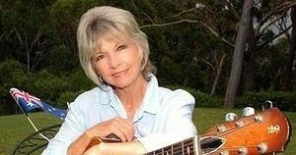 Judy Stone

- Everly Brothers What ever happened to Judy
- Judy Stone Would you lay with me
- Judy Cook Kid’s liberation
- Judy Lynn Hello mr. D.J.
- Judy Banker Fall for lies
- Judy Rodman A place called love
- Judy Thomas Don’t feel like the lone ranger
- Judy Collins, Dolly Parton & Rhonda Vincent
Both sides now
- Moe Bandy & Judy Bailey It’s you and me again
- Betty Amos & Judy & Jean Eighteen wheels a rolling
- Judy Martin Put me to sleep with a western lullaby
- Judy Marshall, Emmylou Harris & & Ralph Stanley
I never will marry
- Judy Welden Kisses
- Judith Edelman Midnight on the water
- Judy & Joyce Nursery rock
- Len & Judy This life I’m living
- Judy Canova Pistol packing mama
- Red Kirk & Judy Perkins I wonder who we think we’re foolin’ (oud)
- Tom T. Hall & Judy Marshall The water lily
- Judy Collins Lovin’ of the game
- Judy Marshall, Ralph Stanley & Alison Krauss
Visions of mother

Zondag 23 november, 19:00-20:00
Bij RTV Purmerend
Waterland CB
Brother duetten
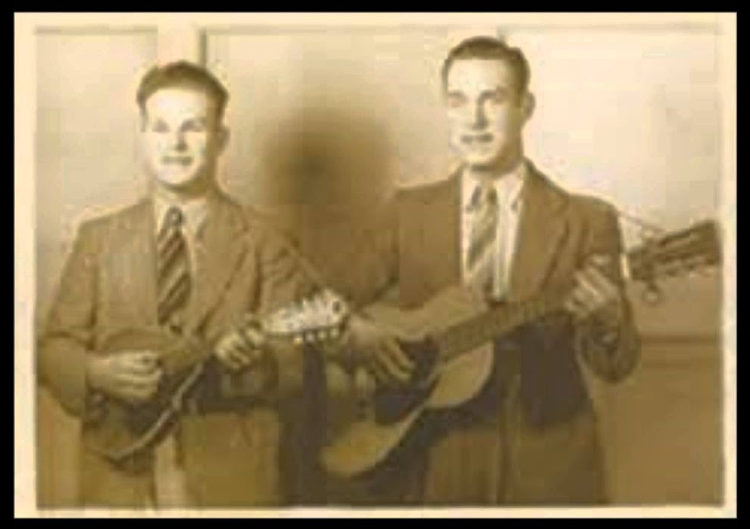
Jonge Blue Sky Boys (1937)

- McGee Brothers Willie and Mary
- Kessinger Brothers Soldier’s joy
- Delmore Brothers Prisoner’s farewell
- Callahan Brothers My darling little girl
- Dixon Brothers After the ball
- Monroe brothers The old man’s story
- Blue Sky Boys Let’s not sleep again
- Hall Brothers The Elevated Railroad In The City
- Bailey Brothers Blow you whistle freight train
- Everly Brothers Kentucky
- Chapparral Brothers Let somebody love you
- Leverett Brothers Anchored in love
- Louvin Brothers Love turned to hate
- Wilburn Brothers Midnight Mary
- Whitstein Brothers What a change one day can make
- Alexander Brothers A mansion for me
- Stanley Brothers Tragic love
- Jim & Jesse Faded love and winter roses
- Jones Brothers The old gray house
- Lawson Brothers Let me rest
- Gibson Brothers Ring the bell

Dinsdag 25 november, 22:00-23:00
Bij Noordkop 247
Noordkop Country
American Folk Music Revival
10 – In het Wikipedia artiekl genoemde
andere performers, die eerste opnamen na 1960 maakten
&
De UCLA Folk Festivals van 1964 en 1965

Andere performers
- Rosalie Sorrels You’re always welcome at our house
- Peter LaFarge Hey. Mister President
- Peter LeFarge Lavender cowboy
- Joe and Eddie Farewell my Cindy
- Guy Clark Queenie’s song
- Eric Andersen Lost in a song
- John Denver Follow me
- David Grisman I ain’t broke but I’m badly bent
- Even Dozen Jug Band Mandolin king rag
- The Serendipity Singers Don’t let the rain come down
- Dick Rosmini The duchess
- Simon & Garfunkel You can tell the world
- Gale Garnett We’ll sing in the sun shine
- Jackson C. Frank Just like anything
- Karen Dalton When first unto this country
- David Bromberg Wallflower
UCLA Folk Festivals 1964 en 1965
- Carl Sprague Cow boy love song
- Jackie De Shannon Little yellow roses
- Bookmiller Shannon Buffalo gals
- Dave Fredrickson Billy the Kid
- The Blue Sky Boys Take me back to Renfro Valley
- Ruth Rubin (& Pete Seeger) Shpits boydim
- Sandy & Caroline Paton I’ve got a song
Bonus
- Sandy & Caroline Paton Come along John

Dinsdag25 november, 23:00-24:00
Bij Noordkop 247
Noordkop Bluegrass
Vaders


- Virgil Harden Daddy
- Pap Brewer & Gary Brewer & the Kentucky Ramblers
Unseen eye watching you
- Papa Truck Million miles
- Ben & Carmen Steneker Under father’s wings
- Scott Partridge Father time
- Ricky Skaggs My father’s son
- Wade Jackson with Weldon & Wanda Rogers
Father Time and Mother Nature
- Ralph Stanley II Daddy’s dinner bucket
- Maureen MacGillavry To daddy
- Lou Reid & Carolina Daddy tried
- Darren Beachley Daddy’s chair
- New Dominion Bluegrass Daddy can you hear me
- Tom T. Hall Mama bake a pie (Daddy kill a chicken)
- Tommy Brown Robin built a nest on daddy’s grave
- King Springs Road My praying daddy
- Wayne Perry & Temperance Road
Daddy’s D-35
- Tammy Jones Robinette My daddy’s mountains
Bonus:
- Wildfire Daddy loved trains
- White Mountain Bluegrass Daddy for a day
- Traver Hollow That silver haired daddy of mine

De vorige week
Wilt u luisteren naar het programma van de vorige week?
Control+klik op onderstaande links

Zaterdag 15 november uur 1, Saturdaymorning C: Townes Van Zandt (1)
https://hans.vdveen.org/muziek/XYZ - CROSSROADS COUNTRY RADIO - Country/481X - Saturday morning Country, 2025-11-15 - Townes Van Zandrt (1).mp3

Zaterdag 15 november uur 2, Saturdaymorning BG: Dixie (1)
https://hans.vdveen.org/muziek/XYZ - CROSSROADS COUNTRY RADIO - Bluegrass/481Y - Saturday morning Bluegrass, 2025-11-15 - Dixie (1).mp3

Zaterdag 15 november uur 3, Saturdaymorning BG: Kentucky
https://hans.vdveen.org/muziek/XYZ - CROSSROADS COUNTRY RADIO - Bluegrass/481Z - Saturday morning Bluegrass, 2025-11-15 - Kentucky.mp3

Zondag 16 november, Waterland CB: Recent verschenen
https://hans.vdveen.org/muziek/W - WATERLAND CB/481W - Waterland CB - 2025-11-16 - Recent verschenen.mp3

Dinsdag 18 november, Noordkop Country: 1940 en 1970 (12)
https://hans.vdveen.org/muziek/B - NOORDKOP COUNTRY/481B - Noordkop Country - 2025-11-18 - 1940 & 1970 (12).mp3

dinsdag 18 november, Noordkop Bluegrass: Wakker
https://hans.vdveen.org/muziek/C - NOORDKOP BLUEGRASS/481C - Noordkop Bluegrass - 2025-11-18 - Wakker.mp3

