Saturdaymorning CB
Waterland CB


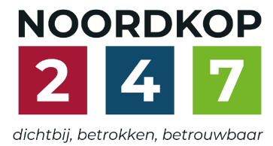
Noordkop Country & Bluegrass

Zaterdag 09:00-12:00: Saturday morning CB
www.Crossroadscountryradio.nl
luisteren kan alleen online via de website.
Herhaling: Donderdag 09:00-12:00
Zondag 19:00-20:00: Waterland CB
https://rtvpurmerend.nl
luisteren online kan via https://rtvpurmerend.nl/radio/live
Dinsdag 22:00-24:00: Noordkop CB
www.regionoordkop.nl
ether: 105.6 en 107.7 FM
luisteren online: www.noordkop247.nl/ live-radio/
Na de uitzending kan het programma worden beluisterd wanneer u maar wilt, via
http://hans.vdveen.org/muziek/
U vindt daar de uitzendingen van het laatste half jaar, waar u vrij uit kunt kiezen.
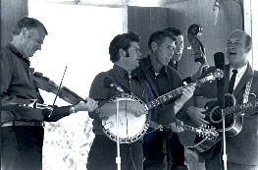

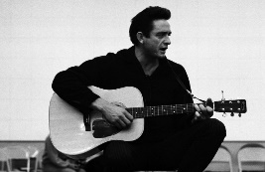
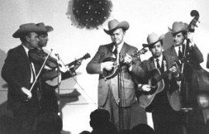
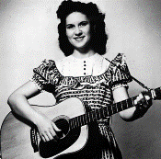
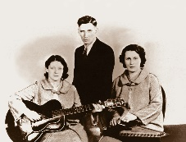
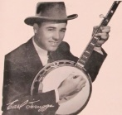
8, 9 & 11 november2025
Zondag 19:00-20:00 – Waterland Country & Bluegrass
Dinsdag 22:00-23:00 – Noordkop Country
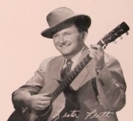
Dinsdag 23:00-24:00 – Noordkop Bluegrass
Zaterdag 09:00-12:00 – Crossroads Radio

samenstelling, montage & presentatie
Hans van der Veen

Het is in stilte gepasseerd: Noordkop Country van de vorige week was mijn 1500ste uur voor de radio. Ik had op zijn minst een van de burgemeesters verwacht en eerlijk gezegd ook wel een minister, maar ik was een groot deel van de dag afwezig, zal ze dus hebben gemist. Het concert van Monroe Crossing heeft alles goed gemaakt: wat een geweldige middag hadden we weer!
Maar nu deze week. Ach, dat ziet u wel. Veel luistergenoegen!!

Zaterdag 8 november
Herhaling: donderdag 13 november
Bij CrossroadsCountryRadio.nl
Saturday morning CB
09:00-10:00: Country
John D. Loudermilk – 3
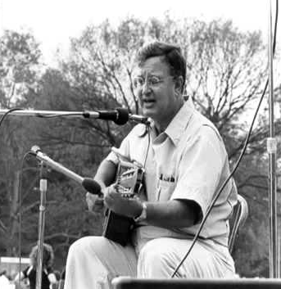

- John D. Laudermilk Ma baker’s little acre
- Bob Gallion You take the table and I’ll take the chairs
- The Browns This time I would know
- Osborne Brothers It’s just the idea
- Hank Snow Father time and mother love
- Hank Locklin When the band plays the blues
- Betty McQuade Midnight bus
- Ricky Nelson Half breed
- Tompall & the Glaser Boys I’ll never tell
- Jim & Jesse Grin and bear it
- Jimmy Newman The ballad of Baby Doe
- John D. The little grave - kerst
- Norma Jean Amigo’s guitar
- Kitty Wells Lonely is a word
- Johnny Ferguson Angela Jones
- Chet Atkins Boo boo stick beat
- Red Foley Travelin’ man
- George Hamilton IV Last night we fell in love
- Ebe Sneezer & the Epidemics That’s all I got
- Jimmy Byron Does my heartache show
- Stonewall Jackson Ward of broken hearts
- Johnny Cash God will
- Frank Necessary Blue train
- John D. Loudermilk Blue train
Bonus:
- Eddy Arnold Then you can tell me goodbye
- Wanda Jackson Big Daddy

10:00-11:00: Bluegrass
River Boys - 2
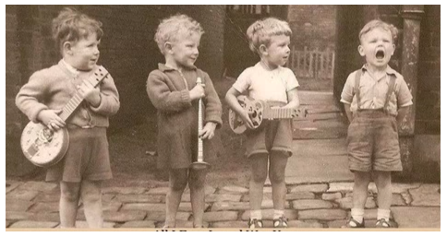

- Charles River Valley Boys Cherokee shuffle
- Ed Blankenship & the Tug River Valley Boys
Rising Sun
- Finley River Boys Old cross roads
- Glen Campbell & Green River Boys This old white mule of mine
- Lowell Varney, Landon Messer & the Riverside Grass & Ralph Stankey How mountain girls can love
- Sharon Cort & New River Ranch & Howard Yearwood
Many mansions
- Silver River String Band Old lonesome welcome back
- Old Ditch Riverhoppers Kentucky trainwreck
- L. W. Lambert & the Blue River Boys Light at the river
- Kentucky River Boys Rueben’s train
- River City Ramblers Battle of New Orleans
- New River Ramblers Sally Ann
- New River Line Good to see the homeplace once
again
- Smokey River Boys Rolling in my sweet baby’s arms
- Red River Bluegrass Band Frankie & Johnny
- Stephen Helton & the Flint River Boys In the pines
- Pine River Valley Boys All I ever loved was you
- Kane’s River Stars and stones
- Big River Bluegrass Start over again
- Thirsty River Donald Kraus
- Silver River String Band Ground hog
- River Plate Ridge Runners Rocky top
- River Valley Rangers Mountain
Bonus:
- Adrian Farmer I’ll always love you

11:00-12:00: Country
De tweede orde van 1966 – 1
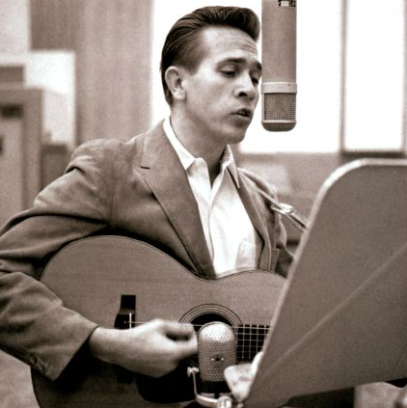

- Buck Owens & the Buckaroos Think of Me
- Johnny Cash The One on the Right Is on the Left
- Waylon Jennings Time to Bum Again
- Sonny James True Love's a Blessing
- Kenny Price Walking on New Grass
- Bobby Lewis How Long Has It Been
- Johnny Dollar Stop the Start (Of Tears in My Heart)
- Jan Howard Bad Seed
- Dottie West Would You Hold It Against Me
- Wilma Burgess Don't Touch Me
- The Browns I'd Just Be Fool Enough
- Dave Dudley Long Time Gone
- Ray Pillow Thank You Ma'am
- Gene Pitney & Melba Montgomery Baby, Ain't That Fine
- Kitty Wells A Woman Half My Age
- Del Reeves Women Do Funny Things to Me
- Hank Williams, Jr. Standing in the Shadows
- Marty Robbins The Shoe Goes On the Other Foot
Tonight
- Buddy Starcher History Repeats Itself
- Faron Young My Dreams
- Don Gibson A Born Loser
- Warner Mack It Takes a Lot of Money
- Johnny Paycheck The lovin’ machine
- Porter Wagoner Skid row Joe

Zondag 9 november 19:00-20:00
Bij RTV Purmerend
Waterland CB
Happy people

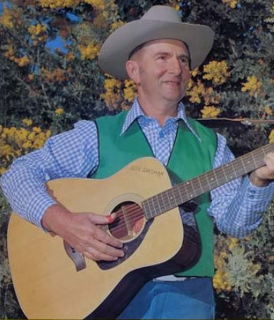
Don Gresham

- Slim Dusty (Austr) Sing a Happy Song
- Carl Story Everybody Will Be Happy
- Carter Family Happy in Prison
- McCormick brothers I'm Happy To Know
- Don Gresham (Austr) One big Happy Family
- Donna Fargo The Happiest Girl In The Whole USA
- Hank Snow Born to be Happy
- Hank Williams Happy Rovin' Cowboy
- Hank Locklin Happy birthday to me
- Walter Brennan Happy Birthday Old Folk
- Stanley Brothers that happy night
- Stoney Creek BG Band So happy I'll be
- Nashville Bluegrass Band Happy on the Mississippi shores
- Bluegrass Family Happy Sunny Side Of Life
- Dick Nolan Happy Newfoundlanders
- Lena Johnson & Brittany Haas Keeping the Cats Happy
- Dixon Brothers How can a broke man be happy
- Simon St Pierre (Can) Happy acres 2 step
- Charlie Monroe Happy Spirit
- Tut Taylor & Clarence White Happy dobro
- Red Foley Happy song
- Bailey Brothers Take me back to happy valley

Dinsdag 11 november 22:00-23:00
Bij Noordkop 247
Noordkop Country
Verongelukte artiesten – 2
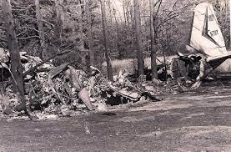
Het toestel waarin Ricky Nelson had gezeten

- Hawkshaw Hawkins Silver threads and golden needles
- Hawkshaw Hawkins My story
- Patsy Cline I love you so much it hurts me
- Patsy Cline Pick me up on your way down
- Cowboy Copas Cryin’ doll
- Cowboy Copas Tell me more
- Randy Hughes Feel so good
- Randy Hughes Sweetly neatly and so completely
- Anglin Brothers They’re all going home but one
- Johnnie & Jack Why not confess
- Jim Croce Alabama rain
- Jim & Ingrid Croce The man that is me
- Abby Nicole The journey
- Shelby King Live opname
- Jud Strunk Daisy a day
- Jud Strunk Corporation blues
- Amie Comeaux I heard it from my heart
- Ricky Nelson Teenage idol
- Ricky Nelson Today’s teardrops
- John Denver Grandma’s feather bed
- John Denver Late nite radio
Toegift:
- Hank Snow Unwanted sign upon your heart
- Hank Snow & Willie Nelson A fool such as I

Dinsdag 11 november 23:00-24:00
Bij Noordkop 247
Noordkop Bluegrass
Sleepy


- Sleepy Man Banjo Boys Wildflower
- Lyman Enloe Sleepy eyed Joe
- Foghorn Stringband Sleepy Lou
- Gothard Sisters Sleepy Maggie
- Wells Fargo Sleepy Chris
- Yonder Mountain Stringband Sleepy cowboy
- Grascals Sleepy little town
- Gary Brewer Sleepy valley
- Hank Snow Sleepy Rio Grande
- Rusty Draper When it’s sleepy time down south
- Laurie Lewis & Tom Rozum Sleepy eyes
- Tut Taylor & Clarence White Sleepyhead
- Lucas & Harmon brothers Sleepy time
- Jim Conners & the Voyagers Sleepy time jig
- G2 Bluegrass band Sleepy hollow
- Mountain Dew Sleepy hollow reel/real
- Burke Barbour Sleepy hollow breakdown
- Uncle Earl Sleepy desert
- Butch Baldassari Sleepy gap / Tucker
- Troy Eagle Sleepy town of Bethlehem
Bonus
- Peter Ostroushko Sleepy Jesus rag
- Montana Slim Where the sleepy Rio’s flowing

De vorige week
Wilt u luisteren naar het programma van de vorige week?
Control+klik op onderstaande links

Zaterdag 1 november uur 1, Saturdaymorning C: John D. Loudermilk (2)
https://hans.vdveen.org/muziek/XYZ - CROSSROADS COUNTRY RADIO/479x - Saturday mornin Country, 2025-11-02 - John D. Loudermilk (2).mp3

Zaterdag 1 november uur 2, Saturdaymorning BG: Songs of the mountains
https://hans.vdveen.org/muziek/XYZ - CROSSROADS COUNTRY RADIO/479y - Saturday mornin Bluegrass, 2025-11-02 - Songs about the mountains.mp3

Zaterdag 1 november uur 3, Saturdaymorning BG: River Boys (1)
https://hans.vdveen.org/muziek/XYZ - CROSSROADS COUNTRY RADIO/479z - Saturday mornin Bluegrass, 2025-11-02 - River boys (1).mp3

Zondag 2 november, Waterland CB: Bad news
Programma verviel

Dinsdag 4 november, Noordkop Country: Folk revival (9)
https://hans.vdveen.org/muziek/B - NOORDKOP COUNTRY/479B - Noordkop Country - 2025-11-04 - -Folk revival (9).mp3

dinsdag 4 november, Noordkop Bluegrass: 50 meest gedraaid in de USA
https://hans.vdveen.org/muziek/C - NOORDKOP BLUEGRASS/479C - Noordkop Bluegrass - 2025-11-04 - Top 50 van 2024.mp3

