Saturdaymorning CB
Waterland CB


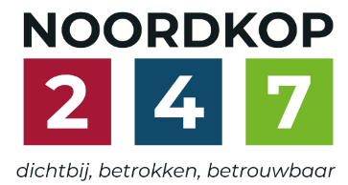
Noordkop Country & Bluegrass

Zaterdag 09:00-12:00: Saturday morning CB
www.Crossroadscountryradio.nl
luisteren kan alleen online via de website.
Herhaling: Donderdag 09:00-12:00
Zondag 19:00-20:00: Waterland CB
https://rtvpurmerend.nl
luisteren online kan via https://rtvpurmerend.nl/radio/live
Dinsdag 22:00-24:00: Noordkop CB
www.regionoordkop.nl
ether: 105.6 en 107.7 FM
luisteren online: www.noordkop247.nl/ live-radio/
Na de uitzending kan het programma worden beluisterd wanneer u maar wilt, via
http://hans.vdveen.org/muziek/
U vindt daar de uitzendingen van het laatste half jaar, waar u vrij uit kunt kiezen.
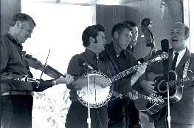


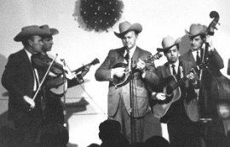
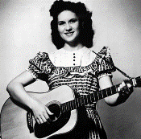
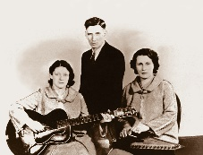
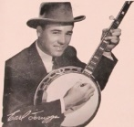
1, 2 & 4 november 2025
Zondag 19:00-20:00 – Waterland Country & Bluegrass
Dinsdag 22:00-23:00 – Noordkop Country
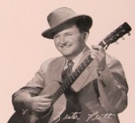
Dinsdag 23:00-24:00 – Noordkop Bluegrass
Zaterdag 09:00-12:00 – Crossroads Radio

samenstelling, montage & presentatie
Hans van der Veen

November, altijd november, sprak de dichter J.C. Bloem. Daar merk je weinig van in de thema’s van deze week. Ach, u moet zelf maar weer kijken. Zondag krijgen we Monroe Crossing op bezoek, ik heb het de afgelopen weken een paar keer verkeerd vermeld maar er zijn aardig wat reserveringen. Even kijken hoe ver we zitten.
Veel luisterplezier!!!

Zaterdag 1 november
Herhaling: donderdag 6 november
Bij CrossroadsCountryRadio.nl
Saturday morning CB
09:00-10:00: Country
John D. Loudermilk – 2

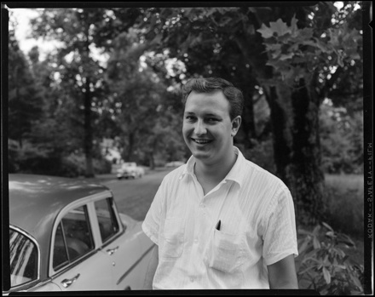

- John D. Loudermilk Blue train
- Stonewall Jackson Waterloo
- Bob Luman The great snowman
- John D. Loudermilk Interstate 40
- Johnny Tillotson Then you can tell me goodbye
- Sue Thompson James, hold the ladder
- Sue Thompson Sad movies always make me cry
- John D. Loudermilk Angela Jones
- Nancy Sinatra This little bird
- George Hamilton IV Abilene
- Ernest Ashworth Talk Back Trembling Lips
- Don McLean Sittin’ in the balcony
- John D. Loudermilk Jimmie’s song
- Everly Brothers Ebony eyes
- Johnny Cash Bad news
- John D. Loudermilk Geraldine
- Doc & Merle Watson Windy and warm
- Skeeter Davis Sun glasses
- John D. Loudermilk What would you take for me
- Johnny Dee & the Bluenotes Teenage Queen
- Flying Burrito Brothers Break my mind
- John D. Loudermilk Language of love
- The Browns Halfway to heaven
- Skeeter Davis A Dixie cup of sand

10:00-11:00: Bluegrass
Songs about the mountains


- Homer & the Barnstormers Fire on the mountain
- Norman Blake & Tut Taylor Fire on the mountain
- Po’ Ramblin’ Boys Back to the mountains
- Jack Lynch Home in the mountains
- Jim Greer & Mac-O-Chee Valley Folks My home’s across
the Blue Ridge Mountains
- Southern Show Boys In the great Smokey Mountains
- Southern Rail Mountains and memories
- Bluegrass Blackjacks Springtime in the mountains
- Wayne Scott In the mountains
- Jim & Jesse The grass is greener in the mountains
- Mac Odell & his Alabama Jubileers
Wild Rose of the mountains
- Riley Puckett I want to wander
in the Cumberland Mountains
- Wilf Carter Blue Canadian mountains
- Ron Rigsby Blue Kentucky Mountains
- Backyard Buskers Poney mountains
- Mark Kuykendal & Bobby Hicks Sweetheart of the mountains
- Buddy Meriam & Backroads Berkshire Mountains waltz
- Spring Creek High up in the mountains
- Chris Button Mountains and moonshine
- Bluegrass Strangers Dusty roads and blue Kentucky mountains
- Blue Highway Still climbing mountains

11:00-12:00: van Bluegrass
River Boys - 1
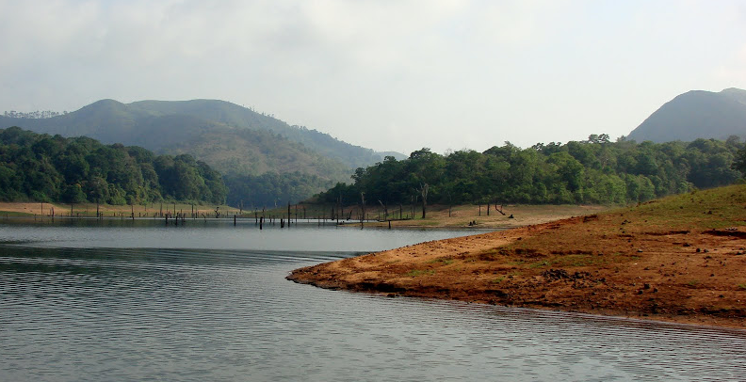

- Jerry Rivers Bill Cheatham
- Humber River Valley Boys Dear old Dixie
- Blue River Detroit blues
- Laurel River Line Somewhere between
- White River BG Band Heavenly light is shining on me
- Allegheny River Boys Could you love me one more time
- Tar River Boys Cherokee shuffle
- Tennessee River Boys The master’s bouquet
- Hocking River String Band Back pocket bible
- Ch. River Valley Boys Before I met you
- Warrior River Boys The singing waterfall
- Lonesome River Band Close the door lightly when you go
- Lonesome River Boys Railroad Bill
- New River Bluegrass Band High cotton
- Green River Boys (& Glen Campbell?) Kentucky means paradise
- Cumberland River Give me one more try
- Alex Campbell & Olabelle & New River Boys
You don’t ever know
- Trinity River Band Heartstrings
- Brushy River Boys Leather bridges
- Toe River Valley Boys Toe River Train
- Dave Evans & River Bend I’ll just pretend
- Charles River Valley Boys Cherokee shuffle

Zondag 2 november, 19:00-20:00
Bij RTV Purmerend
Waterland CB
Bad news

The wreck of the L & N railroad, 1918

- Jussy Syren (Finl) Bad news
- John D. Loudermilk Bad news (zelfde)
- Johnny Cash Bad news
- Emmylou Harris Bad news
- Justin Tubb And then I heard the bad news
- Porter Wagoner Bad news travels fast
- Hawkshaw Hawkins Bad news travels fast
- David Parmley Bad news fior the blues
- Paul Family Bluegrass Bad news for the devil
- New Lost City Ramblers Wreck of the Tennessee Gravy train
- Phipps Family The wreck of the L & N railroad
- Dick Unteed The wreck of the Titanic
- Ruth Hazelton & Kate Burke The wreck of the Dandenong
- Weavers The wreck of the John B
- Red Fox Chasers Wreck on the mountain road
- Norman Blake & Tut Taylor Train wreck
- Mac Beattie Train wreck at Almonte
- Bill Harrell & the Virginians Wreck of the old 97
- Arlo Guthrie & Emmylou Harris Deportee (Plane wreck at Los Gatos)
- Rhonda Vincent Good news
Bonus
- Br549 A little good news

Dinsdag 4 november,- 22:00-23:00
Bij Noordkop 247
Noordkop Country
American Folk Music Revival
9. Newport 1968 (vervolg) & 1969
& andere performers,
in het Wikipedia artikel genoemd, en al in 1960 actief, en nog niet genoemd
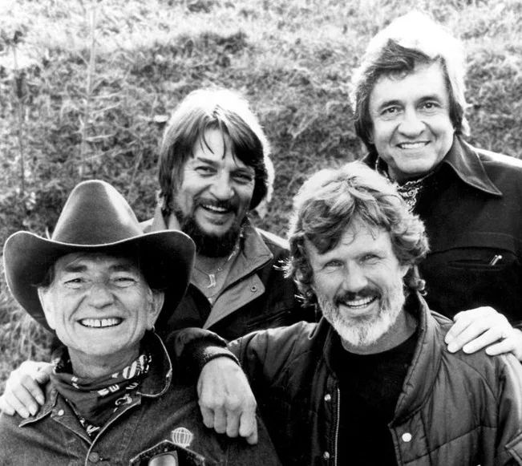
The Highwaymen

Newport 1968 (restant)
- Bruce Murdoch Just be careful with my friend
- John Hartford Untangle your mind
Newport 1969
- Jean Bosco Mwenda Masanga (original version)
- Billy Edd Wheeler Anne
- Carl Perkins If I could come back
- Doug Kershaw Diggy liggy lo
- Kris Kristofferson Help me make it through the night
- Don Reno & Bill Harrell Welcome home
- Jaime Brockett One too many mornings
- James Taylor That lonesome road
- Van Morrison Brown eyed girl
- The Everly Brothers Oh so many years
- Fred Cockerham Holly ding
- Björn Ståbi & Ole Hjorth Systerpolska
- Jerry Jeff Walker Gypsy song man
Andere performers door Wikipedia genoemd
- Erik Darling Charlie Green
- Kossoy Sisters (met ED) I’ll fly away
- Glenn Yarborough I’ll catch the sun
- Logan English I’ll write ‘n’ draw
- Jo Mapes Turtle dove
- The Highwaymen Michael
- Gil Robbins (= Cumberland Three)
Hallowed ground
Bonus
- Highwaymen Big rock candy mountain

Dinsdag 4 november, 23:00-24:00
Bij Noordkop 247
Noordkop Bluegrass
Meest gedraaid in de USA in 2024
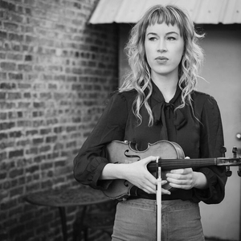
Bronwyn Keith Hynes

- Wood Box Heroes Cross The Line
- Ashby Frank Knee Deep In Bluegrass
- Jason Carter & Michael Cleveland Outrun The Rain
- Travelin’ McCourys Runaway Train
- Darin & Brooke Aldridge w/ John Jorgenson Price I Pay
- Lonesome River Band Blues Of The Night
- Bronwyn Keith Hynes Will You Ever Be Mine
- Authentic Unlimited Big Wheels
- Daniel Grindstaff w/ Trey Hensley Looking At The World Through A
Windshield
- Blue Highway The North Side
- Sister Sadie Cannonball
- Daniel Grindstaff Finnland
- Darren Nicholson Big Sky
- Del McCoury Band If You Talk In Your Sleep
- Lonesome River Band Hang Around For The Heartbreak
- Unspoken Tradition Weary Town

De vorige week
Wilt u luisteren naar het programma van de vorige week?
Control+klik op onderstaande links

Zaterdag 25 oktober uur 1, Saturdaymorning C: John D. Loudermilk (1)
https://hans.vdveen.org/muziek/XYZ - CROSSROADS COUNTRY RADIO/478x - Saturday mornin Country, 2025-10-25 - John D. Loudermilk (1).mp3

Zaterdag 25 oktober uur 2, Saturdaymorning BG: Bluegrass uit 2017 (2)
https://hans.vdveen.org/muziek/XYZ - CROSSROADS COUNTRY RADIO/478y - Saturday mornin Bluegrass, 2025-10-25 - Bluegrass uiit 2017 (2).mp3

Zaterdag 25 oktober uur 3,Saturdaymorning C: Train wreck songs
https://hans.vdveen.org/muziek/XYZ - CROSSROADS COUNTRY RADIO/478z - Saturday mornin Country, 2025-10-25 - Train wreck songs.mp3

Zondag 26 oktober, Waterland CB: Storm
https://hans.vdveen.org/muziek/W - WATERLAND CB/478W - Waterland CB - 2025-10-26 - storm.mp3

Dinsdag 28 oktober, Noordkop Country: Hank Locklin
https://hans.vdveen.org/muziek/B - NOORDKOP COUNTRY/478B - Noordkop Country - 2025-10-28 - Hank Locklin.mp3

dinsdag 28 oktober, Noordkop Bluegrass: Rebel singles (1)
https://hans.vdveen.org/muziek/C - NOORDKOP BLUEGRASS/478C - Noordkop Bluegrass - 2025-10-28 - De singels van Rebel (1).mp3

