Saturdaymorning CB
Waterland CB



Noordkop Country & Bluegrass

Zaterdag 09:00-12:00: Saturday morning CB
www.Crossroadscountryradio.nl
luisteren kan alleen online via de website.
Herhaling: Donderdag 09:00-12:00
Zondag 19:00-20:00: Waterland CB
https://rtvpurmerend.nl
luisteren online kan via https://rtvpurmerend.nl/radio/live
Dinsdag 22:00-24:00: Noordkop CB
www.regionoordkop.nl
ether: 105.6 en 107.7 FM
luisteren online: www.noordkop247.nl/ live-radio/
Na de uitzending kan het programma worden beluisterd wanneer u maar wilt, via
http://hans.vdveen.org/muziek/
U vindt daar de uitzendingen van het laatste half jaar, waar u vrij uit kunt kiezen.
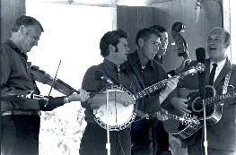


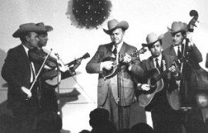
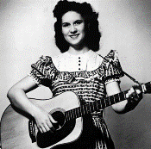
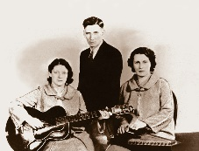
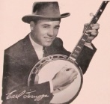
4, 5 & 7 oktober 2025
Zondag 19:00-20:00 – Waterland Country & Bluegrass
Dinsdag 22:00-23:00 – Noordkop Country
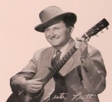
Dinsdag 23:00-24:00 – Noordkop Bluegrass
Zaterdag 09:00-12:00 – Crossroads Radio

samenstelling, montage & presentatie
Hans van der Veen

Stap zoveel van het maken van een programma is: zoek een plaatje bij de playlist. Ik kies dan vaak iets aardigs van een van die artiesten die aan bod komen, omdat je altijd moet oppassen met publicatierechten. Maar soms kom je zoiets aardigs tegen, dat je er niet onderuit kunt. Zoals deze keer bij de lijst van Waterland CB. Het is een foto, maar zou net zo goed een schilderij kunnen zijn. Als dank beloof ik van de Misty Mama’s af en toe eens iets te draaien.
Ik heb niets van de muziek gezegd. Ach, dat hoort u wel.
Veel luisterplezier!!

Zaterdag 4 oktober
Herhaling: donderdag 9 oktober
Bij CrossroadsCountryRadio.nl
Saturday morning CB
09:00-10:00: Waterland Bluegrass van 11 december 2017
Van alles wat
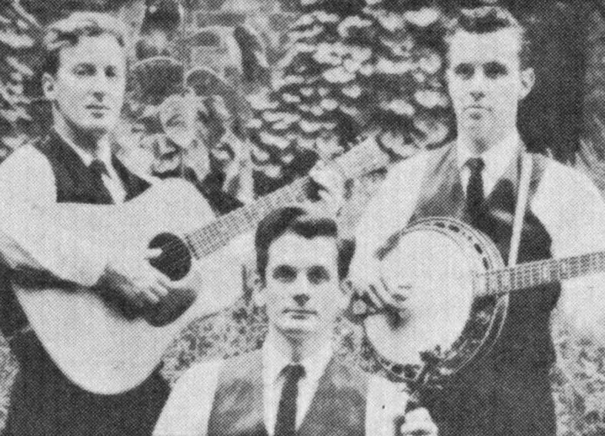
New Lost City Ramblers

- Foghorn Stringband Grey eagle
- Lynn Morris Mama’s hand
- Mac Wiseman Jimmy Brown the newsboy
- Steve Martin Wally on the run
- Baker Boys Lonesome weary heart
- Morris brothers Let me be your salty dog
- Country Gentlemen God’s coloring book
- Vern Williams Band Field of flowers
- Norman Blake & Tut Taylor Liberty
- Rachel Harrington Sunshine girl
- Wolfe Brothers Honey. I’m rambling away
- Hack Johnson & his Tennesseans Home sweet home
- New Lost City Ramblers Soldier, soldier will you marry me
- Lilly Brothers Rosewood casket
- Kentucky Colonels Faded love
- Down Hill Strugglers New Bright Land
- David Linley The Johnson Boys
- Ray & Ina Patterson The house where we were wed
- Ronnie Bowman Go home
- Norman Blake Done Gone
- Nancy Sluys Cacklin’ hen
- New Lost City Ramblers The waves of the sea

10:00-11:00: Noordkop Country van 12 december 2017
Country hitjes 1952-1973 (2)
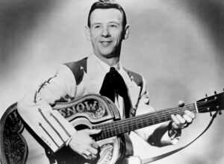
Hank Snow

- 1952 Hank Snow The Gold Rush Is Over
- 1953 Hank Williams with His Drifting Cowboys
Take These Chains from My Heart
- 1954 Jim Reeves Bimbo
- 1955 Myrna Lorrie & Buddy DeVal Are you mine
- 1956 Wilburn Brothers Go away with me
- 1957 Johnny Cash Train of Love
- 1958 Kalin Twins When
- 1959 Hawkshaw Hawkins Soldier's Joy
- 1960 Lewis Pruitt Timbrook
- 1961 Hank Locklin Happy Birthday to Me
- 1962 Stonewall Jackson A Wound Time Can't Erase
- 1963 Kathy Dee Unkind Words
- 1964 Jean Shepard Second Fiddle (To an Old Guitar)
- 1965 Bobby Bare Four Strong Winds
- 1966 Bill Phillips & Dolly Parton Put it off until tomorrow
- 1967 Dolly Parton Something Fishy
- 1968 Lynn & Liz Anderson Mother, May I
- 1969 Bobbie Gentry & Glen Campbell
Let It Be Me
- 1970 Charley Pride Is anybody going to San Antone
- 1971 Sammi Smith Help me make it through the night
- 1972 Statler Brothers The Class of '57
- 1973 Tom T. Hall Ravishing Ruby
- Townes Van Zandt & Kimmie Rhodes
Brother flower
- Stroatklinkers Over ‘t wotter

11:00-12:00: Noordkop Bluegrass van 12 december 2017
Popsongs Bluegrass style
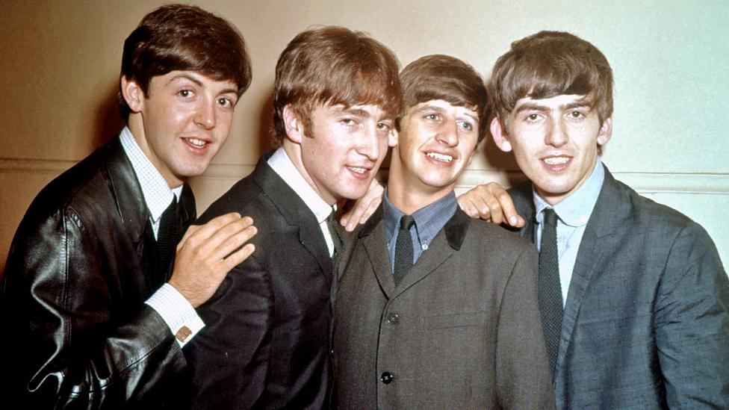
The Beatles

- Seldom Scene Hello Mary Lou Ricky Nelson
- Dewey Farmer Yesterday Beatles
- Claire Lynch Hitchcock railway Joe Cocker
- Jim & Jesse Maybelline Chuck Berry
- Bill Clifton & Red Rector Dominique Soeur Sourire
- J.D. Crowe As tears go by Marianne Faithfull
- Richard Bailey a.o. Mother’s little helper Rolling Stones
- Connor Brothers Wake up little Susie Everly Brothers
- Charles River Valley Boys & Ashley Lilly Help Beatles
- Joe Val What goes on Beatles
- Charlie Moore & Sm.Str. Wooden heart Elvis Presley
- Charlie Moore You’re my best friend Don Williams
- Alison Brown Homeward Bound Simon & Garfunkle
- Jerry Douglas The Boxer Simon & Garfunkel
- Joey & Rory Let it be me Everly Brothers
- David West Teach your children Crosby, Stills, Nash & Young
- Rice, Rice, Hillman & Pedersen
Friend of the devil Grateful Dead
- Cliff Waldron Reason to believe Tim Hardin / Rod Stewart
- John Hartford Piece of my heart Janis Joplin
- RFD Boys Take me home, country roads John Denver
- J.D. Crowe I’m walking Fats Domino

Zondag 5 oktober, 19:00-20:00
Bij RTV Purmerend
Waterland CB
Nog één keer over de herfst
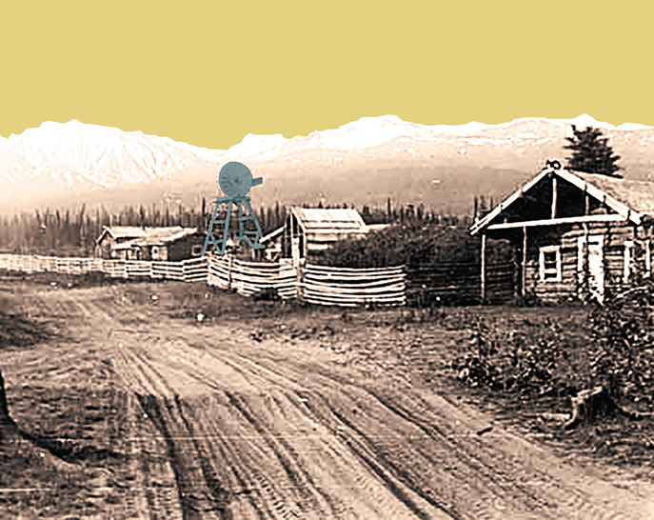
De hoes van de Misty Mama’s

- Karl Shiflett It’s fall again
- Vernon Oxford Move to town in the fall
- Mainer’s Mountaineers Going back West in the fall
- Wilf Carter The round up in the fall
- Misty Mama’s Reflections in the fall
- The Coachmen Marry in the fall
- Relentless Mules See you in the fall
- Rosanne & Johnny Cash September when it comes
- Bill Grant & Delia Bell Memories in the fall
- Anna Lynch Apples in the fall
- Bolt Brothers & Stacie When fall comes around
- Dana Jennejohn & Bennett Sun September colours of fall
- Shenandoah Blue When fall comes around
- Stew Clayton The barn dance in the fall
- Kody Norris Show Petals in the fall
- Roy Clark September song
- By the Lee In the fall
- Thomas Cassell Autumn leaves don’t fall in the fall
Bonus
- The Original Five Carolina in the fall
- John Reischman & Jaybirds In the fall

Dinsdag 7 oktober, 22:00-23:00
Bij Noordkop 247
Noordkop Country
Songs (co-)written by
Wayland Holyfield – 5


- Lee Greenwood I Don't Want to Wake You
- John Conlee Is There Anything I Can Do
- Shelly West Let’s Stay The Way We Are Tonight
- Nicolette Larson Break Away
- Vince Gill Turn me to love
- The Judds River Roll On
- Reba McEntirue Whose Heartache Is This Anyway
- Waylon Jennings I Take My Comfort in You
- Michael Martin Murphy Out Of Touch
- Wayland Holyfield Arkansas (You run deep in me)
- Jimmy Buckley Blue Ridge Mountain Girl
- T. Graham Brown I’ll Believe It When I Feel It
- Mickey Gilley She reminded me of you
- Baillie & the Boys (Wish I had a) Heart of stone
- Mickey Gilley Dancing to the beat of a broken heart
- John Conlee Love stands tall
- Johnny Lee Dangerous lonely
- Ronna Reeves Ain’t no future in the past
- Billy Dean Only here for a little while
- Clay Walker She won’t be lonely for long

Dinsdag 7 oktober, 23:00-24:00
Bij Noordkop 247
Noordkop Bluegrass
Songs written by
Hazel Dickens - 2
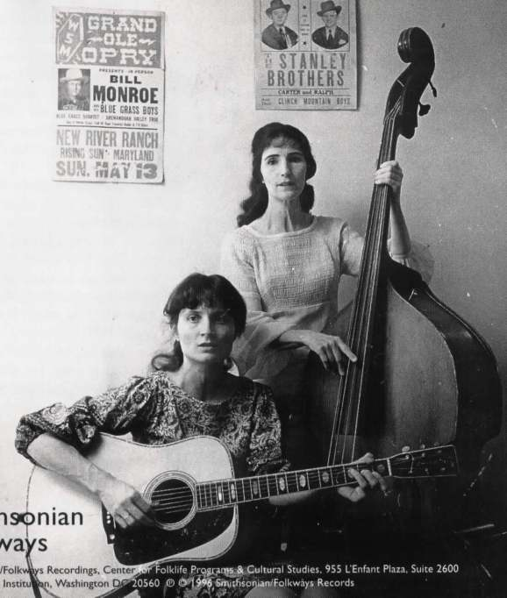
Hazel & Alice

- Dry Branch Fire Squad Mount Zion’s lofty heights
- Emmylou Harris Montana cowboy
- Lynn Morris Mama’s hand
- Cathy Fink Coal mining woman
- Foghorn Stringband Only the Lonely
- Dayna Kurtz Scars from an Old Love
- Tim O’Brien A Few Old Memories
- Molly & Jack Tuttle It's Hard to Tell the Singer from the Song
- Bill Frisell Will Jesus Wash the Bloodstains from Your Hands?
- Flatt Lonesome You'll Get No More of Me
- Beezus Rebel girl (fragment)
- Hazel Dickens The Yablonski murder
- Laurie Lewis Darling Nellie
- Bill & Maggie Anderson My Heart's Own Love
- John Lilly Coal miner’s grave
- Hazel Dickens Hills of home
Bonus
- Laurie Lewis Beyond the river bend
- Hazel Dickens Little Lenando
- Hazel Dickens Your greedy heart

De vorige week
Wilt u luisteren naar het programma van de vorige week?
Control+klik op onderstaande links

Zaterdag 27 september uur 1, Saturdaymorning C: De hits van 1959
https://hans.vdveen.org/muziek/XYZ - CROSSROADS COUNTRY RADIO/474x - Saturday mornin Country. 2025-09-27 - De hits van februari 1959.mp3

Zaterdag 27 september uur 2, Saturdaymorning BG: Divers
https://hans.vdveen.org/muziek/XYZ - CROSSROADS COUNTRY RADIO/474y - Saturday mornin Bluegrass, 2025-09-27 - Divers.mp3

Zaterdag 27 september uur 3, Saturdaymorning C: Country 1952-1973 (1)
https://hans.vdveen.org/muziek/XYZ - CROSSROADS COUNTRY RADIO/474z - Saturday mornin Country, 2025-09-27 - Country 1952-1973 (1).mp3

Zondag 28 september, Waterland CB: Vallende bladeren in september
https://hans.vdveen.org/muziek/W - WATERLAND CB/474W - Waterland CB - 2025-09-28 - Vallende bladeren in september.mp3

Dinsdag 30 september, Noordkop Country: Goin’ fishin’ (4)
https://hans.vdveen.org/muziek/B - NOORDKOP COUNTRY/474B - Noordkop Country - 2025-09-30 - Going'Fishing'(4) .mp3

dinsdag 30 september, Noordkop Bluegrass: Hazel Dickens (1)
https://hans.vdveen.org/muziek/C - NOORDKOP BLUEGRASS/474C - Noordkop Bluegrass - 2025-09-30 - Hazel Dickens (1).mp3

