Waterland CB
Noordkop Country & Bluegrass

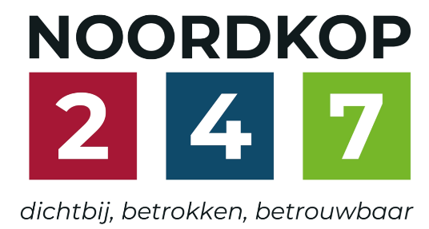

Dinsdag 22:00-24:00  www.regionoordkop.nl  ether: 105.6 en 107.7 FM  luisteren on line kan via  www.noordkop247.nl/live-radio/ | Zondag 19:00-20:00  https://rtvpurmerend.nl  luisteren online kan via  https://rtvpurmerend.nl/radio/live
Zaterdagmorgen 9:00-12:00
www.crossroadsradio.nl
herhaling: elke donderdag 9:00-12:00
Na de uitzending kan het programma worden beluisterd
wanneer u maar wilt, via
http://hans.vdveen.org/muziek/
U vindt daar de uitzendingen van het laatste half jaar, waar u vrij uit kunt kiezen.
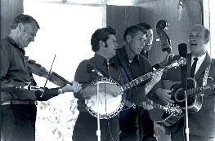


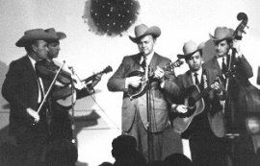
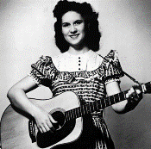
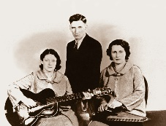
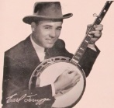  31 augustus, 2 & 6 september 2025  Zondag 19:00-20:00 – Waterland Country & Bluegrass  Dinsdag 22:00-23:00 – Noordkop Country  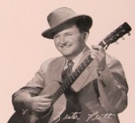  Dinsdag 23:00-24:00 – Noordkop Bluegrass  Zaterdag 09:00-12:00 – Crossroads Radio  samenstelling, montage & presentatie  Hans van der Veen | 31 augustus & 2 september 2025  Zondag 19:00-20:00 – Waterland Country & Bluegrass  Dinsdag 22:00-23:00 – Noordkop Country  Dinsdag 23:00-24:00 – Noo  rdkop Bluegrass  samenstelling, montage & presentatie  Hans van der Veen

Opgepast: zondag kom ik nog gewoon om 7 uur – mooie fotot van grootpapa – maar dinsdag is het september en heten we niet meer Regio Noordkop, maar Noordkop 24.7 en zit ons programma van 10 tot 12. Is het u te laat? U kunt luisterten via Gemist of via hans.vdveen.org.
Ik heb de playlist voor zaterdagmorgen 5 september er ook bij gezet, maar ik ben het met mezelf nog niet helemaal eens hoe we dat moeten doen. Als ik de playlisten op donderdag of vrijdag verstuur, dan beginnen we op zaterdag. Daar valt wat voor te zeggen. Ik kan ze ook op zondagavond versturen, dan is dinsdag het eerst aan de beurt. De kans is groot dat er een minister aftreedt tijdens het overleg, maar dat went ook.
Veel luisterplezier in elk geval!!!!

Zondag 31 augustus, 19:00-20:00
Waterland CB
CB-021
Jones – 1
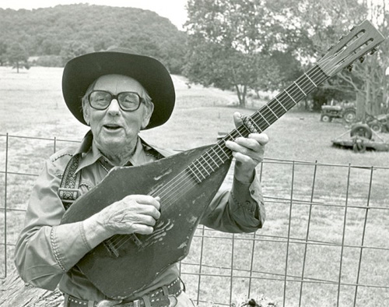
Jimmie Driftwood
Country
- John D. Loudermilk Angela Jones
- Rosie Daze Band Agatha Jones
- Tom Paxton Clarissa Jones
- Waylon Jennings Willie And Laura Mae Jones
- George Hamilton Iv Old Bill Jones
- Jimmie Driftwood Davy Jones
- Logan English Old Doc Jones
- Ian Robb Jim Jones
- Kathy Matthea Lawrence Jones
Bluegrass
- Nu-Blu Mandy Jones
- Doyle Lawson Sweet Rosie Jones
- Mike Eisler Smarty Jones
- Don Reno Ex-Missus Jones
- Curly Ray Cline Flem Jones
- Jussi Syren Old Deacon Jones
- Tim O’brien Jonesy
- Del Mccoury J.D. Jones
- Trampled by Turtles Chippin’ at my jones
- Grandpa Jones When the Jones’ get together
- Jim Lauderdale Janis Jones
Bonus:
- Sally Jones Angels by my side

Dinsdag 2 september, 22:00-23:00
Noordkop Country
Country Sweethearts – 1
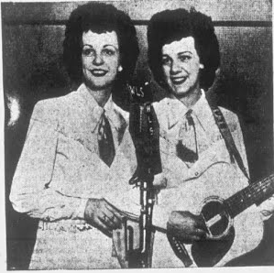
The Beaver Valley Sweethearts
Artiesten
- The Canadian Sweethearts Colinda
- Rainbow Valley Boys & Sweetheart - Home sweet home
- Sierra Sweethearts Cowgirl yodel number 3
- Sweethearts of the Rodeo Muleskinner blues
- Charlotte Harden & Ozark Sweethearts - Alone With You
- Ann Jones and her Western Sweethearts - God gave me you
- Dirt Road Sweetheart Dream of the miner’s child
- Sweetheart Sisters Valse dans mes bras ce soir
- Beaver Valley Sweethearts Mockingbird Hill
- Oklahoma Sweethearts When you’re out cheating
- Mary Rose & the Country Sweethearts - Loving you
- Country Sweethearts (Canada) Hang them all
- Dixie Sweethearts When he heard my plea
- Nashville Songwriting Sweethearts All I have to do is dream
Albums
- Patsy Montana Back to strangers
- Ray Price Margie’s at the Lincoln Park Inn
- Ann Breen That’s an Irish Lullaby
- Tabby West Send me somebody like Joe
- Wynn Stewart & Jan Howard We’ll never love again
- David Kersh Until now
Bonus
- Catharina Valente Sweetheart, my darling, mijn schat
- Emmylou Harris Sweetheart of the rodeo

Dinsdag 2 september, 23:00-24:00
Noordkop Bluegrass
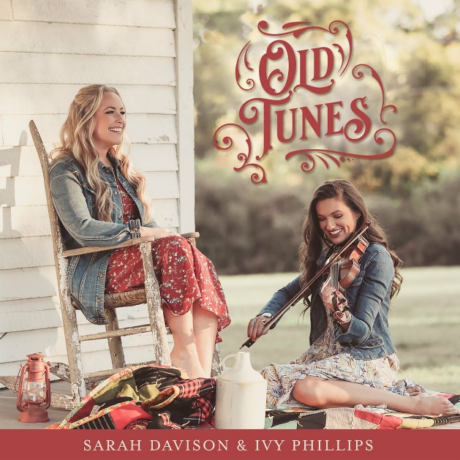
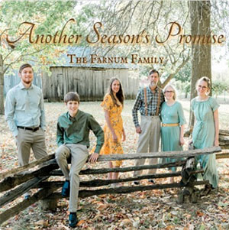
Wilde dieren

- Rob Ickes The last polar bear
- Batten Family Tiger by the tail
- Hamilton County BG Band Tiger huntin in the Ureweras
- Sarah Davison & Ivy Phillips Tiger rag
- Rose Maddox Lion in the winter
- North Carolina Cooper Boys Daniel in the den of lions
- Volume Five The lamb, the lion, and the king
- Jimmy Martin Jimmy Martin
- Laurie Lewis The bear song
- Hylo Brown The preacher and the bear
- Damascus Road Fox fire
- Bluegrass Rebels Fox on the run
- Hastily Assembled BG Band The fox went out on a chilly night
- Farnum Family The fox
- Ron Block Wolves a howling
- Mac Odell Wolves in sleep’s clothing
- Cactus Mac & Stuart Hamblen’s Covered Wagon Jubilee
The crocodile (1936)
- Bill Napier & the Mountain Music Clan - Alligator man
- Faris Family Skunk river
- Tony Trischka band Lynx
- Joe Mullins Reindeer Boogie
- Roger Sprung Puff the magic dragon
Niet meer in de uitzending
- Tom Hanway Elephant hop
- Highrise Lonesome Elephant mountain
- Trevor Holder & Conner Vlietstra – Chattanooga dog

Zaterdag 5 september
Herhaling: donderdag 10 september
Crossroads Radio
09:00-10:00: Waterland CB van 30 maart 2025
De Country Hits van 1960 (1)
- Jim Reeves He’ll have to go
- Hank Locklin Please help me
- Cowboy Copas Alabam
- Ferlin Husky Wings of a dove
- Johnny Cash I Love You Because
- Ted Self Little Angel (Come Rock Me to Sleep)
- The Browns The Old Lamplighter
- Elmer Snodgrass Until Today
- Sammy Kaye, orkest & Billy Williams
The old lamp-lighter
- Bill Anderson Dead or Alive
- Billy Walker I Wish You Love
- Adrian Roland Imitation of Love
- Carl Belew Too Much to Lose
- Jimmy Smart A Broken Dream
- Freddie Hart The Key's in the Mailbox
- Ray Sanders World So Full of Love
- Webb Pierce (Doin' the) Lover's Leap
- Connie Hall It's Not Wrong
- Wilma Lee and Stoney Cooper Johnny, My Love (Grandma's Diary)
- The Stanley Brothers How Far to Little Rock
- Townes Van Zandt & Kimmy Rhodes
Brother flower
- Ben & Carmen Steneker Never ending love
- Della Mae Jamie Dear

10:00-11:00: Noordkop Country van 6 september 2022
Bluegrass gedraaid in Purmerend 1-10-2012
- Carl Story Get on board
- Bill Harrell & Friends Flower blooming in the wildwood
- Stroatklinkers Koekoek
- Red Allen New Campton races
- J.E. Mainer Forty years ago
- Carl Story Angel BaND
- Slim Dusty Family Foggie Mountain Breakdown
- Ralph Stanley & Iris Dement Ridin’ that midnight train
- Lester Flatt & Earl Scruggs You are my flower
- Adam Dewey Old Thaddeus
- Lilly Brothers On the sunny side of life
- Kentucky colonels There ain’t nobody gonna miss me
- Lewis Hicks & The Spring Valley Ramblers
John Hardy
- Wade Family Lord Lead Me
- Chicky Williams Beyond the sunset
- Eddy Poirier Woodchopper breakdown
- Curly Seckler What’s the matter with you darling
- Everett Lilly Waves of the sea
- Dry Branch Fire Squad Dixie Cowboy
- Mark Newton Band Are you lonesome tonight
- Alaskan Sunnyside Sisters I went down a beggar but I came up a millionair

11:00-12:00: Noordkop Bluegrass van 6 september 2022
Waterland Bluegrass van 29-8-2016
- Carter Family Broken Engagement
- Osborne brothers & Red Allen Ruby, are you mad?
- Bill & Mary Reid Your Sweet Loving Man
- Don Reno & Red Smiley I Know You're Married (But I Love You Still)
- Bill Clifton Railroading on the Great Divide
- Hylo Brown One Way Train
- Carroll Best Y'all come
- Jim Eanes Don’t Stop Now
- Wilburn Brothers Great Big Love
- Flatt & Scruggs No Doubt About It
- Lilly Brothers & Don Stover Southern Skies
- Pete Pike All because of my jealous heart
- Jimmy Martin Skip, hop and wobble
- Stanley Brothers Who Will Call You Sweetheart
- Homer & Jethro Cigarettes, Whisky And Wild, Wild Women
- Roy Acuff It's Hard to Love
- Wilma Lee & Stoney Cooper Loving You
- Lee Moore You’re my own sweet darling wife
- Johnnie & Jack You can’t divorce my heart
- Louvin Brothers I Cried After You Left
- Frankie Miller Just for Spite
- Farmer Boys Oh! How It Hurts

De vorige week
Wilt u luisteren naar het programma van de vorige week?
Control+klik op onderstaande links

Zondag 24 augustus, Waterland CB: Kruideniers
https://hans.vdveen.org/muziek/W - WATERLAND CB/469W - Waterland CB - 2025-08-24 - Kruideniers.mp3

Dinsdag 26 augustus, Country & Bluegrass NieUw
https://hans.vdveen.org/muziek/A - COUNTRY NU (pas verschenen)/469A - R-N C&BG NieUw - 2025-08-26.mp3

Dinsdag 26 augustus, Noordkop Country: Folk Revival (7)
https://hans.vdveen.org/muziek/B - NOORDKOP COUNTRY/469B - R-N Country - 2025-08-26 - Folk Revival (7).mp3

dinsdag 26 augustus, Noordkop Bluegrass: Kisses (3)
https://hans.vdveen.org/muziek/C - NOORDKOP BLUEGRASS/469C - R-N Bluegrass - 2025-08-26 - Kisses (3).mp3

